Latent Heat

Content
Matter exists in different states, and the three common states are solids, liquids and gases. Matter in one state can transition to another state; a phenomenon called phase change. When a substance changes phase, thermal energy is absorbed by the substance from its surroundings. The temperature of the substance, however, remains constant during the phase change. The heat or thermal energy per unit mass is called the latent heat of the phase change. For historical reasons the latent heat for melting (solid $→$ liquid) is called the latent heat of fusion and evaporation (liquid $→$ gas) is called latent heat of vaporisation. The thermal energy required or released due to phase change is given by
$$Q=mL$$
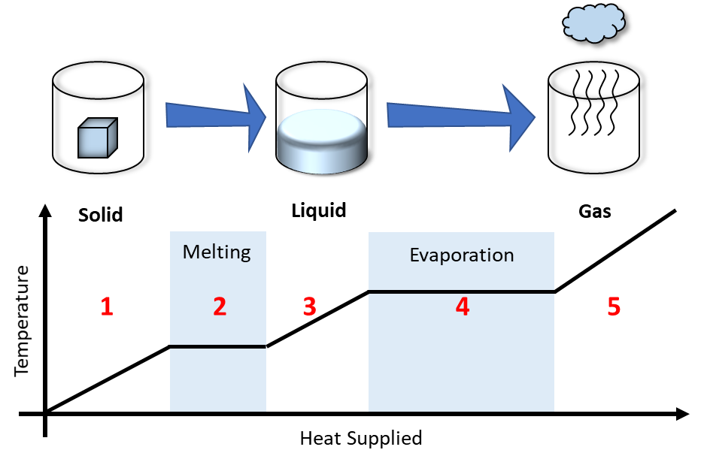
where $Q$ is the thermal energy, $m$ is the mass and $L$ is the latent heat. The units of latent heat are joule per kilogram ($\text{J/kg}$). Below is a diagram showing the different processes for water.
Following the diagram above:
- At low temperatures, water is in the solid form we call ‘ice’. Adding thermal energy to ice will increase the temperature of the ice.
- At some stage, the ice will melt into liquid (i.e. undergo a phase change) but the temperature will remain the same during this process.
- With further thermal energy added, the temperature of the liquid will rise again.
- At a much higher temperature, the liquid will start to evaporate into gas (a second phase change). The temperature will also not change during this process similar to melting.
- Once the phase change is complete, the temperature of the gas will increase.

Worked Example - Ice to Water
How much energy, as heat flow, is required to change $\text{0.40} \text{kg}$ of ice at $0\text{℃}$ into the water at $60\text{℃}$? The latent heat of fusion of water is $\text{335}\text{,000} \text{J/kg}\text{,}$ and the specific heat is $\text{4184 }\text{J/(}\text{kg.℃)}$.

- Let’s break down the question into stages. The ice melts into the water without any change in temperature (a phase change). After this, the water temperature is increased from $0℃$ to $60℃$.
$$0℃$$
$$60℃$$
$$0℃$$
Stage 1
Stage 2
ice
water
water
- Let’s now write down all the information we are given or know
- Energy due to phase change $Q=mL$  - Energy from heating $Q=mC(T_{f}-T_{i})$  - Mass of water and ice, $m_{ice}=m_{water}=\text{0.40 kg}$ | - Temperature changes from $T_{i}=\text{0}\text{℃}$ to $T_{f}=60\text{℃}$  - Latent heat of fusion is $L=\text{335,000} \text{J/}\text{kg}$  - Specific heat of water is $C=\text{4184 }\text{J/(}\text{kg.℃)}$
- Starting with stage 1 we find the amount of energy required to melt the ice.
$$\text{Energy from melting the ice}=\text{mass of ice × latent heat of ice} \\ Q_{\text{ice}}=mL \\ =\left(\text{0.40} \text{kg}\right) × \left(\text{335,000} \text{J}\text{/}\text{kg}\right) \\ =\text{0.134} \text{MJ}$$
- Moving to stage 2 we find the thermal energy required to raise the temperature of the water from $0℃$ to $60℃$
$$\text{Energy from heating water}=\text{mass of water × specific heat of water × temperature change} \\ Q_{\text{Water}}=mC(T_{f}-T_{i}) \\ =\left(\text{0.40 }\text{kg}\right) × \left(\text{4184 }\text{J}\text{/}\text{(}\text{kg}\text{.℃)}\right) × (60\text{℃}\text{- }\text{0}\text{℃}\text{)} \\ =\text{0.1004} \text{MJ}$$
- Finally, the total heat flow required is the sum of the energies from the two stages.
$$\text{Total heat flow required}=\text{Energy of ice melting + Energy of heating water} \\ Q_{\text{Total}}=Q_{\text{ice}}+Q_{\text{Water}} \\ =0.134 \text{MJ}+\text{0.1004 }\text{MJ} \\ =0.23 \text{MJ}$$

