Specific Heat Capacity

Content
The previous two topics deal with heat or thermal energy and the difference between temperature and internal energy (the kinetic energy of particles within an object). The symbol for thermal energy is $Q$ and has units of joules (J). A change in temperature results in a change in thermal energy. Writing the mass of an object as $m$, the initial and final temperatures of the object $T_{1}$ and $T_{2}$ and the resulting change in thermal energy as Q, we have the equation

$$Q=mc(T_{2}-T_{1}) \\ Q=mc∆T$$

In this equation, $c$ is a property of matter called the specific heat capacity. The specific heat capacity is defined as the amount of thermal energy needed to raise the temperature of a $\text{1 kg}$ object by $1 ℃$. The SI unit for specific heat is $\text{J/(kg.℃})$. Different materials will behave differently to a change in temperature and is described by the value of the specific heat capacity. The change in temperature $∆T$ can either be positive or negative depending on whether thermal energy is entering or leaving the body.

Example - Laboratory
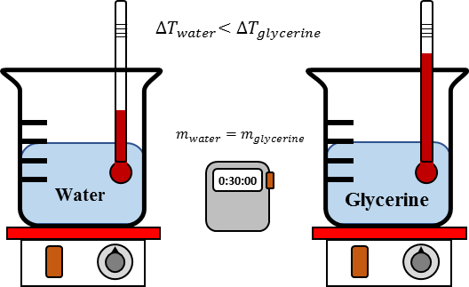
Consider equal masses of $\text{1 }\text{kg}$ of water and glycerine in separate beakers, both initially at the same temperature $T_{1}$.
As both beakers are heated the temperatures as shown by the thermometers will increase. However, the increase shown on the thermometer in the glycerine will be greater than that shown on the thermometer in the water. This is because the specific heat of glycerine is less than that of water ($c_{water}=4184 \text{J/(kg.℃})$ and $c_{glycerine}=2430 \text{J/(kg.℃})$).

Question 1 - Internet Research
Track down and compare the specific heat capacities of common substances – water, alcohol, ice, aluminium, iron, copper, gold, mercury, wood and steel.

Question 2
If we take 10 $\text{g}$ of water and add 700 $\text{J}$ by heating it, what will be the rise in its temperature? (Remember that the SI unit of mass is $\text{kg}$.)

Example - Real world
In an attempt to reduce electric bills for homes, some innovators have developed liquid filled windows to cool houses in summer and help keep them warm in winter explain how a water-filled window can cool the house in summer but the opposite in winter. Is it better to use alcohol than water for the liquid instead? The specific heat of glass is $c_{glass}=753 \text{J/(kg.℃})$, water is $c_{water}=4184 \text{J/(kg.℃})$ and alcohol is $c_{alcohol}=2440 \text{J/(kg.℃})$.

- The two windows are illustrated below for both the glass and liquid filled.
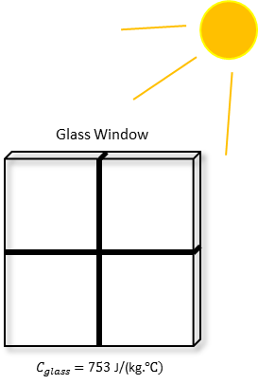  $$Q_{sun to glass}=Q_{sun to liquid}$$ | 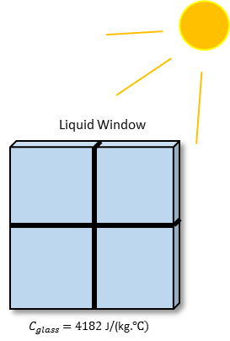  $$m_{glass}=m_{liquid}$$
- Both windows should receive the same amount of thermal energy from the sun. Starting with the equation
$$Q=mc∆T$$
- Rearrange to get the change in temperature
$$∆T=\frac{Q}{mc}$$
- The change in temperatures for the two windows then becomes
Glass | Water-filled
$$∆T_{glass}=\frac{Q}{m×753}$$ | $$∆T_{water}=\frac{Q}{m×4184}$$
$$∆T_{glass}>∆T_{water}$$
Since the specific heat capacity of glass is about 5x smaller than water
- Therefore, the liquid filled window will have a change in temperature about five times smaller than the glass window.
- If alcohol is used instead of water then the change in temperature is:
Alcohol | Water-filled
$$∆T_{alcohol}=\frac{Q}{m×2440}$$ | $$∆T_{water}=\frac{Q}{m×4184}$$
$$∆T_{alcohol}>∆T_{water}$$
Since the specific heat capacity of alcohol is about 2x smaller than water
- If we were to use alcohol to fill the window, the change in temperature would be about twice the change for the water-filled window. Therefore, it would be better to use water.

