Thermal equilibrium

Concept
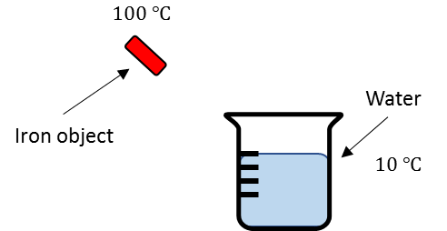
Two objects are said to be in thermal equilibrium if they are in contact with each other, and no heat transfer occurs. To understand this, consider a hot iron object placed in a container of cold water illustrated in the diagram below.

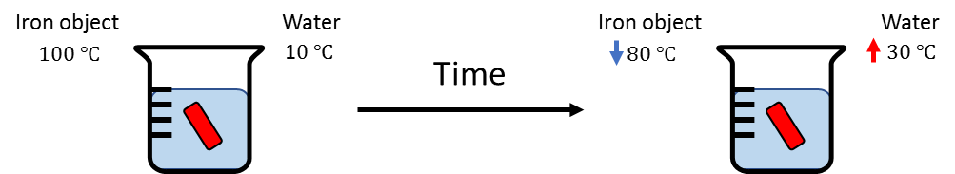
The iron has a higher temperature than the temperature of the cold water. When the iron object is dipped into the container (thermal contact) heat transfer occurs. Thermal energy is passed from the iron to the cold water. The iron object slowly loses heat while the cold water gains heat.

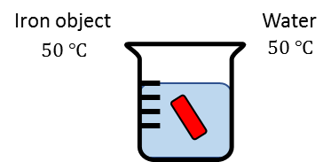
The heat transfer stops when both the iron object and water reaches the same temperature.

When this happens, the iron object and water are said to be in a state of thermal equilibrium.

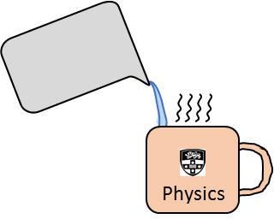
Example – Real World
The example above can be applied to a common real-world example: your coffee mug. When you pour hot water into the coffee mug, the hot water transfers energy (heat) to the mug. As a result, the temperature of the mug will increase. The temperature of the hot water will continue to decrease as the mug gets hotter. After some time, the temperature of the water and mug will be the same. Thus the two are in thermal equilibrium.

