Elastic and Inelastic Collisions

Content
If the total kinetic energy of the system before and after a crash is the same, the crash is called an elastic collision. If the kinetic energy isn’t the same before and after, the crash is called an inelastic collision. The ‘missing’ kinetic energy has actually been converted to other forms of energy. These include sound, heat and light. As an example of the most extreme inelastic collision, imagine two balls moving towards each other, like in the diagram below. In a perfectly elastic collision, these balls would bounce off each other and move away with the same total kinetic energy. In a perfectly inelastic collision, the two balls stick together.
In both elastic and inelastic collision, the momentum is the same before and after the collision.

Example 1
A ball with a mass of 2kg is travelling with a velocity of 4m/s to the right. It is travelling towards another ball with the same mass. The second ball is travelling with a velocity of 2m/s to the right. When these two balls collide, the stick together and start travelling together. Using the conservation of momentum, calculate the velocity of the combined two balls after the collision. Is this collision elastic or inelastic?
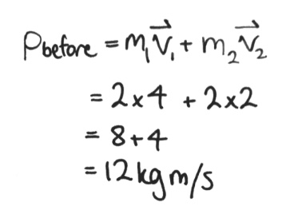
- We start with the conservation of momentum. First, we calculate the total momentum before the collision:
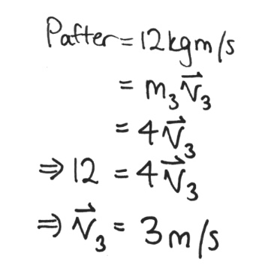
- Now, we know the mass of the two balls after the collision is just the sum of the mass of the two balls. We also know, by the conservation of momentum, the momentum after the collision must be 12kgm/s. So, we solve the equation for the velocity of the two balls:

- Now, to determine if the collision was elastic or inelastic. To do this, we calculate the kinetic energy before and after the collision and see if they are equal.
- Since the kinetic energy before and after isn’t the same, the collision is inelastic.

