Wave Behaviours

Content
Waves behave differently when they reach a barrier or a new medium. These behaviours can be sorted into reflection, refraction, diffraction or superposition. We will be looking at superposition later.

When a wave encounters a barrier, the wave can be reflected. This means the wave ‘bounces’ off the barrier and changes direction. An example of this is when light hits a mirror. If you shine a torch at a mirror the light reflects off the surface and you can see a ‘picture’ of the torch in the mirror.
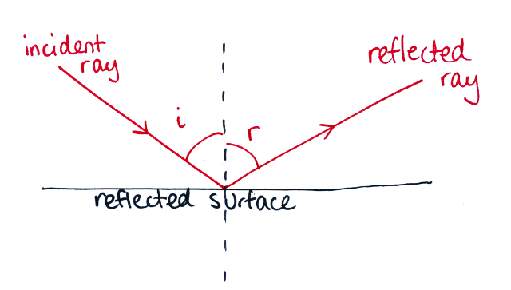
When a ray hits the surface, this is called the incident ray and the angle the ray hits the surface is called the angle of incidence, $i$. The angle of incidence is measured from the normal to the surface. Once the ray is reflected it is called the reflected ray and the angle of the ray is called the angle of reflection, $r$. This is also measured from the normal of the surface. The angle of incidence is equal to the angle of reflection.
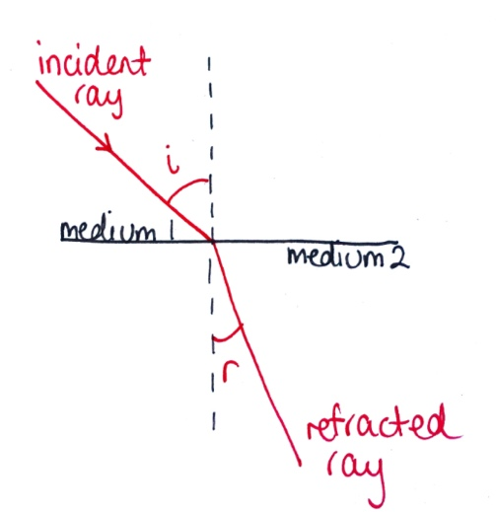
Sometimes, instead of being entirely reflected, a wave can pass through into a different medium and it is refracted. Refraction is when the light ‘bends’ in the new medium. Similar to a reflected wave, there is also an incident ray and angle of incidence as well as a refracted ray and angle of refraction. The only difference is the refracted ray is not entirely reflected off the surface, instead travels through the new medium.
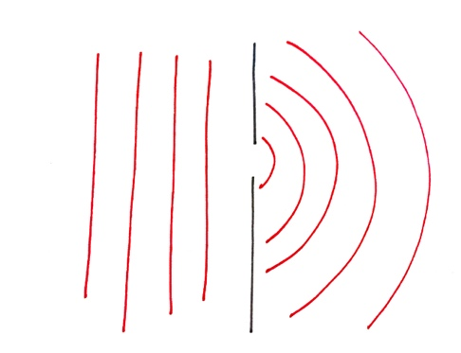
When waves pass through an opening they can also bend around the obstacles or change directions. This is called diffraction. For example, if straight water waves are travelling through the water and then pass through a slit the waves change direction and the water waves spread out, like in the diagram below.

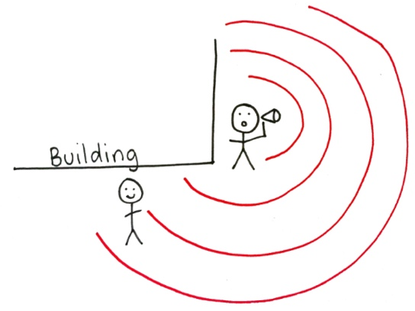
Waves can also be diffracted around an obstacle. For example, if you are standing next to a building and shouting into a megaphone, around the corner, your voice can be heard. This is because the sound waves are being bent around the corner of the building.
The angle of diffraction is directly proportional to wavelength. The longer the wavelength, the greater the amount of diffraction, i.e. the more the wave can ‘bend’ around the obstacle.

Example 1
If a hiker is lost in a forest and wishes to send out a distress sound, should they use a high frequency or low frequency sound (assuming the waves have the same velocity) to bend around the trees in the forest? Explain your reasoning.

- Given the hiker needs the signal to travel as far as possible and avoid being blocked by a large tree, we need to determine which of the two sound signals can ‘bend’ around the trees more. So, let us look at how the wavelength is related to the frequency so we can determine which signal will be able to diffract around larger trees.
- We know the equation for velocity of a wave is $\vec{v}=fλ$ and we also know the velocity of the waves are the same. If we increase the frequency of the wave, the wavelength must decrease to keep the velocity constant. Likewise, if we decrease the frequency of the wave, the wavelength must increase.
- This means, the lower the frequency, the longer the wavelength.
- So, the hiker is best sending out a low frequency (longer wavelength) signal because the longer the wavelength, the more the sound waves can ‘bend’ around the trees.

Example 2
Kirra is looking at a window of a café, trying to see if her friend, Nala, is already waiting inside. Kirra notices she can see Nala inside but can also see her reflection in the window. Explain this behaviour of light.

- Since Kirra can see both Nala and herself in the window, there must be a combination of behaviours involved.
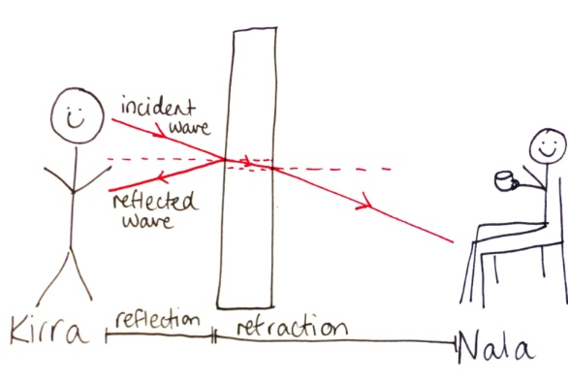
- Firstly, Kirra can see herself which means that at least some of the incident light wave is being reflected. However, since Kirra can also see Nala inside the café, light waves must also be travelling through the glass (being refracted). This is demonstrated in the diagram below. This is called partial reflection and refraction.

