Worked Example – Series Circuit  Find the voltage running through each resistor for the series circuit on the right. The resistance values are $R_{1}=1 Ω, R_{2}=2 Ω \text{and} R_{3}=5 Ω$. |  | 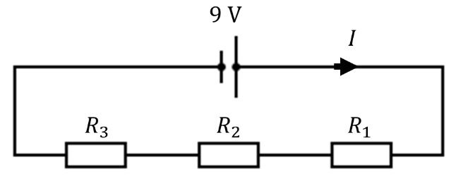
- We have three resistors connected in series, and according to Kirchoff’s Current Law, the current passing through each resistor is the same. Thus, if we know the total current is running through the circuit, we know the current running through each resistor.
- We start by combining the three resistors connected in series into one equivalent resistor |  | 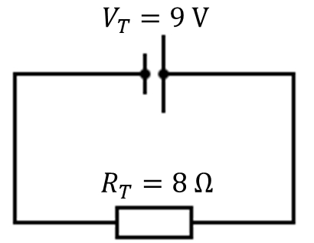
$$R_{T}=R_{1}+R_{2}+R_{3} \\ =1 Ω+2 Ω+5 Ω \\ =8 Ω$$
- The total current running through the whole circuit is: |  | $$V=IR \\ I_{T}=\frac{V_{T}}{R_{T}}=\frac{9 V}{8 Ω}=1.125 A$$
- Thus, the voltage across each resistor is:
$$V_{R_{1}}=I_{T}R_{1} \\ =1.13 A×1 Ω \\ =1.125 V$$ | $$V_{R_{2}}=I_{T}R_{2} \\ =1.13 A×2 Ω \\ =2.250 V$$ |  | $$V_{R_{1}}=I_{T}R_{1} \\ =1.13 A×5 Ω \\ =5.625 V$$
- To check if we calculated the voltage correctly, make sure the sum of the voltages across each resistor is equal to $9.0 V$ (Kirchoff’s Voltage Law). |  | $$V_{T}=V_{R_{1}}+V_{R_{2}}+V_{R_{3}} \\ =1.125 V+2.250 V+5.626 V \\ =9.0 V$$

Worked Example – Parallel Circuit  Find the current running through each resistor for the parallel circuit on the right. The resistance values are $R_{1}=1 Ω, R_{2}=2 Ω \text{and} R_{3}=5 Ω$. |  |  | 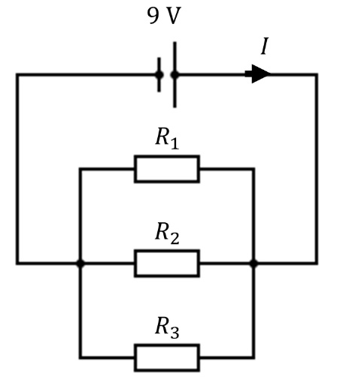
- The three resistors are connected in parallel and the current entering and exiting the node of the resistors is the same. The voltage across each resistor is the same.
- We combine the three resistors into on equivalent resistor |  |  | 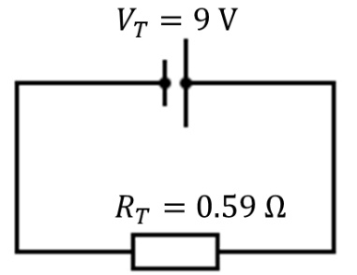
$$\frac{1}{R_{T}}=\frac{1}{R_{1}}+\frac{1}{R_{2}}+\frac{1}{R_{3}} \\ =\frac{1}{1 Ω}+\frac{1}{2 Ω}+\frac{1}{5 Ω} \\ =\frac{17}{10 Ω}$$ | $$R_{T}=\frac{1}{17/10 Ω} \\ =0.59 Ω$$
- The total current running through the whole circuit is: |  |  | $$V=IR \\ I_{T}=\frac{V_{T}}{R_{T}}=\frac{9 V}{0.59 Ω}=15.3 A$$
- The voltage running through each resistor is $9 V,$ and thus the current through each resistor is:
$$I_{R_{1}}=\frac{V_{T}}{R_{1}} \\ =\frac{9 V}{1 Ω} \\ =9.0 A$$ |  | $$I_{R_{2}}=\frac{V_{T}}{R_{2}} \\ =\frac{9 V}{2 Ω} \\ =4.5 A$$ |  | $$I_{R_{3}}=\frac{V_{T}}{R_{3}} \\ =\frac{9 V}{5 Ω} \\ =1.8 A$$
- Check that the sum of the currents is equal to the total current:  - Observe that adding resistances (e.g. $1 Ω$, 2$Ω$ and $5Ω$) in parallel decreases the total resistance ($0.59 Ω)$ |  |  | $$I_{T}=I_{1}+I_{2}+I_{3} \\ =9.0 A+4.5 A+1.8 A \\ =15.3 A$$

Worked Example – Combined Series and Parallel Circuit  Find the voltage and current running through each resistor for the series-parallel circuit on the right. The resistance values are $R_{1}=1 Ω, R_{2}=2 Ω \text{and} R_{3}=5 Ω$. |  |  | 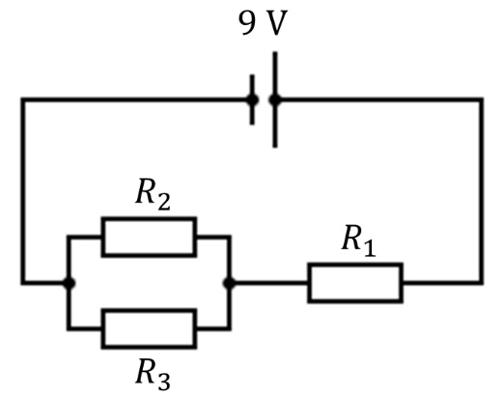
- For this circuit, the current flows through $R_{1}$ in series and then splits on a node to $R_{2}$ and $R_{3}$ in parallel. Much like solving the series and parallel only circuit we want to reduce the circuit into a one resistor circuit.
- We first combine the resistors connected in parallel and then combine the resistors in series. Pictorially we perform the transformation below.
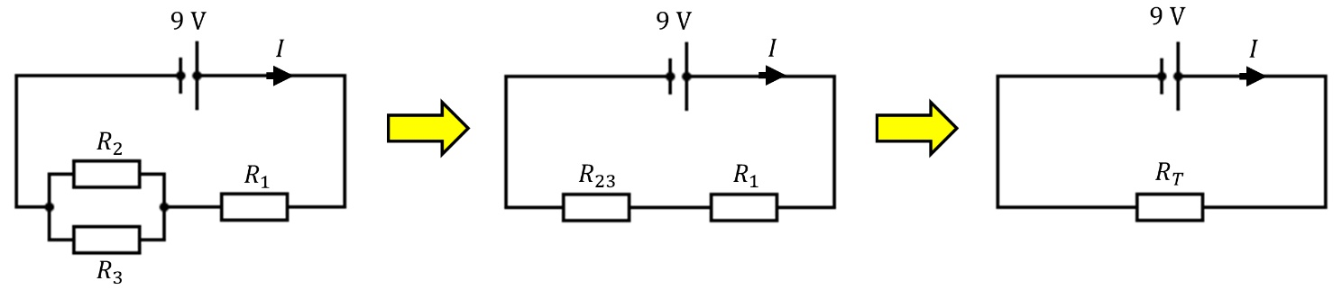
- Below is the working out of combining the resistors as shown above
$$\frac{1}{R_{23}}={\frac{1}{R}}_{2}+{\frac{1}{R}}_{3} \\ =\frac{1}{2 Ω}+\frac{1}{5 Ω} \\ =\frac{7}{10 Ω}$$ |  | $$R_{23}=\frac{1}{\frac{7}{10 Ω}} \\ =1.43 Ω$$ |  | $$R_{T}=R_{23}+R_{1} \\ =1.43 Ω+1 Ω \\ =2.43 Ω$$
- The total current is: |  |  | $$V=IR \\ I_{T}=\frac{V_{T}}{R_{T}}=\frac{9.0 V}{2.43 Ω}=3.70 A$$
- Once we have the total current, we work our way back and expand the circuit to get the current and voltages
- The current is constant for resistors connected in series. Thus $3.70 A$ flows through both $R_{23}$ and $R_{1}$.  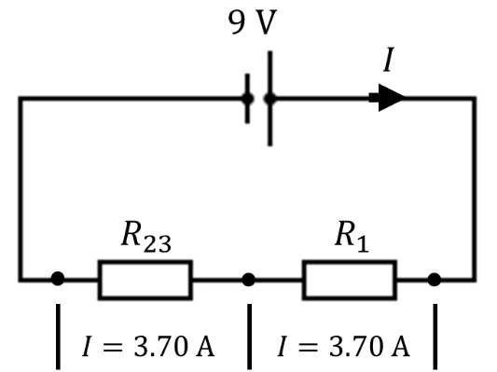 |  |  | - The voltage across $R_{23}$ and $R_{1}$ is:
$$V_{R_{23}}=I_{T}R_{23} \\ =3.70 A ×1.43 Ω \\ =5.30 V$$
$$V_{R_{1}}=I_{T}R_{1} \\ =3.70 A ×1 Ω \\ =3.70 V$$
 |  |  | - Check sum of voltage is equal to $9.0 V$:
 |  |  | $$V_{T}=V_{R_{23}}+V_{R_{1}} \\ =5.30 V+3.70 V \\ =9.0 V$$
- Now that we have the voltage running through $R_{23}$ we can calculate the current through $R_{2}$ and $R_{3}$.
$$I_{R_{2}}=\frac{V_{R_{23}}}{R_{2}} \\ =\frac{5.29 V}{2 Ω} \\ =2.65 A$$ | $$I_{R_{3}}=\frac{V_{R_{23}}}{R_{3}} \\ =\frac{5.29 V}{5 Ω} \\ =1.05 A$$ |  | 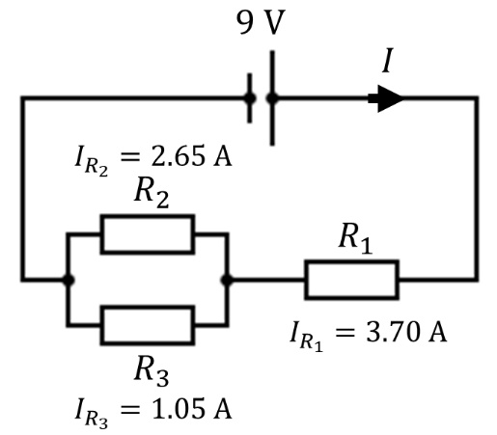
- Check that the sum of the currents is equal to $3.70 A$
$$I_{R_{23}}=I_{R_{2}}+I_{R_{3}} \\ =2.65 A+1.05 A \\ =3.70 A$$
- Summary of the current and voltages:
Voltage (V) |  | Current (A)
$$V_{1}$$ | 3.70 | $$I_{1}$$ | 3.70
$$V_{2}$$ | 5.30 | $$I_{2}$$ | 2.65
$$V_{3}$$ | 5.30 | $$I_{3}$$ | 1.05
$$V_{\text{T}}$$ | 9.00 | $$I_{\text{T}}$$ | 3.70

