Electric Circuits
Content – Ohm’s Law
Ohm’s law relates the voltage (i.e. potential difference V) with the current and resistance of an ideal conductor. The law states that
$$V=IR$$
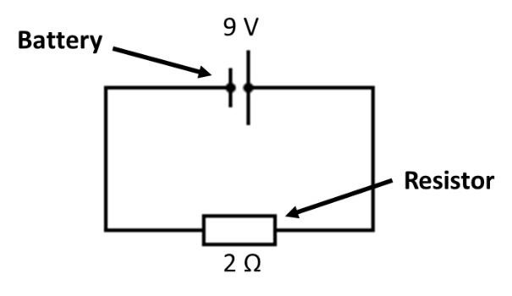
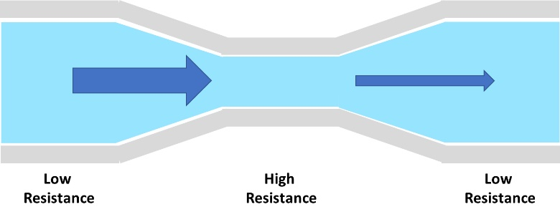
where $I$ is the currrent and $R$ is the resistance of the conductor. The units for current and resistance is Ampere ($A$) and Ohm ($Ω$) respectively. The current is a measure of the flow of electrons in the circuit and is inversely proportional to the resistance. Hence, a large resistance will reduce the flow of electrons. As an analogy, this is similar to water flowing through a tube. A narrow tube will reduce the amount of water flowing through whilst larger tube will allow more water to flow through.
As a simple example, consider a one resistor circuit connected to a battery on the right. The battery provides a source of 9 V, and the resistance of the resistor is 2 $Ω.$ With the information we have, we can calculate the current flowing through the resistor using Ohm’s law. The current flowing through the 2 $Ω$ resistor is $I=V/R=9 V/2 Ω=4.5 A$. If the resistance is doubled to $4 Ω$ the current is reduced to 2.25 $A$.
It is important to note that resistors can either be ohmic or non-ohmic. Ohmic resistors have a constant resistance, hence in the equation above, if a resistor is an ohmic resistor with a constant resistance, then the graph of velocity against time is a straight line. In the case of non-ohmic resistors, where resistance in a resistor varies with, say current, then the graph of velocity against time is not a straight line. In the case of latter, the resistor is said not to obey Ohm’s Law.
Content – Series Circuits
For a single resistor circuit like the circuit above applying Ohm’s law is trivial. However, when more than one resistor is connected in either series or parallel, then Ohm’s law cannot be applied the same way. For resistors connected in series (i.e. connected next to each other) the current flowing through each resistor is the same, but the voltage is divided amongst the resistors. For the circuit below with an incoming voltage of $V_{T}$, the voltage drop after passing through $R_{1}$ is $V_{T}-V_{1}$. Then the voltage drop after passing through $R_{2}$ is $V_{T}-V_{1}-V_{2}$ and similarly for $R_{3}$. Thus, after passing through each resistor the potential of the current flow decreases. If all resistors in series have same resistance, then the voltage drop across each resistor is the same. However, in the case of resistors with different resistance, the resistor with a greater resistance will result in the greatest voltage drop.
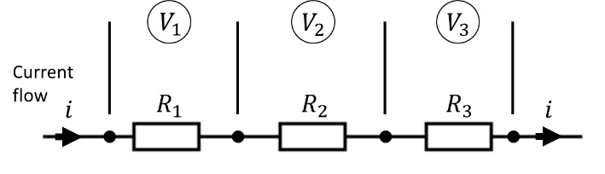 | 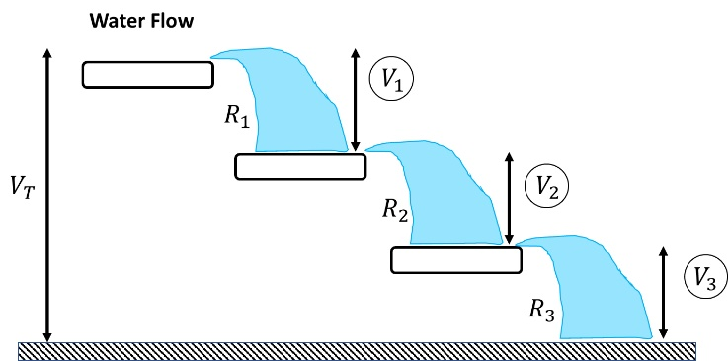
We can also use the analogy of water flowing from a higher to lower potential energy. Each drop in potential energy represents the electric current flowing through a resistor. When the water flows horizontally, there is no change in potential energy (like an electric current flowing through the wire). The sum of each potential energy drop is equal to the total potential energy the water is at initially. In electric circuits, this is called the Kirchoff’s Voltage Law (KVL), which states that the total potential difference in a closed circuit is equal to zero (i.e. conservation of energy).
$$V_{Series}=V_{T}=V_{1}+V_{2}+…+V_{n}$$
The total resistance of resistors connected in series can be calculated by summing up the resistance value of each resistor.
$$R_{Series}=R_{T}=R_{1}+R_{2}+…+R_{n}$$
The total resistance is also called the equivalent resistance, and we can reduce the multi-resistor circuit to one equivalent resistor.
Content – Parallel Circuits
For resistors connected in parallel the voltage flowing through each resistor is the same but the current is divided, which is the opposite behaviour to resistors connected in series. Consider the image of water tubes below where the flow of water splits into three tubes of different widths (point A). The amount of water flowing through tube 1 to 3 depends on the width of the tubes. As the water reaches the exit junction, point B, the current flow returns to the same state as the current it enters in at point A. The potential difference, however, is the same in tubes 1 to 3.
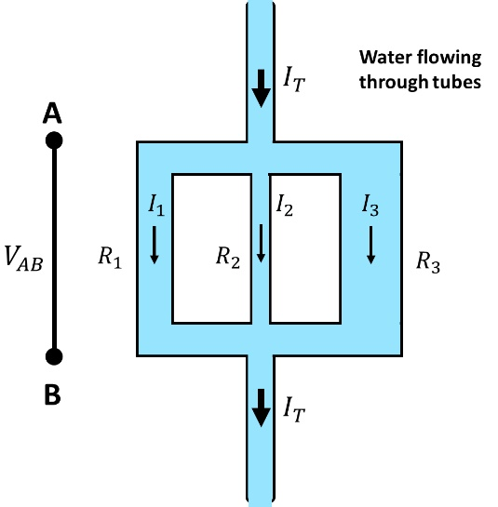 | 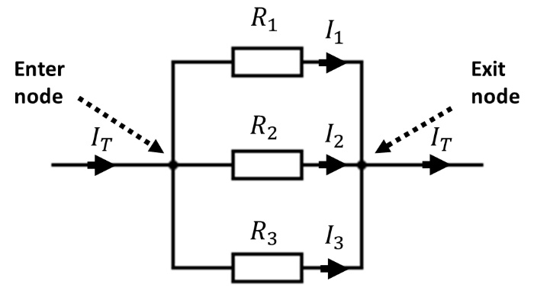
Similarly, for an electric circuit, the sum of the electric current flowing through each resistor connected in parallel is equal to the total current flowing into or out of the node/junction. This behaviour is known as the Kirchoff’s Current Law (KCL), which states that the total current entering a node is equal to the total current exiting the node (i.e. conservation of charge). Mathematically this is written as
$$I_{Parallel}=I_{T}=I_{1}+I_{2}+…+I_{n}$$
The equivalent resistance of resistors connected in parallel is calculated by summing up the reciprocal of each resistance value
$$\frac{1}{R_{Parallel}}=\frac{1}{R_{1}}+\frac{1}{R_{2}}+…+\frac{1}{R_{n}}$$
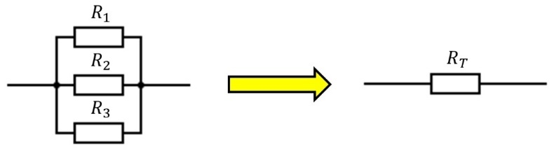
Transforming the resistors connected in parallel into one equivalent resistor
Summary
The table below summarises the general behaviour of current and voltage in circuits.
Resistor Connection | Voltage | Current
Series | Divided | Constant
Parallel | Constant | Divided

Worked Example – Series Circuit  Find the voltage running through each resistor for the series circuit on the right. The resistance values are $R_{1}=1 Ω, R_{2}=2 Ω \text{and} R_{3}=5 Ω$. |  | 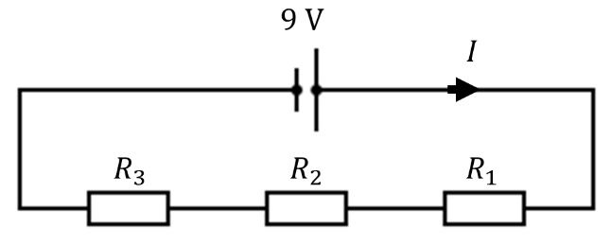
- We have three resistors connected in series, and according to Kirchoff’s Current Law, the current passing through each resistor is the same. Thus, if we know the total current is running through the circuit, we know the current running through each resistor.
- We start by combining the three resistors connected in series into one equivalent resistor |  | 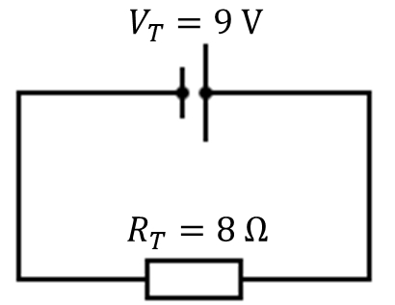
$$R_{T}=R_{1}+R_{2}+R_{3} \\ =1 Ω+2 Ω+5 Ω \\ =8 Ω$$
- The total current running through the whole circuit is: |  | $$V=IR \\ I_{T}=\frac{V_{T}}{R_{T}}=\frac{9 V}{8 Ω}=1.125 A$$
- Thus, the voltage across each resistor is:
$$V_{R_{1}}=I_{T}R_{1} \\ =1.13 A×1 Ω \\ =1.125 V$$ | $$V_{R_{2}}=I_{T}R_{2} \\ =1.13 A×2 Ω \\ =2.250 V$$ |  | $$V_{R_{1}}=I_{T}R_{1} \\ =1.13 A×5 Ω \\ =5.625 V$$
- To check if we calculated the voltage correctly, make sure the sum of the voltages across each resistor is equal to $9.0 V$ (Kirchoff’s Voltage Law). |  | $$V_{T}=V_{R_{1}}+V_{R_{2}}+V_{R_{3}} \\ =1.125 V+2.250 V+5.626 V \\ =9.0 V$$

Worked Example – Parallel Circuit  Find the current running through each resistor for the parallel circuit on the right. The resistance values are $R_{1}=1 Ω, R_{2}=2 Ω \text{and} R_{3}=5 Ω$. |  |  | 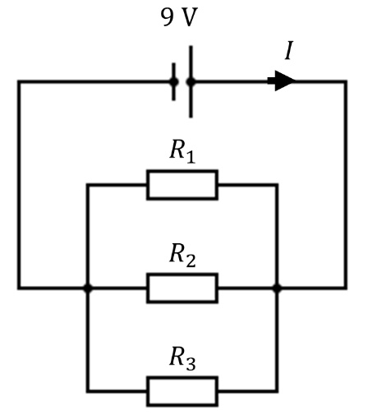
- The three resistors are connected in parallel and the current entering and exiting the node of the resistors is the same. The voltage across each resistor is the same.
- We combine the three resistors into on equivalent resistor |  |  | 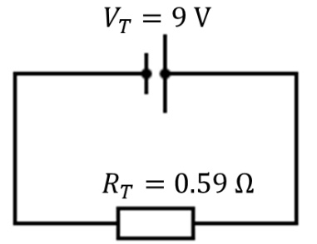
$$\frac{1}{R_{T}}=\frac{1}{R_{1}}+\frac{1}{R_{2}}+\frac{1}{R_{3}} \\ =\frac{1}{1 Ω}+\frac{1}{2 Ω}+\frac{1}{5 Ω} \\ =\frac{17}{10 Ω}$$ | $$R_{T}=\frac{1}{17/10 Ω} \\ =0.59 Ω$$
- The total current running through the whole circuit is: |  |  | $$V=IR \\ I_{T}=\frac{V_{T}}{R_{T}}=\frac{9 V}{0.59 Ω}=15.3 A$$
- The voltage running through each resistor is $9 V,$ and thus the current through each resistor is:
$$I_{R_{1}}=\frac{V_{T}}{R_{1}} \\ =\frac{9 V}{1 Ω} \\ =9.0 A$$ |  | $$I_{R_{2}}=\frac{V_{T}}{R_{2}} \\ =\frac{9 V}{2 Ω} \\ =4.5 A$$ |  | $$I_{R_{3}}=\frac{V_{T}}{R_{3}} \\ =\frac{9 V}{5 Ω} \\ =1.8 A$$
- Check that the sum of the currents is equal to the total current:  - Observe that adding resistances (e.g. $1 Ω$, 2$Ω$ and $5Ω$) in parallel decreases the total resistance ($0.59 Ω)$ |  |  | $$I_{T}=I_{1}+I_{2}+I_{3} \\ =9.0 A+4.5 A+1.8 A \\ =15.3 A$$

Worked Example – Combined Series and Parallel Circuit  Find the voltage and current running through each resistor for the series-parallel circuit on the right. The resistance values are $R_{1}=1 Ω, R_{2}=2 Ω \text{and} R_{3}=5 Ω$. |  |  | 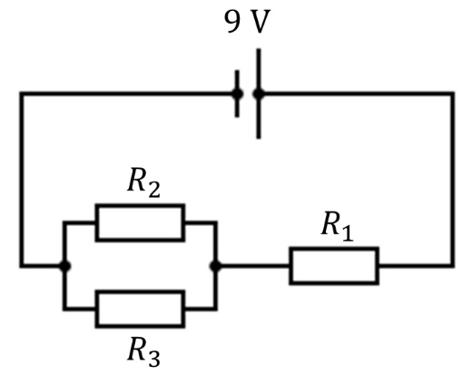
- For this circuit, the current flows through $R_{1}$ in series and then splits on a node to $R_{2}$ and $R_{3}$ in parallel. Much like solving the series and parallel only circuit we want to reduce the circuit into a one resistor circuit.
- We first combine the resistors connected in parallel and then combine the resistors in series. Pictorially we perform the transformation below.
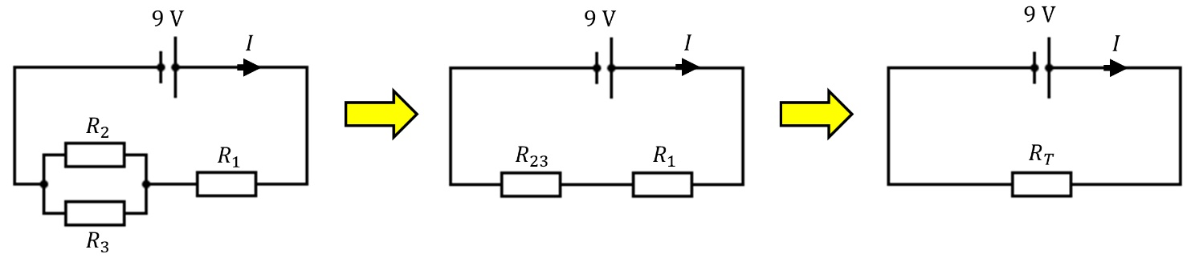
- Below is the working out of combining the resistors as shown above
$$\frac{1}{R_{23}}={\frac{1}{R}}_{2}+{\frac{1}{R}}_{3} \\ =\frac{1}{2 Ω}+\frac{1}{5 Ω} \\ =\frac{7}{10 Ω}$$ |  | $$R_{23}=\frac{1}{\frac{7}{10 Ω}} \\ =1.43 Ω$$ |  | $$R_{T}=R_{23}+R_{1} \\ =1.43 Ω+1 Ω \\ =2.43 Ω$$
- The total current is: |  |  | $$V=IR \\ I_{T}=\frac{V_{T}}{R_{T}}=\frac{9.0 V}{2.43 Ω}=3.70 A$$
- Once we have the total current, we work our way back and expand the circuit to get the current and voltages
- The current is constant for resistors connected in series. Thus $3.70 A$ flows through both $R_{23}$ and $R_{1}$.  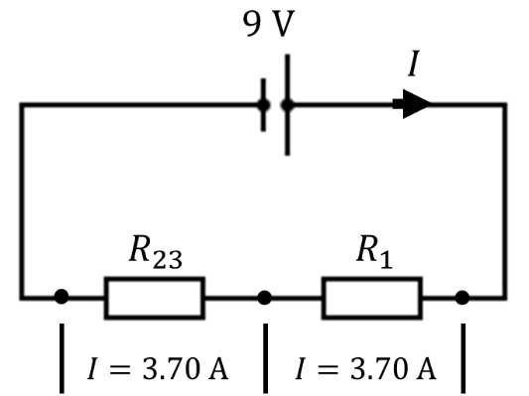 |  |  | - The voltage across $R_{23}$ and $R_{1}$ is:
$$V_{R_{23}}=I_{T}R_{23} \\ =3.70 A ×1.43 Ω \\ =5.30 V$$
$$V_{R_{1}}=I_{T}R_{1} \\ =3.70 A ×1 Ω \\ =3.70 V$$
 |  |  | - Check sum of voltage is equal to $9.0 V$:
 |  |  | $$V_{T}=V_{R_{23}}+V_{R_{1}} \\ =5.30 V+3.70 V \\ =9.0 V$$
- Now that we have the voltage running through $R_{23}$ we can calculate the current through $R_{2}$ and $R_{3}$.
$$I_{R_{2}}=\frac{V_{R_{23}}}{R_{2}} \\ =\frac{5.29 V}{2 Ω} \\ =2.65 A$$ | $$I_{R_{3}}=\frac{V_{R_{23}}}{R_{3}} \\ =\frac{5.29 V}{5 Ω} \\ =1.05 A$$ |  | 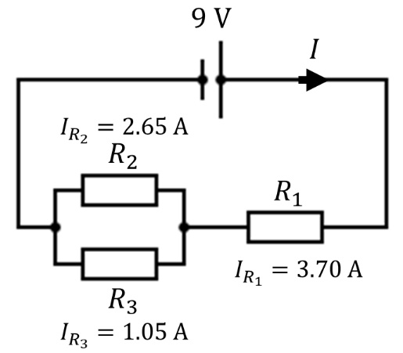
- Check that the sum of the currents is equal to $3.70 A$
$$I_{R_{23}}=I_{R_{2}}+I_{R_{3}} \\ =2.65 A+1.05 A \\ =3.70 A$$
- Summary of the current and voltages:
Voltage (V) |  | Current (A)
$$V_{1}$$ | 3.70 | $$I_{1}$$ | 3.70
$$V_{2}$$ | 5.30 | $$I_{2}$$ | 2.65
$$V_{3}$$ | 5.30 | $$I_{3}$$ | 1.05
$$V_{\text{T}}$$ | 9.00 | $$I_{\text{T}}$$ | 3.70

