Charges in an electric field

Content – Potential Energy and Work
A charge in an electric field is analogous to an object in a gravitational field. An object positioned at higher gravitational potential energy will, if unrestrained, naturally move towards lower potential energy. In this situation, work is done by the gravitational force. If we move the object from a position of lower gravitational potential energy to higher potential energy, then work is done by the external force used to move it. Similarly, a charge in an electric field, will, if unrestrained, naturally move from a higher to lower electric potential energy. The reverse movement from a posiition of lower electrical potential energy will require an external force to do the work. This is illustrated in the diagram below for a charged particle in an electric field created by two conducting parallel plates. The arrows represent the electric field direction.

The potential difference between two points A and B in the electric field is defined as the amount of work done in moving a unit charge from A to B and is given by
$$V=\frac{∆U}{q}=\frac{U_{B}-U_{A}}{q}$$
Where $∆U$ is the difference in potential energy between point A and B and $q$ is the charge of the particle. $V$ is the potential difference or voltage and is given in units of Volts (V) (This concept is important when we deal with electric circuits).

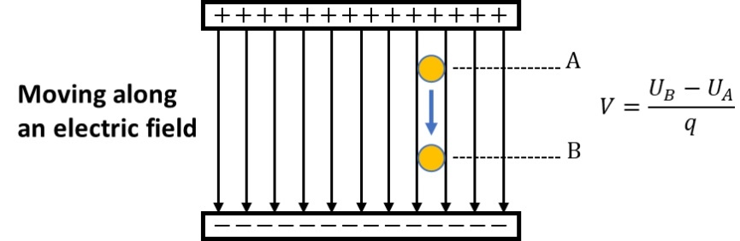

Content – Equipotential Lines
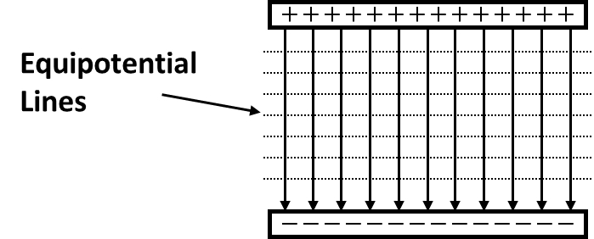
The electric potential can be represented graphically by drawing lines that are perpendicular to the electric field. These lines represent the points at which the electric potential energy is the same. Hence the name equipotential lines. The concept of equipotential lines in two dimensions can be extended to equipotental surfaces in three dimensions. For two parallel conducting plates, the equipotential surfaces are surfaces parallel to the plates.
Since the electric potential along an equipotential line is the same, no work is done moving a charged particle along the equipotential line. However, moving the particle from one equipotential line to another will require work either by the electric field or an external force.
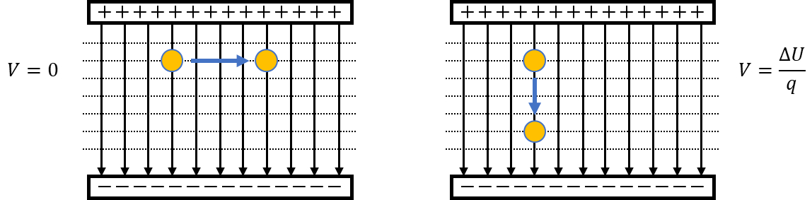
Below are two more examples of equipotential lines for a single positive charge and for two positive charges. Red lines represent the electri field lines while the dashed lines represent the equipotential lines.
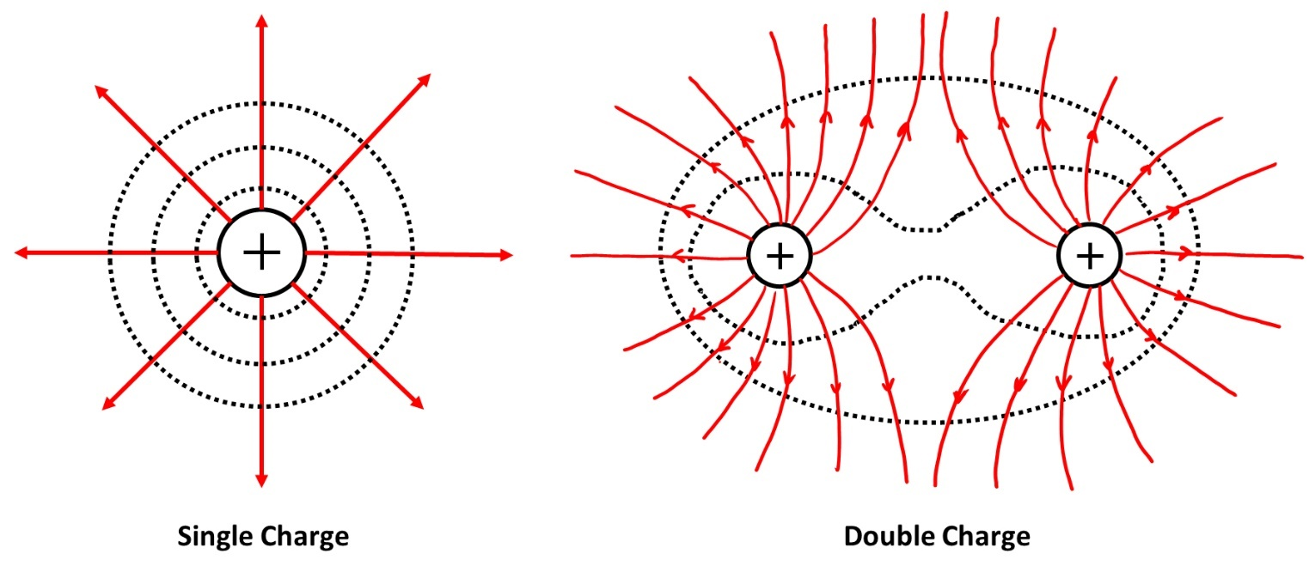

Question 1
Calculate the amount of work done by an electric field (1.0 V/m) on a particle with a charge of 1.0 C that moves along an equipotential surface.

Question 2 - Pencil
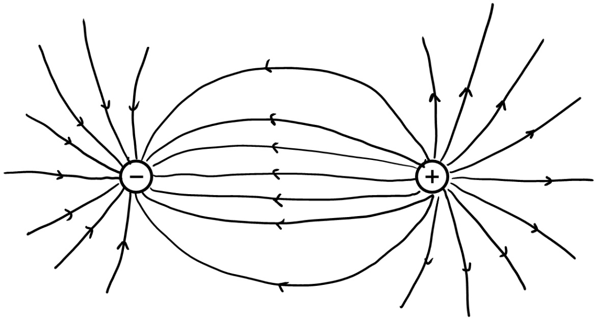
Draw the equipotential lines for the positive and negative charges below.

