Heating Effects of Electric Currents

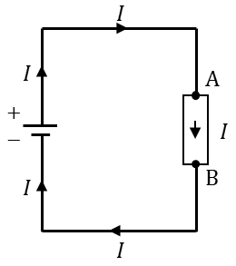
Content – Conservation of Energy
An electric current that passes through an electric component will have its potential energy dropped by a certain amount (potential difference or voltage). Following the circuit on the right, the electric current flows from a source starting from the positive terminal. As the current passes through the resistor, the potential energy of the electric current drops between point A and B. Finally, the current flows to the negative terminal completing the circuit. Following the law of conservation of energy, the drop in potential energy from point A to B must be transformed into a different kind of energy (the energy loss across the resistor cannot be destroyed). For a resistor, the electrical energy is transferred into heat (electrical to thermal). Other devices connected similarly will convert the electrical energy differently. Examples include electric current passing through a motor connected to a mechanical load, light bulb and a storage battery. The electrical energy is transferred as work done on the mechanical load (electrical to mechanical), converted to light (electrical to electromagnetic) and transferred to a stored chemical in the battery (electrical to chemical).
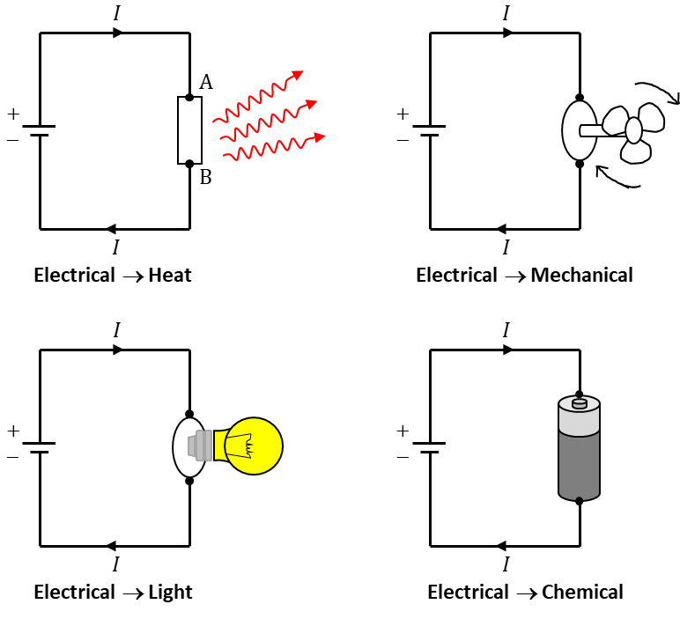

Content – Power in Circuits
The transfer of energy is quantitatively described with a variable called power, $P$. The units for $P$ is joule/sec or Watts, hence it is a measure of the amount of energy transferred per second or unit time. The power transferred from electric current is given by the voltage multiplied by the current.
 | $$P=VI$$ | (1)
To check if the expression above is correct, we will look at the units of both voltage and current. Voltage is defined as the amount of work done per unit charge (joule/coulomb), and current is the flow of charge per unit time (coulomb/sec). Thus, if we have 1 Volt and 1 Amp the multiplication of the two is
$$\text{1}\frac{\text{Joule}}{\text{Coulomb}}×\text{1}\frac{\text{Coulomb}}{\text{sec}}=\text{1}\frac{\text{Joule}}{\text{sec}}\text{or 1 Watt}$$
which is the unit for power. We can combine Ohm’s law with the power equation above to get the dissipation rate of electrical energy across a resistor. Ohm’s law is usually written as $V=IR$ and if we substitute Ohm’s law into equation (1) we get
 | $$P=(IR)×I=I^{2}R$$ | (2)
If instead, we write Ohm’s law as $I=V/R$ then power dissipated across the resistor is
 | $$P=V×\left(\frac{V}{R}\right)=\frac{V^{2}}{R}$$ | (3)
In the case of a series circuit, where current is the same across all resistors, the resistor with the greater resistance will have a greater power dissipation. In other words, if current $I$ stays the same in equation 2), then the greater the resistance, the greater the power dissipation. In the case of a parallel circuit, however, where voltage across the resistors stays the same, the resistor with the greater resistance will have a smaller power dissipation. This can be explained by visualising voltage $V$ as a constant in equation 3) and varying the resistance $R$.
It is important to remember that equation (1) is the rate of transfer of electrical energy to all forms of energy. Equation (2) and (3) gives the rate of transfer of electrical energy to thermal energy for an electrical component with resistance. This behaviour of electric current in circuits is used in the design of electric heaters.

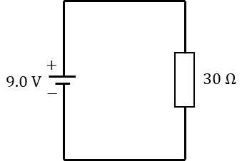
Question 1
A 30 Ω resistor is connected to a 9.0 V battery as shown on the circuit on the right.
- How much work is done on moving an electron across the resistor?
- What is the rate of energy transferred into heat across the resistor?
- How much thermal energy is produced in 1 hour?
ans: (a) 9.0 J (b) 2.7 W (c) 9.7 kJ

Question 2
Heat is generated in a resistor at a rate of 50 W. If the current running through the resistor is 1.5 A what is the resistance value of the resistor? What is potential difference across the resistor?
ans: R=22.2 Ω and V=33.3 V

Question 3
The standard voltage in Australia is 230 V and if a 1000 W heater is plugged into an outlet, find:
- The amount of current flowing through the heater
- The resistance of the heater
- The total cost of continuously running the bulb for seven days if it cost 12.5 cents/(kW.h)
ans: (a) 4.3 A (b) 53.5 Ω (c) $21.00

Question 4 Internet Research
- Investigate the physics of fireworks in terms of energy conversions. How many energy conversions can you list?
- Research the power consumption of common household appliances. Pick one appliance and study the energy rating of that appliance. What does the star rating mean?

