Wave Superposition

Content – Travelling and Standing Wave
When we think of waves, we associate the word with waves on the beach or a Mexican wave. The definition of waves in physics states that waves are oscillations that propagate in space and matter. The most common type of waves we encounter in our daily lives are mechanical waves. These include sound waves and wave motion in a string. Sound waves are an example of a travelling wave whereas a wave propagating in a string is an example of a standing wave. The position of a standing wave does not change while a travelling wave moves through space and matter.
Travelling wave | Standing wave
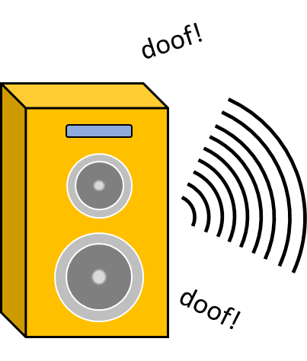 | 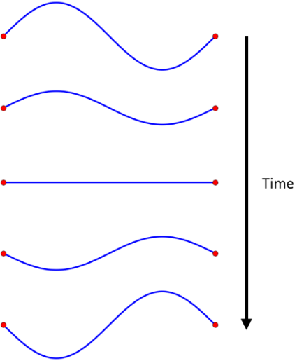
Content – Wave Superposition
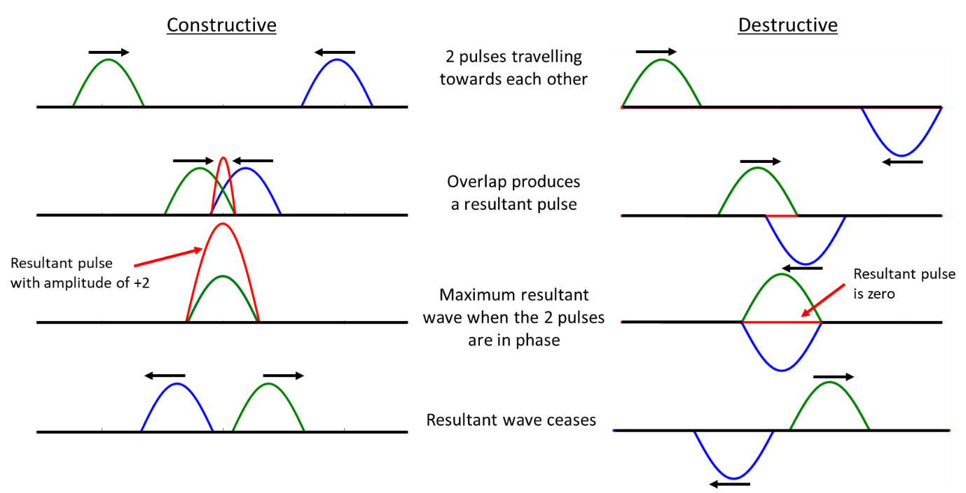
When two waves overlap, they combine to produce a resultant wave. This phenomenon is called the principle of superposition or wave superposition. The amplitude of the resultant wave increases when the two interacting waves are in phase, and it decreases when they are out of phase. To illustrate, consider two pulses with an amplitude of +1 travelling towards each other. When the two pulses start overlapping, the amplitude of the two pulses starts adding up following the superposition principle. When the two pulses reach maximum overlap (i.e. in phase), the resultant pulse will have an amplitude of +2. This behaviour is known as constructive interference. When the pulses have amplitudes in opposite directions, as shown in the diagram, the resultant pulse will have an amplitude of zero. This behaviour is known as destructive interference. The diagram illustrates the two phenomena.
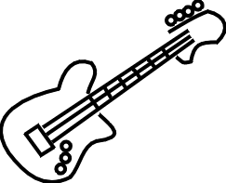
Real World Example
A real-world example of wave superposition at play is in musical instruments like the guitar. If you pluck the first string (string E: the thinnest) on the guitar, the string will vibrate and produce a sound. If you then pluck the second string (string B), you will create another sound different to the first string. Suppose now you pluck both string E and B at the same time, the sound that you will hear will be different than that of the sound produced by plucking strings E and B separately. This is because the sound wave generated by strings E and B add up to create a resultant sound wave (wave superposition). Different sounds can be created through a combination of strings and notes when you put your fingers on the guitar neck. These sets of notes are known as guitar chords.

Question – Internet Research
How do noise-cancelling headphones work?

Question – Pencil
Using the principle of superposition draw the resultant wave produced by the two standing waves below.
