Gravitational Motion 1

Content
A gravitational field is the region surrounding a mass that attracts other bodies to it due to the force of gravity. The more massive the object, the greater its gravitational attraction. For example, the Earth has a far greater gravitational pull than a tennis ball. We can calculate the strength of a gravitational field using the equation:

$$g=\frac{GM}{r^{2}}$$

where $g$is the gravitational field strength, $M$ is the mass that is producing the gravitational field in kg, $r$ is the distance from the mass and $G$ is the universal gravitational constant $6.67×{10}^{-11}$Nm²kg⁻². This gravitational field strength is also known as the acceleration due to gravity, it has units ms⁻². The gravitational field is isotropic, i.e. it is the same in all directions. It depends only on how massive the object is and how far away from the object you are. So being close to a very massive object will mean there is a large gravitational attraction.

When we put two objects near each other, they both have their own gravitational field. So, they are both experiencing a force of attraction to the other masses. Just like in Newton’s Second Law which states $F=ma$, we can calculate the strength of the force of attraction between two masses, $M$ and $m$, due to gravity using the same formula where my acceleration is the acceleration due to gravity calculated above:

$$F=\frac{GMm}{r^{2}}$$

where $F$ is the force due to gravity, $M$and $m$ are the masses of the two objects, $r$ is the distance between them and $G$is the universal gravitational constant again. This means that any two masses experience a force of attraction due to gravity.

But, in both cases, the magnitude of that field and the force is tiny until we get to incredibly large masses like the Moon and the Earth. The strength increases for both if we increase the masses involved and decrease the distance.

Example
Daliah is a space explorer who is tasked with comparing the gravitational field strength in different areas around the Solar System. She compares the strength of the gravitational field due to the Earth at the orbit of the Moon and the strength of the gravitational field due to Saturn at the orbit of one of its moons Rhea. Given the mass of the Earth is $6×{10}^{24}$kg, the mass of Saturn is $568×{10}^{24}$kg, the radius of the moons orbit is $385,000$km and the radius of Rheas orbit is $527,000$km, what are the factors that will affect the strength of the gravitational fields? Which location/position would Daliah measure a stronger gravitational field and why?

- Firstly, we will explain what factors influence the strength of a gravitational field and then we will calculate the field in both positions in order to compare the two.

- So, according to the equation for gravitational field strength, $g=\frac{GM}{r^{2}}$, the two variables that will influence the strength of the field are the mass of the object and the distance from that object. Since Saturn has a much larger mass than the Earth this will increase the field strength. However, the radius of Rheas orbit is also much larger than the orbit of the Moon. Since the gravitational field strength is inversely proportional to the distance squared from the mass this has a larger influence on the strength of the field. In this particular case, however, while the radius of Rheas orbit is larger than the Moon’s the difference is nowhere near as large as the difference between the masses of Earth and Saturn. Thus, it is likely that the mass of Saturn compared to the mass of the Earth will play the dominant role in the gravitational field strength.

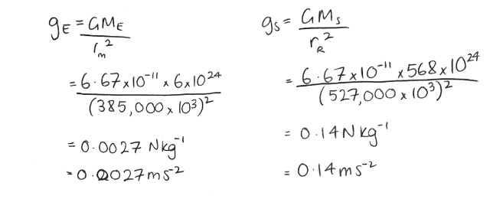
- Now, to test our hypothesis we shall calculate the two gravitational fields at the orbits of their moons and compare:
- So, the gravitational field strength due to Saturn at the orbit of its moon Rhea is larger than the gravitational field strength due to the Earth at the Moons orbit.

Example
After comparing the strength of the gravitation field at Rhea’s orbit and the Moon’s orbit, Daliah decided it was also a good idea to determine the force between each planet and its satellite. Given the mass of the Moon is $73.5×10^20$kg and the mass of Rhea is $2.31×{10}^{20}$kg how does the force due to gravity between Saturn and Rhea compare with the force due to gravity between Earth and the Moon?

- To solve this problem, first we will write down all the variables we have and then sub them into the equations. Then we will compare the two results:
Variable | Value
$M_{E}$ (Mass of the Earth) | $$6×{10}^{24}kg$$
$M_{S}$ (Mass of Saturn) | $$568×{10}^{24}kg$$
$r_{M}$ (Radius of the Moons orbit) | $$3.85×{10}^{8}m$$
$r_{R}$ (Radius of Rheas orbit) | $$5.27×{10}^{8}m$$
$m_{M}$ (Mass of the Moon) | $$7.35×{10}^{22}kg$$
$m_{R}$ (Mass of Rhea) | $$2.31×{10}^{21}kg$$

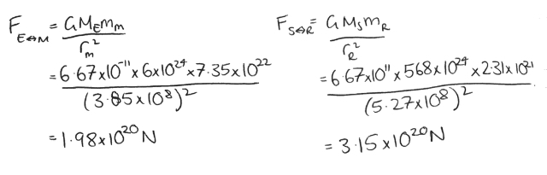
- Now we can calculate the force between the two planets and their moons using the formula $F=\frac{GMm}{r^{2}}$:

