Projectile Motion

Content
Projectile motion refers to the motion of a particle or object that is influenced by the acceleration due to the Earth’s gravity (if we assume there is no air resistance). For example, throwing a ball in the air. Just like in kinematics, we can resolve the velocity of the projectile into its x and y components. (You can revise this in the Kinematics worksheet: Vector Components).

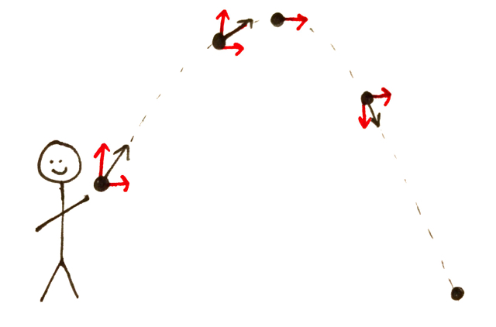
In the example of the ball, once the ball leaves your hands the only acceleration is downwards due to gravity. This means there is no horizontal acceleration. Since there is no horizontal acceleration, there is a constant horizontal velocity. The projectile is a parabola, as shown below. The black vector is the total velocity and the red vectors are the x and y components. Notice how the red horizontal vector doesn’t change at different places despite the overall velocity changing.
We can calculate several things from the path of the projectile using the equations of motion. (You can revise these in the Kinematics worksheet: Equations of Motion).

$$s=ut+\frac{1}{2}at^{2}$$
$$v^{2}=u^{2}+2as$$
$$v=u+at$$

For each of these equations, we can resolve the displacement, $s$, the initial velocity, $u$, the final velocity, $v$, and the acceleration, $a$, into their x and y components. This is how to derive the equations for projectile motion. The acceleration in the x-direction is always zero and the acceleration in the y-direction is always due to gravity. So, the acceleration doesn’t change with time. This is called uniform acceleration.

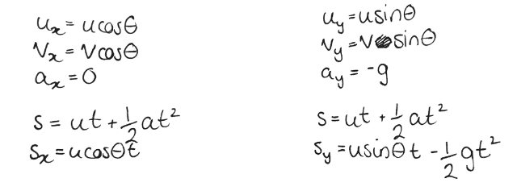
For example, we can resolve the displacement into the x and y displacement in the first equations in the following way:
Just like in kinematics, the best way to approach problems is:
- Draw a diagram of the problem deciding which direction is positive and which is negative
- Write down all the variables we know and what we’re looking for
- Determine what equation to use to solve the problem
Example
A rescue plane is flying at constant elevation of 1200 m with a speed of 430 kmh⁻¹ toward a point directly above a person struggling in the water. At what distance should the pilot release a rescue capsule if it is to strike close to the person in the water?

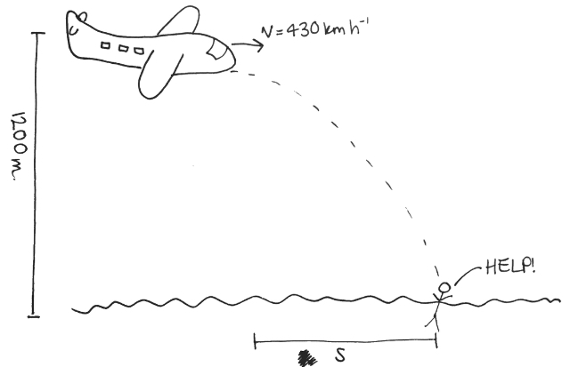
- So firstly, we will draw a diagram of the problem setting downwards as negative and upwards as positive with the origin set at the plane:
- Now, to write down all the variables we have and determine which formula we should use noting, the capsule is released straight ahead so there is no angle, the only acceleration is due to gravity and we are ignoring air resistance:
Variable | Value
$$s_{y}$$ | $$-1200m$$
$$u_{x}$$ | $$119.4ms^{-1}$$
$$u_{y}$$ | $$0ms^{-1}$$
$$θ$$ | $$0°$$
$$a_{y}$$ | $$-9.8ms^{-1}$$
$$s_{x}$$ | $$?$$

Since we need to find $s_{x}$ first we will need to solve $s=ut+\frac{1}{2}at^{2}$ in the y direction for $t$. Then we will sub that value into the same equation so solve for $s_{x}$.
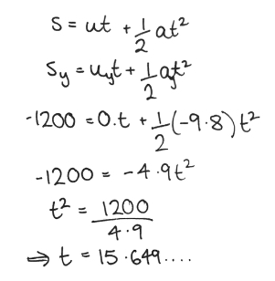
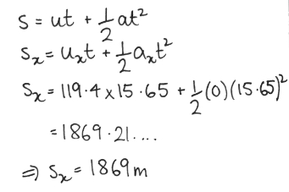
- So, finally calculating:

