Equations of Motion

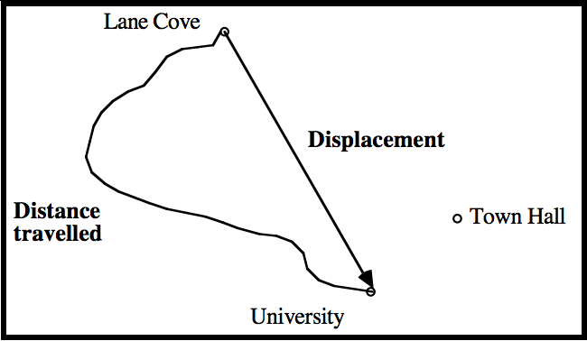
The motion of objects can be described using both scalar and vector quantities. Scalar quantities describe a magnitude only, for example, speed, distance, $d$, and time, $t$, are all scalars. Vectors describe not only a magnitude but also a direction. Displacement, $\vec{s}$, velocity, $\vec{v}$, and acceleration, $\vec{a}$ are all vector quantities denoted with an arrow above the symbol.
The distance travelled is a positive number only that follows the path of the object. While, the displacement is the distance from the starting point to the end point and the direction of the end point relative to the start point with units of meters (m). The displacement resolved into a component is given by:
$$s=ut+\frac{1}{2}at$$
Where $s$ is the displacement, $u$ is the initial velocity, $t$ is the time and $a$ is the acceleration. All of the vector quantities have been resolved into one component (see worksheet Vector Components). Since it is now only in one direction and only has a magnitude, it has no arrow on top.

Velocity describes the speed and the direction of motion and has units of meters per second (m/s). It is best thought of as the rate of change in displacement, since displacement is also a vector. Speed on the other hand is only a magnitude and not a direction. So we consider the speed to be the rate of change in position.
Velocity can be calculated using two equations:
$$v= u+ at$$
$v^{2}= u^{2}+2as$
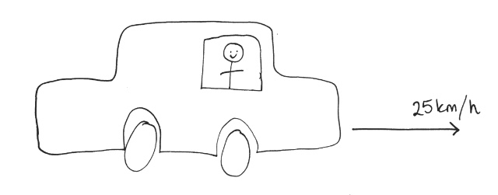
Where $v$ is the final velocity, $u$ is the initial velocity and $a$ is the acceleration.
Acceleration is the magnitude of change in speed or direction and a direction of change. It has units of meters per second squared (m/s²).

Example
Adeline competed in the world championships for rowing and wants to compare her rowing speeds between events. On one day, she was rowing forward at 13km/h but there was a current in the water flowing backwards at 2km/h. On another day, she was rowing at 17km/h but the current was 4km/h against her. Which heat was Adeline rowing faster?
- Firstly, lets determine the differences between the two heats and draw a diagram

Heat 1 | Heat 2
- Rowing velocity: 13km/h forward  - Velocity of water: 2km/h backwards | - Rowing velocity: 17km/h forwards  - Velocity of water: 4km/h backwards
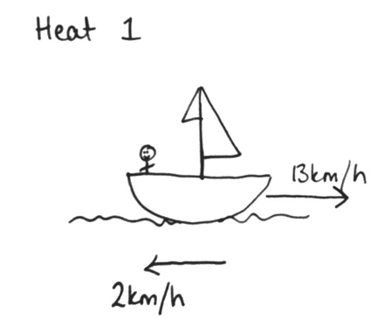
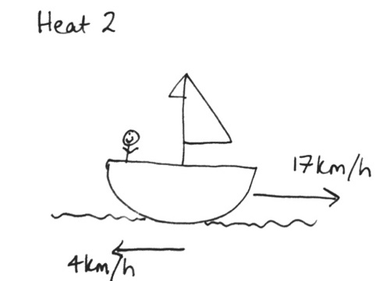
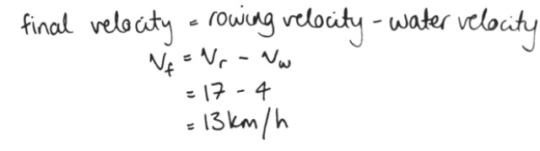
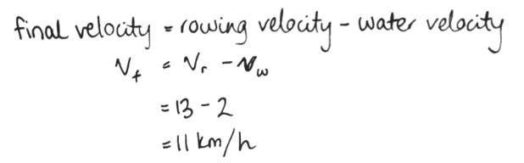
- Secondly, to calculate the final velocity of the row boat.
Heat 1: Heat 2:
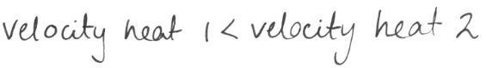
- So, to conclude:
Thus, Adeline is faster in heat 2.

Example
A rock is dropped on Mars from a height of 20 meters. What is the final velocity of the rock when it hits the ground given the acceleration due to gravity on Mars is 3.8m/s²?
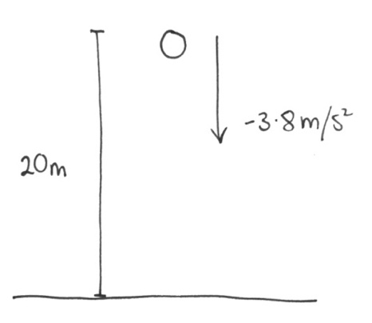
- So again, first we will draw a diagram and determine the equation we need.

Initial Velocity | $$u=0$$
Acceleration | $$a=-3.8$$
Displacement | $$s=-20$$
Final Velocity | $$v^{2}= u^{2}+2as$$

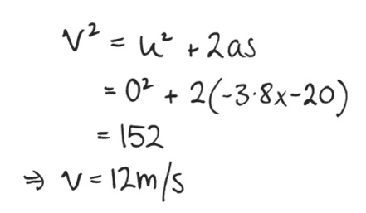
- Step 2, we sub in all the values given (checking units and negatives) and solve for final velocity rounding to 2 significant figures to match the question.

