Qualitative and Graphical Description

Content
We use terms like ‘speeding up’, ‘at a decreasing rate’, ‘with a steady pace’ to describe the motion of an object. To qualitatively describe the motion, we first state whether the object is moving, if their speed is increasing or decreasing and at an increasing rate or decreasing rate, then the direction of travel. For example, as a rocket launches, its speed is increasing at an increasing rate upwards.

Displacement vs time graphs are also used to describe motion. The slope and shape of each of the graphs can tell us how the object is moving:
Displacement
Time
Displacement
Time
Displacement
Time
Displacement
Time

Constant positive Velocity Constant negative velocity Increasing positive velocity Decreasing negative velocity
A negative slope means a negative velocity, and a curved shape means the velocity is changing (accelerating). The steeper the slope the greater the velocity.

Example
A sprinter is in a 100m race. She starts at rest and takes off when the gun fires running steadily faster until she gets to her fastest pace. Qualitatively describe the sprinters motion immediately after the gun fires.
- The sprinter is moving faster and faster in the positive direction towards the finish line. Their velocity is increasing at a constant rate.

Example
- A car is started by rolling it downhill out of gear.
- When it is going sufficiently fast the gears are engaged. This starts the car successfully and the car is driven to the bottom of the hill
- The car is then stopped.
The position vs time graph of the car is given. Complete the velocity vs time graph.
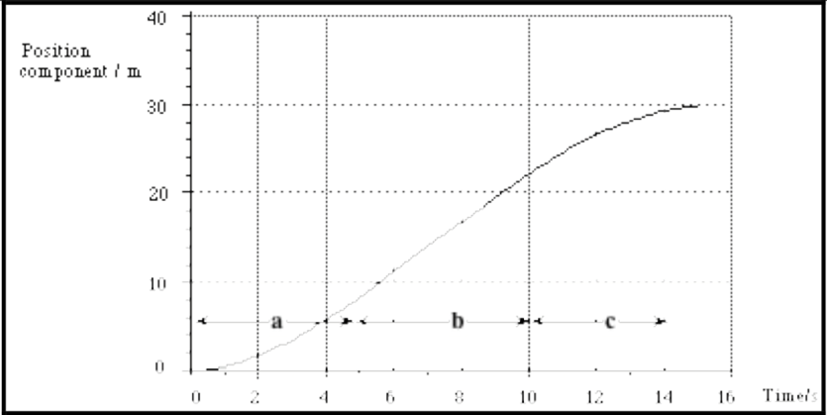

- If we consider the velocity as the slope of the position graph in each section, 0-2s, 2-5s, 5-10s and 10-15s we can simplify the problem.
- Firstly, the section 0-2s.
The position is changing with a slope that is increasing in steepness in the shape of a parabola, this means the velocity graph will appear as a straight line with a positive gradient.
- Secondly, in the section from 2-5s.
Again the position is changing with an increasing slope in the shape of a parabola. However, this time it is increasing at a slower rate. This means the velocity graph will be a straight line with a positive gradient slightly less than the gradient in the first section.
- Thirdly, in the section from 5-10s
The position is changing with a constant positive slope. This means the velocity is unchanging so the velocity graph will be flat for this period
- Lastly, the section from 10-15s.
The position is again changing with a positive slope but the slope is decreasing with time and levelling off until 15s where it remains constant. So the velocity is slightly more complicated, the velocity is still positive in the last section, however now it is decreasing as the car slows down to a stop at a constant position.
- Combining each of the sections we obtain the final velocity graph.

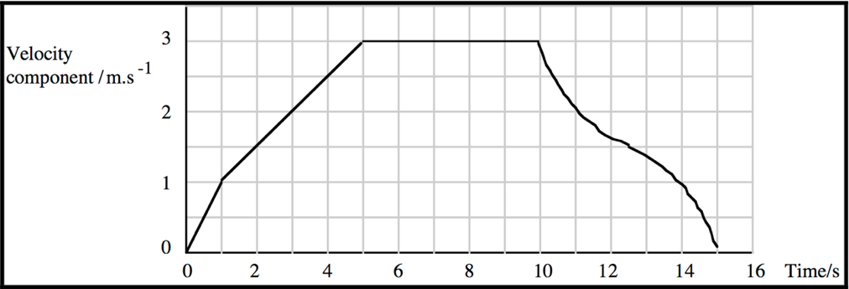

Example
Below is the velocity vs time graph of a car driving on a straight road. Qualitatively describe the motion of the car.

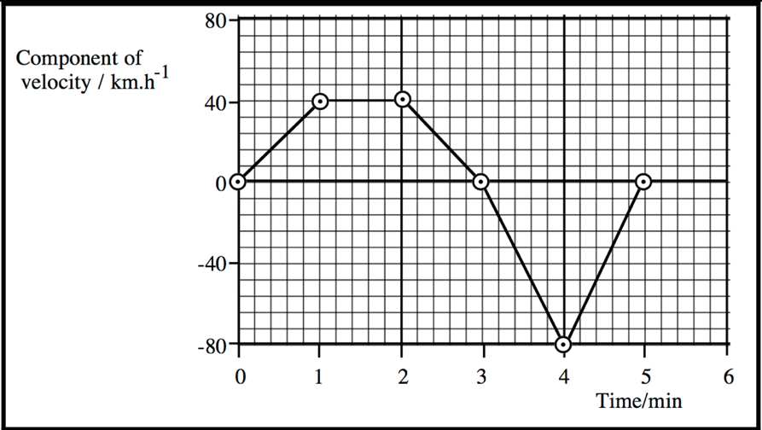

- Again we will cut the velocity into sections and describe the motion piece by piece first.
- So, firstly, considering the velocity from time=0min to time=1min. The velocity is constantly increasing in the positive direction so the car is accelerating at a constant rate forwards in the first minute.
- In the second part from t=1 to t=2, the velocity is flat and positive. So the car is moving with a constant velocity in the positive direction.
- From t=2min to t=3min, the velocity is still positive but is now decreasing towards zero. So the car is still moving in the positive direction however at a decreasing rate toward zero velocity which it reaches for an instant at t=3min.
- From t=3min to t=4min, the velocity is now negative and increasing in magnitude. Now the car’s velocity is increasing with constant acceleration in the negative direction.
- Lastly from t=4min to t=5min. The velocity is again negative, however it is approaching zero, so the magnitude is decreasing. Thus the velocity of the car is constantly decreasing in the negative direction until it reaches rest at t=5min.

