Circular Motion

Content – Uniform Circular Motion
In module 1 we looked at the motion of an object with mass in a straight line. Here in module 5, we will look at the motion of an object moving in a circular path. An example where you might have experienced moving in a circular motion is the Merry-Go-Round, and we feel a ‘force’ pushing us away from the centre. Why do we feel this ‘force’? Let’s use physics to understand this problem and assume that the motion can be represented on a 2D plane with the centre located at the origin $O$. We will represent the person riding the Merry-Go-Round as an object with mass ($m$) positioned distance ($r$) away from the origin (i.e. radius). If the Merry-Go-Round moves anti-clockwise, then we can represent the motion as
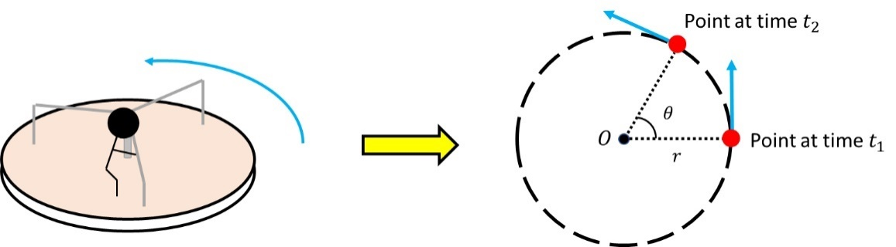
Average speed is equal to distance divided by time, and for circular motion, the total distance travelled is equal to the circumference of the circle ($C=2πr$). The total time it takes for the object to return to its original position is called the period $T$. Thus the average speed of the object moving in a circle with radius $r$ is
 | $$\left|v\right|=\frac{2πr}{T}$$ | (1)
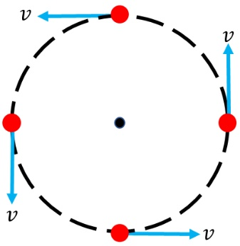
The velocity of the object at any point on the circumference is equal to the instantaneous speed at that point. The direction of the velocity follows the same path as the motion of the object. Since the motion is circular, the direction of the velocity will change continuously as shown on the right.
It is important to note that although the velocity of the object continuously changes (i.e. direction) the average speed (i.e. the magnitude of the velocity) is the same in uniform circular motion. We can quantify the angular velocity by dividing the change in angle, $∆θ=θ_{2}-θ_{1}$, between two points on the circular path over time. In terms of linear velocity the angular velocity is equal to the tangential velocity diveded by the radius.
 | $$ω=\frac{∆θ}{t}=\frac{v}{r}$$ | (2)
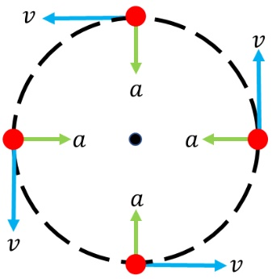
For an object in uniform motion, the acceleration of an object is equal to zero as any change in acceleration will change the velocity. This is also true for uniform circular motion; if the acceleration in the direction of the velocity is not zero, then the motion will not be uniform. However, an object moving in a circle does have an acceleration called the ‘centripetal acceleration’. The centripetal acceleration points in the direction of the centre of the circle (perpendicular to the velocity vector). Since the direction is perpendicular to the velocity vector, the average acceleration does not change. This is demonstrated on the image on the left. The equation for centripetal acceleration is given by
 | $$\vec{a}=\frac{{\left|\vec{v}\right|}^{2}}{r}$$ | (3)
Recall that the force of an object given by Newton’s 2nd law is $F=ma$. Using this equation, we can calculate the ‘centripetal force’ of an object moving in a circular motion in the same direction of the centripetal acceleration.
 | $$\vec{F}=m\frac{{\left|\vec{v}\right|}^{2}}{r}$$ | (4)
So why do we feel a ‘force’ pushing us away from the centre? We feel we are being pushed outwardly because the velocity vector is tangential to the circular path. Our body wants to move in a straight path, but since we are holding on the bar of the Merry-Go-Round, there is a centripetal force pointing towards the centre. This prevents us flying out of the Merry-Go-Round, unless of course until we let go of the bar.

Content – Real World Examples
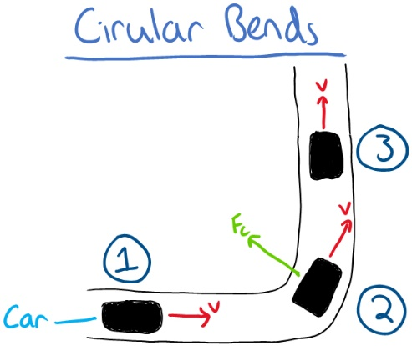
For a car moving around a circular bend the car will experience certain forces. Following the labels on the diagram on the right:
- The car moves in a straight line to the right with velocity $v$.
- As the car makes a turn on the circular bend, the car experiences a centripetal force due to the friction between the tyres and the surface of the road. The passenger inside the car is pushed outwardly in the opposite direction to the centripetal force. The direction of the velocity changes.
- After the turn the car moves in a straight path again and the centripetal force vanishes.

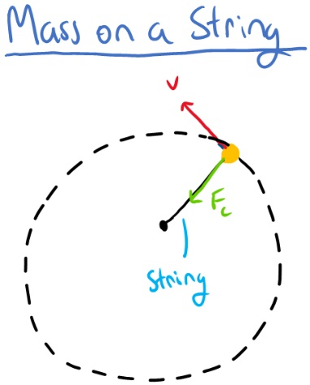

The example on the left is of a mass attached to a string is similar to the Merry-Go-Round example. As we spin the string the mass follows a circular path. The velocity is in the direction of the motion and tangential to the path. The mass at the end of the string experiences a centripetal force pointing to the other end of the string. The centripetal force is a result of the mass attached to the string. If the string breaks the object will fly off the circular path.

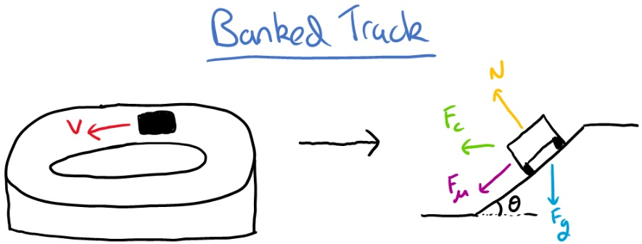

The last example on the right is of an object moving on a banked track. The diagram next to the track shows the forces available on the object. The centripetal force is a result of the sum of the frictional $F_{μ}$ and normal $F_{N}$ force.
$$F_{c}=F_{μ}+F_{N}$$

