Circular Motion – Energy and Work

Content – Total Energy
We have learned the concept of kinetic energy in Module 2: Dynamics and it is given by $\frac{1}{2}mv^{2}$. The velocity in the equation is for linear velocity. Angular velocity is linear velocity divdied by the radius - $ω=v/r$. Rearranging this equation to the make linear velocity on the left-hand side and substituting into the kinetic energy expression we get
 | $$KE=\frac{1}{2}mv^{2} \\ =\frac{1}{2}m{\left(ωr\right)}^{2} \\ =\frac{1}{2}mω^{2}r^{2} \\ =\frac{1}{2}Iω^{2}$$ | (1)
In the last step we have replaced $mr^{2}$ with the variable $I$. This quantity is called the moment of inertia or rotational inertia and is a measure of how much an object resists rotational motion.
The potential energy of a body is given by $PE=mgh$, which depends on the height. For a circular motion on a flat surface, like a car turning in a roundabout, the height can be considered zero resulting in a zero potential energy. Thus, the total energy for an object in uniform circular motion on a flat horizontal surface is just the rotational kinetic energy as shown in Figure (A) below.
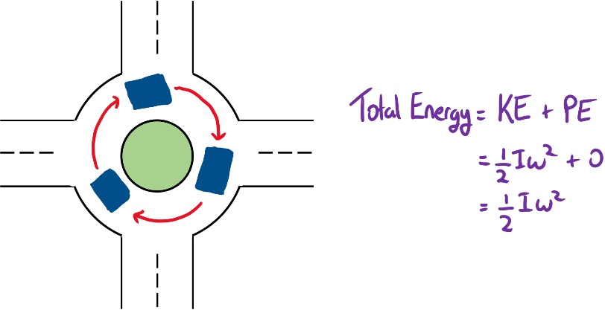
If the circular motion varies with height then the potential energy is not necesarrily zero. Figure (B) shows a Ferris wheel with 8 carrieges. The total energy is equal to the rotational kinetic energy plus the potential energy. The potential energy at the bottom, carriege 5, is at the minimum while at the top, carriege 1, the potential energy is at the maximum. Thus, the total energy of a carriege changes along the circular path.
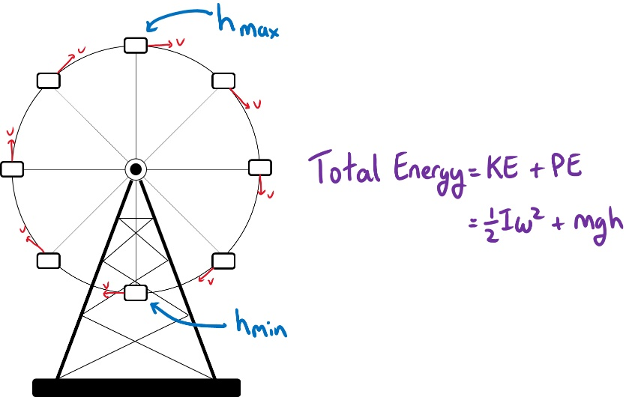
As a final example, consider a ball rolling down a frictionless inclined surface, Figure (C). The ball initially has a potential energy of $mgh$ and as the ball rolls this potential energy is converted into kinetic energy. The ball will move with both translational kinetic energy, $\frac{1}{2}mv^{2}$, and rotational kinetic energy, $\frac{1}{2}Iω^{2}$. Therefore, the total energy of the ball is equal to the sum of both kinetic term and the potential energy.
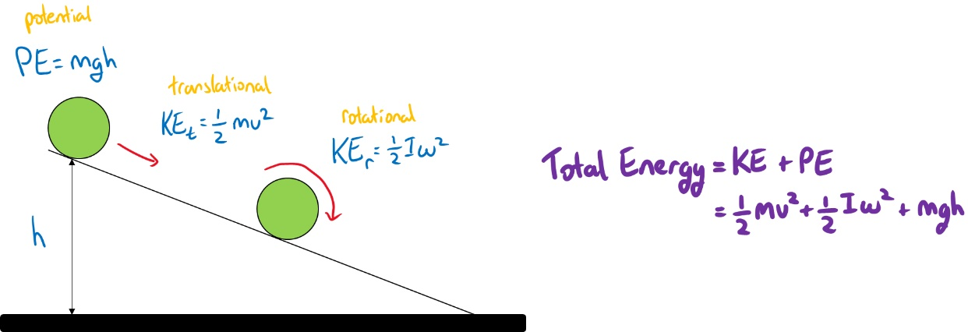

Content – Work
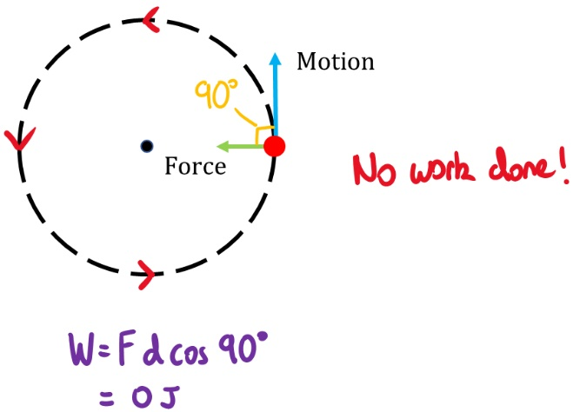
Work is defined as the amount of energy required to move an object from point A to B by a given applied force (i.e. $W=F.d\cos{θ}$). If the displacement is zero then the amount of work done is zero no matter how much force is applied to the object. In uniform circular motion the centripetal force is pointing towards the center and the displacement is perpendicular to the force. This means that the angle $θ$ is $90°$, thus the amount of work is zero (i.e $\cos{90°}=0→F=0$). Alternatively, we can arrive at the same conclusion if we define the work done as the change in kinetic energy (i.e. $W=∆KE$). If the object moves with constant velocity around the circular path then the change in kinetic energy is zero, leading to no work being done.

