Circular Motion – Rotation and Torque

Content – Torque
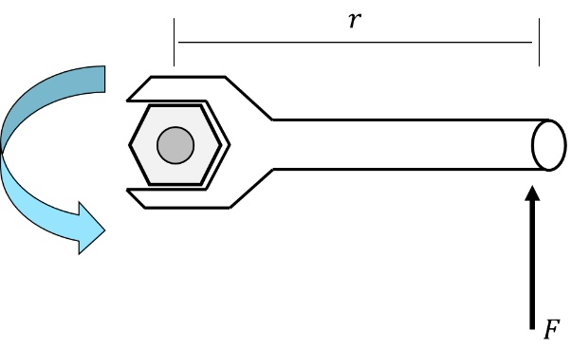
We will now look at the rotation of a mechanical object where previously we have only looked at the circular motion of a simple object. Let’s say we want to loosen a bolt using a wrench. We apply a force on the wrench anti-clockwise direction. If enough force is applied the bolt will be loosen. The tendency for the applied force to cause the rotational motion of the bolt is called torque. Torque depends not only of the applied force but also the distance the force is applied to from a pivot. The equation for torque in vector and scalar form is
 | $$τ=\vec{r}{\vec{F}}_{⊥}=\left|\vec{r}\right|\left|\vec{F}\right|\sin{θ}$$ | (1)
where r is the distance from the pivot point and F is the applied force. The quantity $τ$ has units of Newton-metre N.m or Joule per radian J/rad.

Real World Example – Opening a Door
Using the definition in equation (1) we can learn a few things about the rotation of mechical objects. Let’s say we want to open the door by pushing at a location half way between the hinges and the handle. We apply a perpendicular force on this point (i.e. $θ=90°$), which will make the sine term equal to one. The amount of force required to swing the door open at the same amount of torque as we would if we apply the force at the handle is
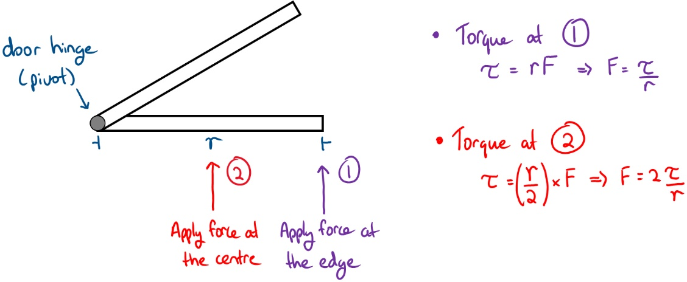
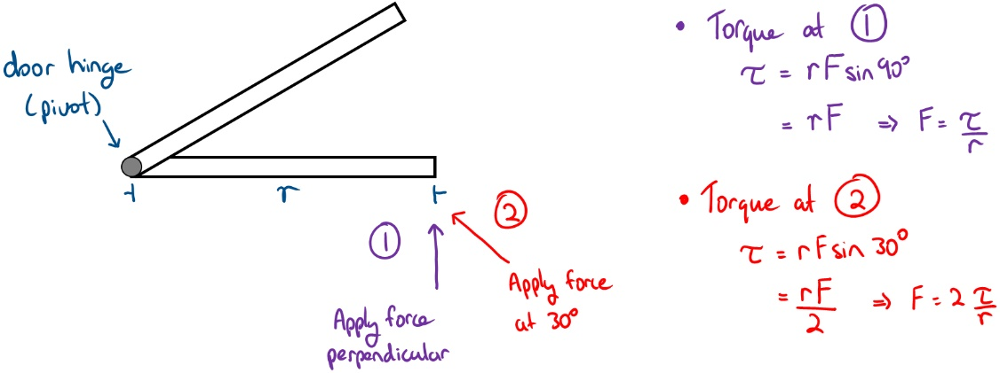
This means that we need to apply two times the amount force on the same door! Another situation we can learn about torque with opening a door is when you apply the force that is not perpendicular. Let’s say we apply the force that is $30°$ to the surface of the door at the handle. The amount of force required to swing the door will be two times as well.
Thus, the reason why doorknobs/handles are located near the edge opposite from the hinges and apply the force perpendicularly is so we only need minimal effort to swing the door.

Real World Example – Seesaw
Another real world example where we see torque in action is the seesaw in the park. The seesaw is pivoted at the centre (fulcrum) and as one end is lifted the other end goes down. Suppose two children are sitting 1 m away from the fulcrum with masses of 20 kg. The amount of force applied on each end is the same (F=mg=196 N) and is perpendicular to the seesaw. The amount of torque applied on each side is 196 N.m.
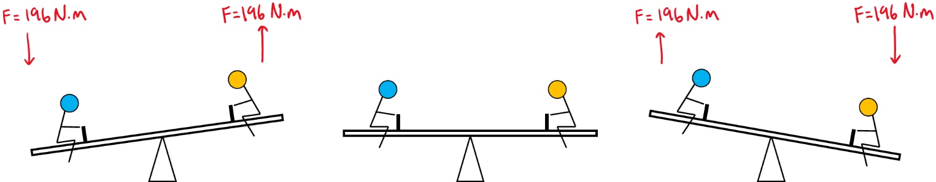
Suppose one of the children is 30 kg, this will create an imbalance in the seesaw. To restore the balance in the seesaw the with the lower mass needs to move on the seesaw. To determine the location we make the torque of each side to be equal. Then we have one unknown in the equation, which is the distance the child must sit.
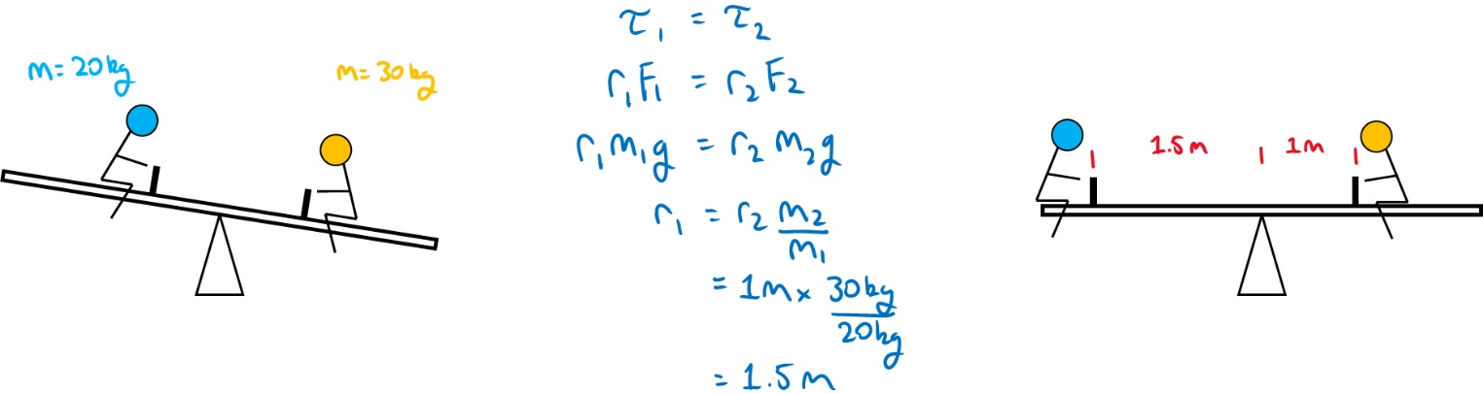
Thus, the child must sit 1.5 m away from the fulcrum for the seesaw to be balanced.

Question 1
What is the torque on a bolt when a 150 N force is applied to a wrench of length 20 cm. The force is applied at an angle of 40⁰ to the wrench.
Ans: 19.28 N.m
Question 2
Determine the angle at which the force is applied to lever if the force applied is 400 N resulting in a torque of 50 N.m. The force applied is located at 1.2 m from the pivot point.
Ans: 5.98⁰

