Beats and Doppler Effect

Content
Both the Doppler Effect and Beats are special effects of waves. They occur with all types of waves such as light waves, sound waves and water waves. In this worksheet we will just be working with sound waves, represented as transverse waves on a graph. Here, the crests of the graph are the compressions and the troughs the rarefactions of the sound waves.

Beats are not to do with the beats of a song or the beats of a drum. In fact, beats occur when there are 2 sources of waves with slightly different frequencies. In order to figure out what beats are we have to first revise what the Principle of Superposition is.
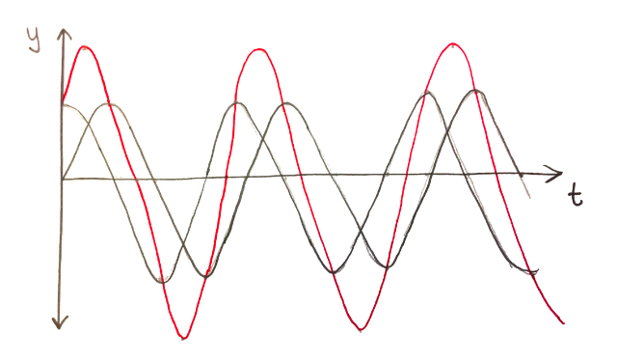
When an observer is receiving multiple waves, it can be difficult to identify the waves separately. Instead a resultant wave that is the addition of the two waves is observed, this is calculated by adding the amplitude of each wave. We can see this below, where the red wave is the resultant wave of the two black waves.
In the above example, both the black waves have the same frequency but the crests just arrive at different times. However, in the example below, the two top waves have different frequencies. The two waves then go from deconstructive interference to constructive and back again. This means the resultant wave goes from a maximum amplitude to no amplitude and back again. In the case of a sound wave, this means the resultant wave sounds like it is getting louder then silent, then loud again, shown in the bottom wave. These are called beats.

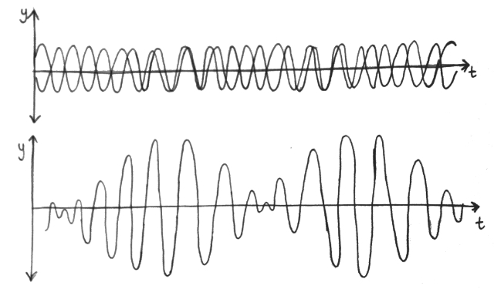
The frequency of the beats is related to the frequencies of the two initial waves. We can calculate the frequency of the beats using

$$f_{beats}={|f}_{2}-f_{1}|$$

Where $f_{1}$ and $f_{2}$ are the frequencies of the two initial waves.

Example
Nero is trying to tune their guitar. They are playing the open B string (which should be tuned to 247Hz), and the higher G string while holding the 4th fret, this plays the same B note. Nero can hear beats but they know the G string is in tune. The beat frequency is 5Hz. When Nero decreases the frequency of the B string by 5Hz, the beat frequency increases to 10Hz.
What are the two possibilities for the initial frequency of the B string? Should Nero continue to decrease the frequency of the B string in order to tune it?

- Firstly, we use the beat frequency formula from above, we know the beat frequency, $f_{beat}$, is 5Hz and the frequency of the second string (the 4th fret of the G string), $f_{2}$, is 247Hz. So:

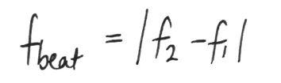
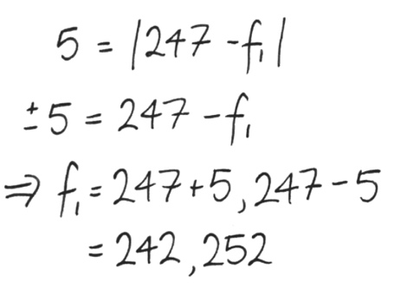

- Now, since the beat frequency increases when Nero decreased the frequency of the B string, we can determine what the original frequency of the B string was and whether they are tuning in the correct direction.
- To do this, we will assume the frequency of the B string is each value calculated in the previous part and subtract 5Hz to calculate the new possibilities for the frequency of the B string. So, after Nero has done the initial changes to the B string, the new frequency becomes either $237$ or $247$. Now, to calculate the beat frequency assuming each of these frequencies of the B string:

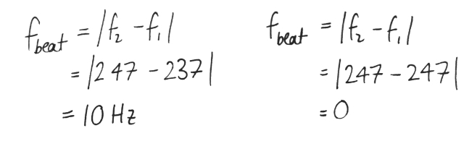
- Since the new beat frequency is 10Hz not 0Hz, the initial frequency of the B string must be 242Hz which means Nero is tuning in the wrong direction.

Content
The Doppler Effect is the result of waves being emitted from a moving source, or an observer moving while detecting waves. Consider the example below where the dot in the middle is moving with a velocity of 5m/s to the right and emitting a pulse every 1 second. The velocity of the wave is 10m/s. When $t=0s$ the pulse emitted 1second earlier has travelled radially outward 10m. When $t=1s$, the pulse emitted 1 second earlier has travelled 10m radially outward from where the dot was 1 second ago (the $x$) but another pulse is emitted from the new location of the dot. Every second, another pulse is emitted from the dot at its new location and the previous pulses continue to travel radially outwards from where they were emitted.

As a result, by the time the pulses reach the observe at the right, the pulses seem to come more frequently. If the observer was standing to the left of the dot and the dot was moving away, it would appear like the pulses are coming less frequently.

This is the Doppler Effect: the apparent frequency observed due to a moving source of waves. If the source is moving towards the observer, the frequency increases and if the source is moving away from the observer the frequency decreases. This is easily observed with a train passing a platform without stopping. As the train approaches, the pitch of the train engine is higher (because of a higher frequency) and after the train passes, the pitch decreases (because of the lower frequency). As a result the train makes a neeeeeee-oowwwww sound as it passes. Astronomers also use the Doppler Effect, they can observe light emitted by distant galaxies become redder (lower frequency) because the galaxy is moving away from the Earth.

We can calculate the apparent observed frequency of a wave using

$$f^{'}=f\frac{v_{wave}+v_{observer}}{v_{wave}-v_{source}}$$

where $v_{wave}$ is the velocity of the wave, $v_{observer}$ is the velocity of the observer, $v_{source}$is the velocity of the source emitting the waves, $f^{'}$ is the observed frequency and $f$ is the original frequency emitted.

Example
Koramo is an emergency doctor and hears the siren of an approaching ambulance. She knows the ambulance siren has a frequency of $950Hz$. The ambulance is travelling towards the hospital at a velocity of $60km/h$ and the speed of sound in air is $330m/s$. Firstly, would you expect Koramo hear the siren with a higher or lower frequency? Secondly, what frequency does Koramo hear as the ambulance approaches?
- Firstly, because the ambulance is moving towards Koramo, we expect the frequency to increase
- Secondly, we will right all the variables we have so we can sub them into the equation.
Variable | Values
$$f'$$ | $$?$$
$$f$$ | $$950Hz$$
$$v_{wave}$$ | $$330m/s$$
$$v_{observer}$$ | $$0m/s$$
$$v_{source}$$ | $$16.7m/s$$

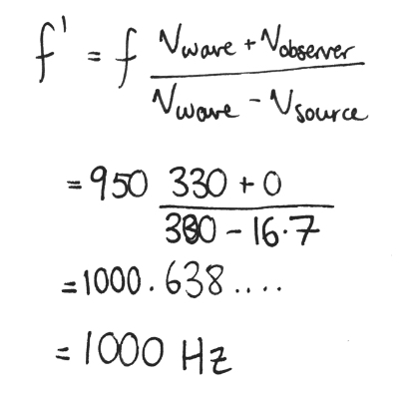
- Subbing these values into the equation we find:

