Energy Transfer

Content
When thermal energy is absorbed or released from an object a change in temperature results. When an object receives thermal energy, the energy is obtained from a source. However, the thermal energy must be transferred from the source to the object. This process is called ‘energy transfer’, and there are three mechanisms in which energy is transferred from one object to another.

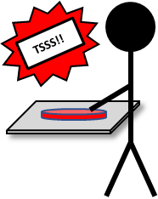
Figure 1.
Conduction
In this mechanism, energy is transferred through direct/physical contact. For example, if you touch a hot stove, thermal energy will be transferred from the hot surface to your hand. We can determine the rate of thermal conduction (labelled as $P$, with units joules/second, or watts) by using the equation
$$P=\frac{Q}{t}=\frac{kA∆T}{d}=\frac{kA(T_{1}-T_{2})}{d}$$
where $Q$ is thermal energy, $t$ is the time, $k$ is thermal conductivity of a material, $A$ is the cross-sectional area where heat transfer occurs, $d$ is the thickness and $∆T$ is the difference in temperature between two objects. Each material will have a different thermal conductivity value (e.g. copper has a high thermal conductivity in comparison to wood), and the unit is watts per meter kelvin $\text{W}/(m.\text{K})$. From the equation above the thermal conduction $P$ is inversely proportional to the thickness $d$. This means that a higher thermal conductivity will result in a higher rate of conduction and larger thickness will result in a lower rate of conduction.

Think: Taking the above equation into account, explain why thick clothing keeps your body warmer than thin clothing (made out of the same material) in winters?

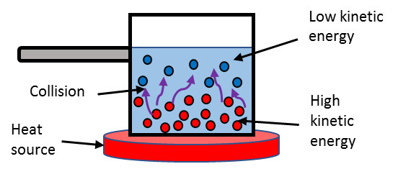
Figure 2.
Convection
Higher temperatures will translate to higher kinetic energy. Using boiling water in a pot as an example (image on the right), water molecules that are closer to the bottom will have a higher kinetic energy. With a higher energy, the water molecules will move and collide with other molecules more often causing the molecules to be further apart. This results in a lower density and consequent rising through the rest of the liquid (like an inflatable ball released at the bottom of the pool). This process is called convection currents where the heated fluid moves away from the heat source, in turn carrying and transferring energy. The transfer of energy results in the increase of temperature of water in the pot.

Radiation
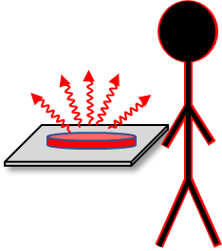
Figure 3.
We experience energy transfer due to radiation almost every day. When we stand outside in the sun, we feel ‘warm’ because the energy from the sun is transferred to your body. To discern the difference between thermal and other electromagnetic signals (like x-rays or gamma (γ)-rays) we refer to this as thermal radiation. For example, when a stove is on, we can feel ‘heat’ when we stand near it. Why? Because the stove is emitting infrared waves into the air and you just happened to be standing nearby. The infrared waves will cause the molecules in your body to move faster, which explains your body heating up.

Example - Real world
On a hot sunny day on the beach, you walk barefoot on a concrete path. After some time your feet get hot, and you run to a wooden platform. On this surface, your feet are not as ‘hot’ as it was on the concrete surface. Why is it ‘cooler’ to stand on the wooden surface? What would happen if it is during a cold night instead? (The thermal conductivity for concrete is $1.7 W/(m.K)$ and wood is $0.17 \text{W}/(m.K)$)

- For this question, we start with the thermal conductivity equation
$$P=κ\frac{A∆T}{d}$$
- Concrete and wood have different thermal conductivity (i.e. $κ$)
$$κ_{concrete}=1.70 W/(m.K)$$ | $$κ_{wood}=0.17 W/(m.K)$$
- The thermal conductance from both surfaces are
$$P_{concrete}=1.70×\frac{A∆T}{d}$$ | $$P_{wood}=0.17×\frac{A∆T}{d}$$
$$P_{concrete}≈10×P_{wood}$$
- This means that the concrete surface absorbs heat from the sun about 10x faster than the wooden surface. Thus, the concrete surface is hotter than the wooden platform.
- In a cold night the scenario becomes:
- The reverse will happen, that is the concrete surface will feel ‘colder’ than the wooden surface. The concrete surface will release thermal energy 10x faster than the wooden surface. This is also because the thermal conductivity of concrete is 10x larger than wood.
- In this example, we see that heat transfer goes both ways (absorbs or releases thermal energy) and we can feel this through direct contact with the surface of an object.

