Ferromagnets

Content
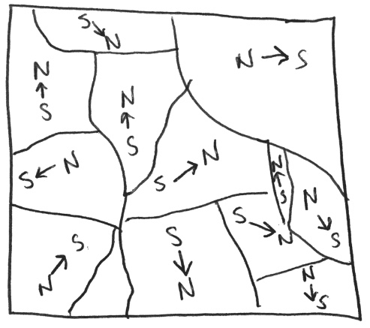
Ferromagnets are materials that have special magnetic properties. Iron is the most common ferromagnetic material, but other metals, including rare earths, can be used. By themselves, ferromagnetic materials are not magnets and on a large scale they show no overall magnetisation. But on a smaller scale, if a magnet is placed near a ferromagnetic material, it can make regions of aligned magnetisation. These are called domains. Each domain acts as a small internal bar magnet and the alignment of each domain is random compared to the other domains, as shown below. As a result on a large scale the internal magnetic fields mostly cancel each other out and the overall magnetisation is minimal.
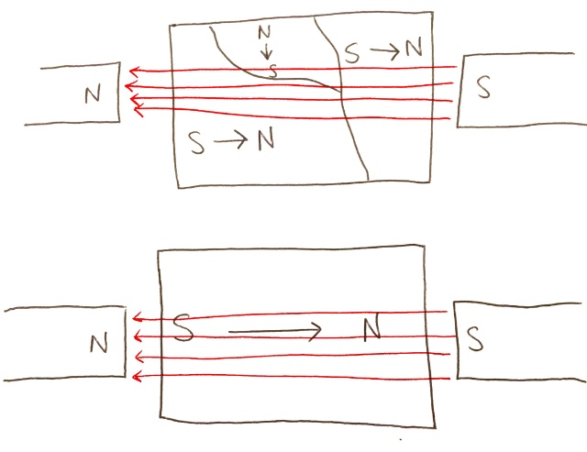
Ferromagnetic material can be made into a permanent bar magnet by placing it within a strong magnetic field and heating it. This causes all the magnetic fields within the domains to align and produce an overall bar magnet, as in the picture below. Note the north and south poles of the ferromagnet are opposite to the north and south poles of the original magnets. That is why iron is attracted to magnets. When the domains align in a magnetic field, they align in such a way that the ferromagnetic material is attracted to the magnets.
The domains act like mini internal bar magnets because of the coupling of electron spins in neighbouring atoms. The electrons in every atom have magnetic moments. In each domain the magnetic moments of the electrons in all the atoms tend to point in the same direction, giving the domain an overall magnetic moment in that direction. So when the ferromagnetic material is exposed to a strong magnetic field, all the magnetic moments in each domain align.

Example
Using your understanding of ferromagnetic material, explain how iron filings (small particles of iron) can be used to display magnetic fields.

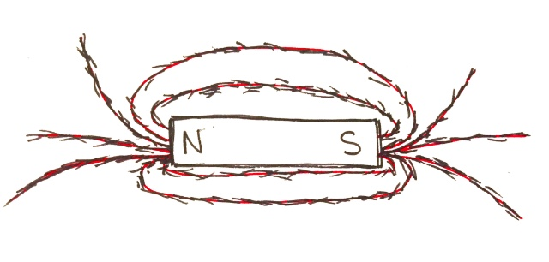
- So, firstly, we know that iron is a ferromagnetic material so it’s very responsive to magnets. They also have domains which have aligned magnetisation. When a magnet is placed inside or near the iron filings, the domains within the iron filings become aligned. Due to the shape of the iron filings, their lowest energy configuration has the magnetisation aligned along the longest side of each individual iron filing. Like all ferromagnets in the presence of a strong magnetic field, the ferromagnets align in the opposite direction of the magnetic field. This means they wish to stay within the magnetic field. The iron filings are also small enough that the friction of the surface is usually too small to stop the iron filings from moving. So each individual iron filing will move so that its longest side is aligned in the direction of the magnetic field.
Thus, the iron filings move to point along the direction of the magnetic field, allowing us to see what the magnetic field lines look like. In the diagram below, the red lines are the magnetic field lines and the small black lines represent the iron filings.

