Magnetic Fields of wires and solenoids

Content
A current-carrying wire produces a magnetic field. We can use this property to generate strong magnetic fields and convert electrical energy into mechanical energy. In this worksheet, we will first look at the magnetic fields of a current-carrying wire and then of a solenoid.

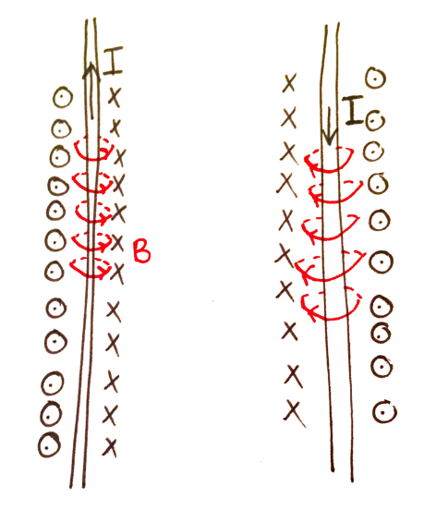
The direction of the induced magnetic field, $B$, from a current-carrying wire depends on the direction of the current, $I$, itself. We use the Right Hand Palm Rule to figure out the direction. By pointing your thumb in the direction of the current and curling your fingers around the wire, the direction of the curl represents the direction of the magnetic field. To draw the magnetic field, we use ‘X’s to represent the magnetic field going into the page and circles with dots to represent the field coming out of the page. An easy way to remember this is that the ‘X’s look like the feathers on the back of an arrow that is pointing away from you, so the direction is away from you.
In the example on the left, the magnetic field is going into the page on the right and out of the page on the left. When the direction of the current is flipped so is the direction of the magnetic field. To calculate the strength of the magnetic field we use the equation
$B=\frac{μ_{0}I}{2πr}$,

where $B$ is the magnetic field strength, $μ_{0}$ is the permeability of free space ($4π×{10}^{-7}$), $I$ is the current and $r$ is the minimum distance to the wire. Thus the stronger the current and the smaller the radius of the wire, the stronger the magnetic field.

If we tightly wrap a long wire around a hollow cylinder we create a solenoid. The coil must be much longer than the diameter. A magnetic field is produced when the current passes through the coil of wire. Since the wires are tightly wound, the magnetic field inside the coil is essentially uniform. It also acts like a bar magnet since the magnetic field outside the coil is weak. As in a single wire, the direction of the magnetic field depends on the direction of the current in the wire.

In the solenoid we can use the Right Hand Rule (slightly different to the Right Hand Palm Rule) to determine the direction of the magnetic field. This time, our fingers wrap around the coil in the direction of the current flow and our thumb points in the direction of the magnetic field. To calculate the strength of the magnetic field for a solenoid we use the equation

$B=\frac{μ_{0}NI}{L}$,

where $N$ is the number of coils, $I$is the current and $L$ is the length of the solenoid.

Example
A wire is wound around a hollow cylinder $500$ times to create a solenoid. The solenoid has a length of $0.5m$. A current of $12A$ is passing through the wire. In the diagram below, add the direction of the magnetic field. What is the magnitude of the magnetic field?
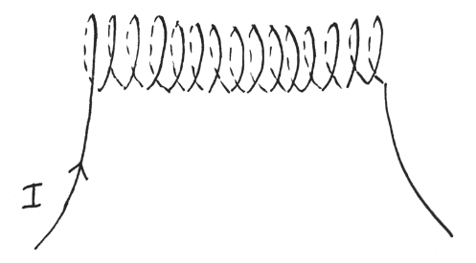
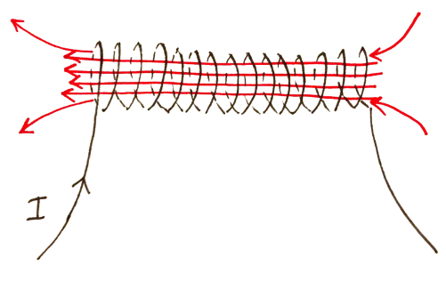
- Firstly, adding in the direction of the magnetic field. We use the Right Hand Rule, wrapping our fingers around the coil in the direction of the current, then our thumb is pointing in the direction of the magnetic field. Thus we find:
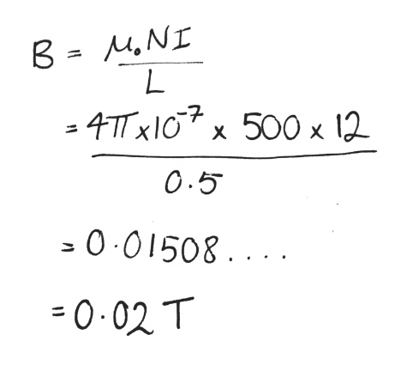
- Now, to calculate the magnitude of the magnetic field. Let’s start by writing down all the variables we have so we can sub them into the equation:
Variable | Value
$$μ_{0}$$ | $$4π×{10}^{-7}$$
$$I$$ | 12A
$$L$$ | 0.5m
$$N$$ | 500 turns
$$B$$ | ?

