Wave PROPERTIES

Content
Waves transfer energy and can come in many different shapes. Some waves need a medium (e.g. a material) for propagation, whilst some waves can travel in a vacuum (i.e. do not require a medium). We can understand the type of wave and the way it transfers energy by plotting the wave: a plot of the displacement as a function of time (called the displacement-time graph) and a plot of displacement and the position of the wave (called the displacement-position graph). Consider a rope where one end is fixed to a wall. When the rope isn’t being moved up or down it is just a flat line, this is its equilibrium position, as shown below.
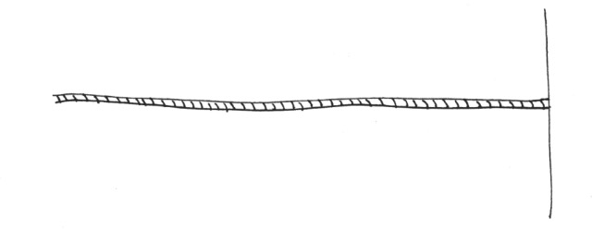
When side not attached to the wall is moved up and down, a wave is created, as seen below.
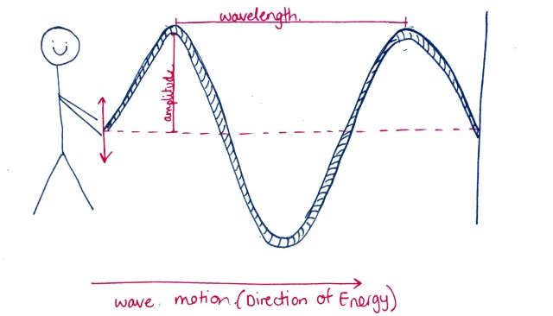
To plot a displacement-time graph, we consider one point on the wave. Then we plot how that point moves from the equilibrium position over time. So, for our rope example, the displacement as a function of time graph involves plotting time on the x-axis and displacement on the y-axis, as shown below:
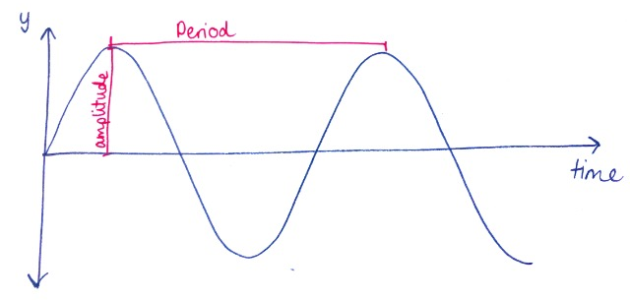
Displacement-time graph

When plotting the position of the wave, we plot the y-position of the wave against the x-position of the wave (see graph below). For the rope example, the graphs look very similar but they are actually showing different information.

There are 6 main properties of waves that we can calculate from these graphs:

- Velocity ($v$)
The velocity of the wave, calculated by multiplying the frequency and the wavelength together (m/s)
- Frequency ($f$)
The frequency is the number of waves that pass through a fixed point every second (Hz)
- Period ($T$)
The period is the time taken for one full oscillation to complete (s)
- Wavelength ($λ$)
Wavelength is the distance of one full oscillation of the wave (m), easily measured from crest to crest or trough to trough
- Amplitude
The amplitude is the height of the wave, the maximum displacement from the equilibrium position (m)

On the displacement-time graph, we can determine the amplitude and the period. To calculate the amplitude, we measure the distance from the y=0 to the first crest, as shown in the graph. The period can be measured from finding the difference between two closest identical points on the wave (e.g. from crest to crest or trough to trough).

On a displacement-position graph, we can determine the amplitude of the wave as well as the wavelength. The wavelength is found using the same technique as the period but since we are now plotting the x-position on the x-axis, not the time, the wavelength can be easily calculated by measuring the distance between two adjacent crests or troughs.
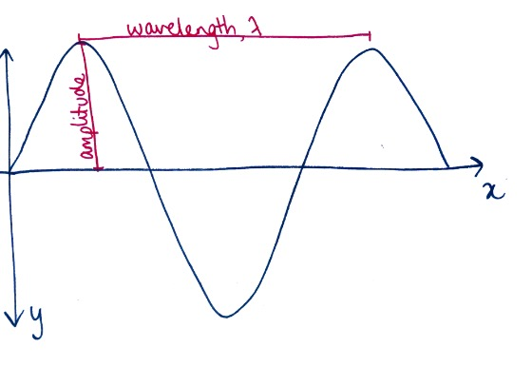
Displacement-position graph
Note that we cannot measure the frequency or period directly from a displacement-position graph. To calculate the frequency of the wave, we can use two equation - either the equation for velocity ($v=fλ$) or that of the period. The frequency and period are inversely related. So, in addition to the aforementioned equation, we can also calculate the frequency using the equation:
$f=\frac{1}{T}$.

Example 1
A wave is travelling with a frequency of 50Hz and a wavelength of 0.25m. What is the velocity of the wave?

- Let us start by writing all the known information, and what we wish to calculate to determine the appropriate formula:
Variable | Value
Frequency ($f$) | 50 Hz
Wavelength ($λ$) | 0.25m
Velocity ($v$) | ???

- Now it is clear that we need to use $v=fλ$ as the equation for velocity.
- So, the velocity is $12.5m/s$in the positive direction.

Example 2
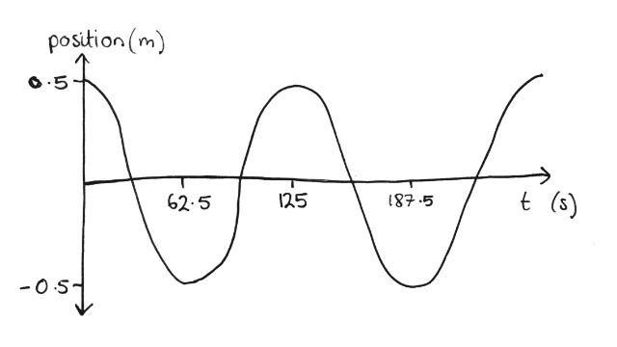
Using the displacement-time graph below, determine the frequency of the wave.
- Firstly, we decide which formula to use. Since we want to calculate the frequency and have a displacement-time graph, we will use the formula $f=\frac{1}{T}$.
- Now, from the graph we can see the period is 125s (difference between two adjacent crests), thus we can calculate the frequency as follows:
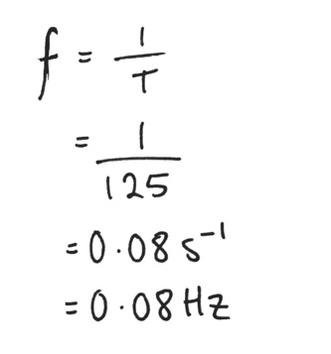
Example 3
A periodic wave has a wavelength 500m and amplitude 3m. Plot a displacement-position graph for the wave.
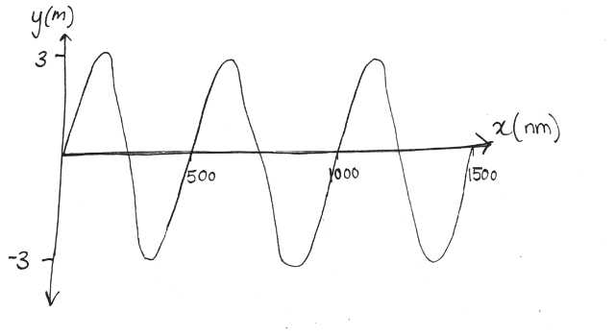
- Since we are plotting a displacement-position graph, we know our axis are going to be the x-position and y-position:

