Vector and scalar quantities

Content
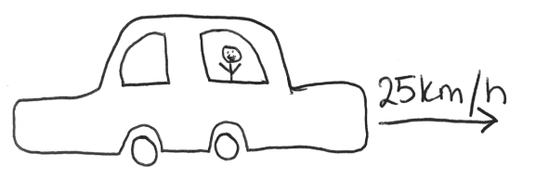
Scalars measure only a magnitude, a number, and have no direction. For example, temperature or mass. Vectors are described by two measurements: a direction and a magnitude. Velocity is a unique example since it is the only vector where its magnitude has a name, speed. In the diagram below, the car has a velocity of 25km/h East, and a speed of 25km/h. Vectors can also be drawn using diagrams where arrows describe the direction of the vector and the magnitude is written beside it.
N
W
S
E
The direction component of vectors lets us easily add vectors together using trigonometry and Pythagoras’ Theorem.
When describing the motion of an object we use both scalars and vectors. Speed, distance, $d$, and time, $t$, are all scalars since they only describe a magnitude. Whereas displacement, $\vec{s}$, velocity, $\vec{v}$, and acceleration, $\vec{a}$ are all vector quantities denoted with an arrow above the mathematical symbol to show a direction is included as well.

Example
Determine which of the following quantities are vectors and which are scalars.
Quantity | Scalar or Vector | Reasoning
60km/h East | Vector | This is a velocity which has both direction and magnitude
27°C | Scalar | This is a temperature and only has magnitude
9.8m/s downwards | Vector | This is acceleration due to gravity on Earth and has both direction and magnitude
$$\vec{v}$$ | Vector | This is the mathematical symbol for velocity with an arrow above the symbol to identify it as a vector

Example
Pair each of the quantities with their name or description.
Velocity
Scalar quantity describing position

Mathematical symbol for displacement

Scalar measurement of heat

Graphical representation of velocity
Speed

6000°F

16m/s

25km/h South

$$\vec{s}$$

34°S, 151°E

88 miles/hour

It is important to note in this example, 34°S, 151°E is a scalar. While it seems to have a direction relative to the defined zero, 34°S, 151°E is a latitude and longitude so just like (x, y) coordinates on a plane, these are coordinates for the position on the Earth.
Example
Raj is rowing North in a river at a speed of 4m/s but there is a current flowing East at a speed of 3m/s. What is Raj’s final velocity?

- Firstly, we will draw a vector diagram that includes all components.
Row boat: 4m/s
Current: 3m/s
Raj: ?m/s

$$θ$$

- Next we will determine the speed of Raj using Pythagoras’ Theorem.

$${c^{2}=a}^{2}+b^{2} \\ c^{2}=4^{2}+3^{2} \\ c^{2}=16+9 \\ c^{2}=25 \\ c=5$$
So Raj is travelling at 5m/s
- Lastly we will determine the direction Raj is travelling using trigonometry.
$$\sin{x}=\frac{3}{5} \\ x=\sin^{-1}{\frac{3}{5}} \\ x≈37°$$So Raj is travelling with a velocity of 5m/s 37° East of North.

