Charged Particles in AN Electric Field 1

Content – Charged Particles
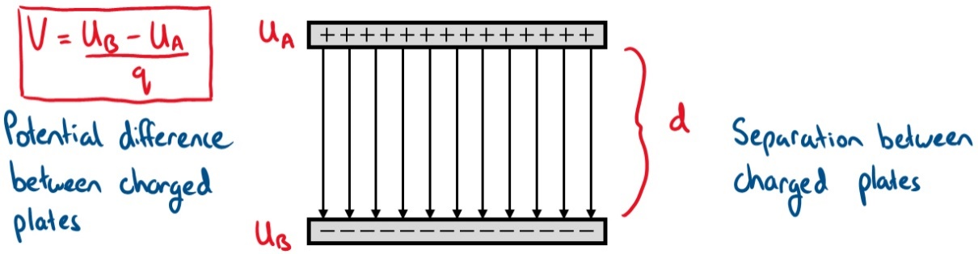
In module 4 we have looked at the definition of the voltage. Voltage is the difference in potential energy between two points. For parallel charged plates the potential difference is illustrated below.

The electric field between the parallel plates is uniform and is defined as the potential difference divided by the distance between the plates.
 | $$\left|E\right|=-\frac{V}{d}$$ | (1)
The units for the electric field defined above is Volts per metre (V/m).
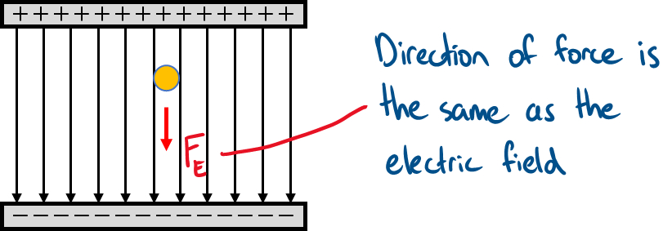
Let’s now suppose a positively charged particle is placed in between the parallel plates. The particle will experience a force resulting from the electric field, and the direction will be parallel to the field.

If the charge on the particle is $q$ the force on the particle from the electric field is
 | $$F_{charge}=qE$$ | (2)
If we equate this force to the force of a moving object (i.e. $F=ma$) we, can determine the acceleration of the charged particle when it is inside the electric field.
 | $$F_{net}=F_{charge} \\ ma=qE \\ a=\frac{qE}{m}$$ | (3)
The acceleration above is the acceleration of the particle as it moves towards the negative plate and is analogous to the acceleration due to gravity (i.e. $g=9.8 m/s^{2}$). Meaning, the charged particle is moving like an object falling in a gravitational field. If the charge is negative then ,the direction will be upwardly instead.
In addition to the force, we can calculate the work done on the particle from the potential difference between the two plates
 | $$W=qV$$ | (4)
We can also define the work in terms of the electric field using equation (1) and arrive with the expression below
 | $$W=qEd$$ | (5)
Now that we have defined the expression for work we can obtain the velocity of the particle. Recall the work-energy theorem that states work done on a particle is equal to the change in kinetic energy (i.e. $W=1/2 mv^{2}$). With this definition the velocity of the charged particle is
 | $$W=KE \\ qEd=\frac{1}{2}mv^{2} \\ v=\sqrt{\frac{2qEd}{m}}$$ | (6)
Note: the terms $Ed$ can be replaced with $V$ in the velocity equation above.

Worked Example
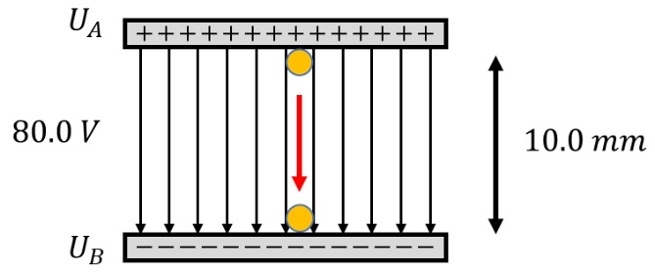
A positively and negatively charged plates are separated by 10.0 mm as shown on the right. If the potential difference is 80.0 V what is the velocity of a proton as it hist the negative plate? What is the velocity if the potential difference is 1.0 V instead? (mass of proton = 1.67 x 10⁻²⁷ kg and charge = 1.6 x 10⁻¹⁹ C).

- To determine the velocity, we start with the work-energy theorem to arrive at an expression for velocity | $$W=KE \\ qEd=\frac{1}{2}mv^{2} \\ v=\sqrt{\frac{2qEd}{m}}$$
- The electric field can be written in terms of the potential difference thus, | $$V=Ed →v=\sqrt{\frac{2qV}{m}}$$
- We now have an expression for velocity where we have all the numbers. | $$v=\sqrt{\frac{2×1.6×{10}^{-19}C×80.0 V}{1.67×{10}^{-27}kg}} \\ =1.24×{10}^{5} m/s$$
- The velocity above is extremely fast and to put it in perspective it is 375x the speed of sound.
- If the potential difference is 1.0 V, then the velocity is | $$v=\sqrt{\frac{2×1.6×{10}^{-19}C×1.0 V}{1.67×{10}^{-27}kg}} \\ =1.38×{10}^{4} m/s$$
- So even with only 1.0 V, the velocity is still large because the mass of the proton is very small.

