Charged Particles in AN Electric Field 2

Content – Moving Charged Particles
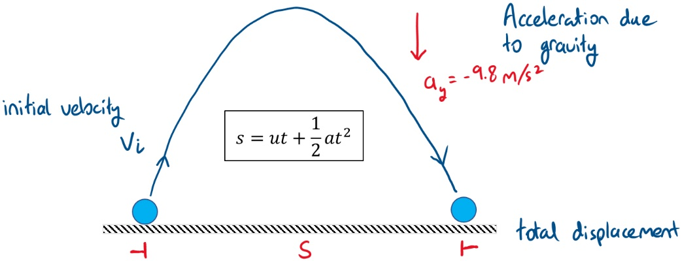
Previously we looked at what happens to a charged particle when it is placed in a uniform electric field. However, the question that comes up after is what happens to the charged particle if it moves across the parallel plates. The acceleration due to the electric field is constant and depends on the electric field and the properties of the charged particle. Since it is constant, we can use 2D kinematics that we learned in module 1 (i.e. projectile motion). Suppose we have an electron placed just outside the parallel plates, the position in two dimensions is (x,y). The initial velocity of the electron is $v_{i}$. Recall that the displacement of a moving object for a constant acceleration and given the initial velocity is
If we decompose the displacement in two dimensions we get
$$x=v_{x}t+\frac{1}{2}a_{x}t^{2}=v_{x}t \\ y=v_{y}t+\frac{1}{2}a_{y}t^{2}=\frac{1}{2}a_{y}t^{2}$$
We arrive at the expression above by taking acceleration in the x-direction as zero ($a_{x}=0$) and the velocity in the y direction also zero ($v_{y}=0$). For the electron moving through the parallel plates, the initial velocity is ${v_{x}=v}_{i}$ and the acceleration from the electric field is $a_{y}=qE/m$. Thus the position of the electron moving through the parallel plates at a given time is
$$x=v_{i}t \\ y=\frac{qE}{2m}t^{2}$$
If we rearrange the equation for $x$ to make $t$ the subject ($t=x/v_{i}$) we can substitute this term to the equation for $y$. The displacement of the electron in the y direction is then
$$y=\frac{qE}{2m}{\left(\frac{x}{v_{i}}\right)}^{2}=\left(\frac{qE}{2mv_{i}^{2}}\right)x^{2}$$
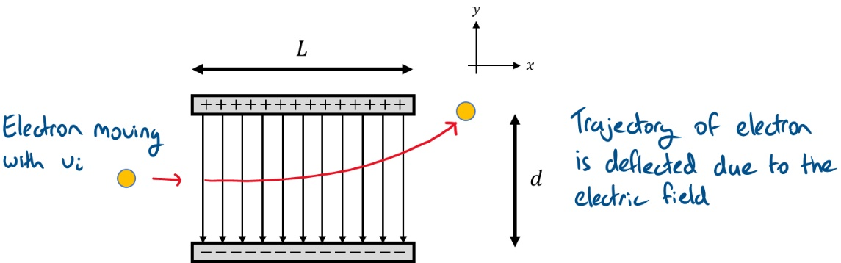
The terms in the parenthesis are constant, and the trajectory of the electron is parabolic. The sharpness of the parabola depends on the electric field and the mass and velocity of the particle. An illustration of the electron’s trajectory is shown below.

The electron is deflected in the y-direction because of the electric field, and it deflects towards the positively charged plate because of the negative charge on the electron. If the particle is a proton instead, then the particle will be deflected towards the negative plate.

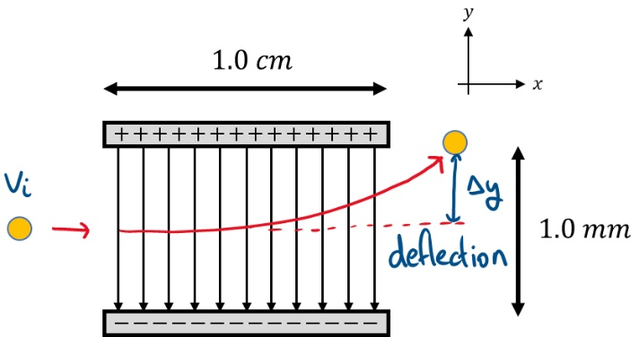
Worked Example
An electron moves through a uniform electric field produced by two parallel conducting plates separated by 1.0 mm and 1.0 cm in length shown in the diagram to the right (not to scale). The initial velocity of the electron is 1.5 x 10⁶ m/s and the potential difference between the plates is 9.0 V. Find (a) the acceleration due to the electric field, (b) the time taken for the electron to pass through the field and (c) the deflection of the electron in the y-direction.

a)
- We first need to determine the electric field produced by the conducting plates | $$E=\frac{V}{d}=\frac{1.0 V}{1.0×{10}^{-3} m}=1000 V/m$$
- Given the electric field, we can calculate the acceleration of the particle in the y-direction | $$a_{y}=\frac{qE}{m}=\frac{1.6×{10}^{-19} C×1000 V/m}{9.11×{10}^{-31} kg} \\ =1.76×{10}^{14} m/s^{2}$$
b)
- The total displacement in the x-direction is 1.0 cm, then the total time for the electron to move through the plates is is | $$x=\frac{v_{i}}{t}→t=\frac{x}{v_{i}} \\ t=\frac{1.0×{10}^{-2} m}{1.5×{10}^{6} m/s}=6.67×{10}^{-9} s$$
c)
- For the deflection in y, we use the kinematic displacement equation | $$y=\frac{1}{2}a_{y}t^{2} \\ =\frac{1}{2}×1.76×{10}^{14} m/s^{2} ×{\left(6.67×{10}^{-9} s\right)}^{2} \\ =3.9×{10}^{-3} m$$
- Therefore, the electron is deflected in the y-direction by 3.9 mm as a result of the electric field

Question – Internet research
Explain how the phenomenon of charged particles moving in an electric field is used in cathode ray tubes (CRT) and subsequently how is it exploited in old CRT televisions.

