Electromagnetic Induction

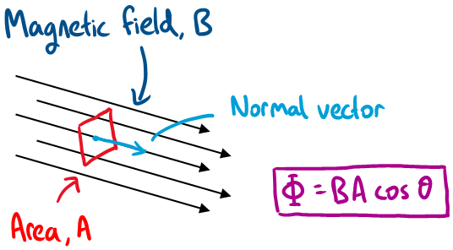
Content – Magnetic Flux
Magnetic fields, written with the symbol B, are measured in units of Telsa (T). To describe magnetic fields, we introduce a quantity called the magnetic flux. The magnetic flux quantifies the total magnetic field passing through a certain surface area. Following the diagram on the right, the total magnetic field coming through the small rectangular area is
 | $$Φ=B_{∥}A=BA\cos{θ}$$ | (1)
where $Φ$ is the magnetic flux having units of Weber (Wb). The angle in the cosine is the angle between the normal vector of the area and the magnetic field line. If the area is perpendicular to the direction of the magnetic field, $θ=0°$, then the cosine term becomes one, which means that the magnetic flux is at a maximum. When the area is tilted by an angle other than zero then the magnetic flux through the area will be less than the maximum. As a final case, if the angle is 90⁰, then the magnetic flux through the area is zero.
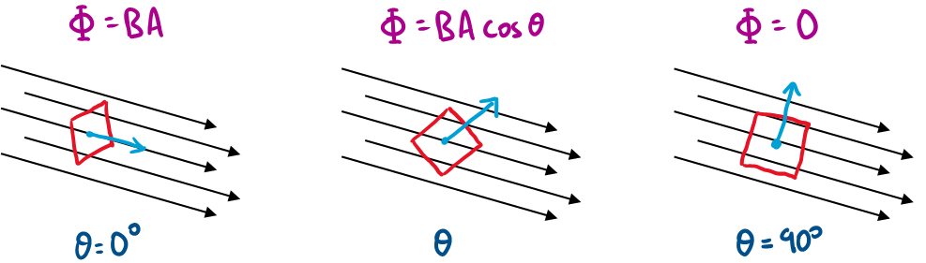
Content – Electromagnetic Induction
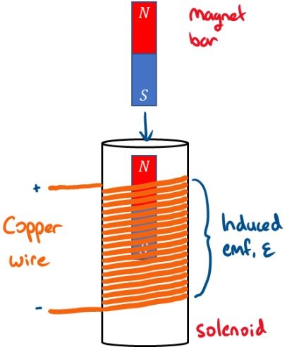
Suppose we have a solenoid with a copper wire wrapped around N times. If we move a magnetic bar through the solenoid, the magnetic flux will change along the way. This change in magnetic flux induces an electromotive force (emf) $ε$ to the solenoid. The electromotive force is the potential difference and measured in units of Voltage (V). This induction of emf to the solenoid is known as Faraday’s law of induction. The direction of the emf will be opposite to the magnetic flux and is known as Lenz’s law. Combining Faraday’s and Lenz’s laws the induced emf due to changing magnetic flux is
 | 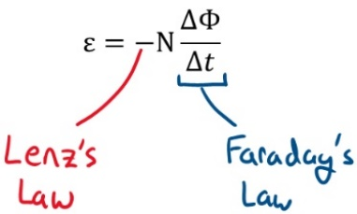 | (2)
Suppose now we have two copper coils positioned side-by-side as shown below (basically two solenoids). When a current passes through coil one, a magnetic field is produced around the coil. If coil B is close to coil A, then the magnetic field produced by coil one will move the electrons in coil B. Following the induction laws, coil two will produce an emf due to the change in magnetic flux produced by coil A. Thus, energy is transferred from one coil to another propagated through space.
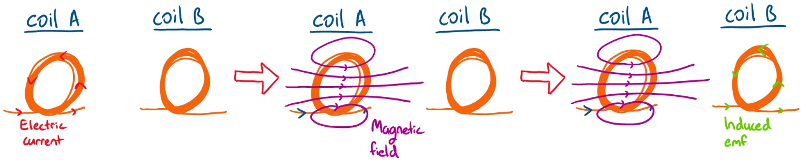
Content – Transformers
The induction laws are used in devices such as transformers. Transformers transfer electricity between two or more circuits using electromagnetic induction (i.e. not connected by wires). Consider the magnet core below with copper wires wrapped around on each side with N turns.
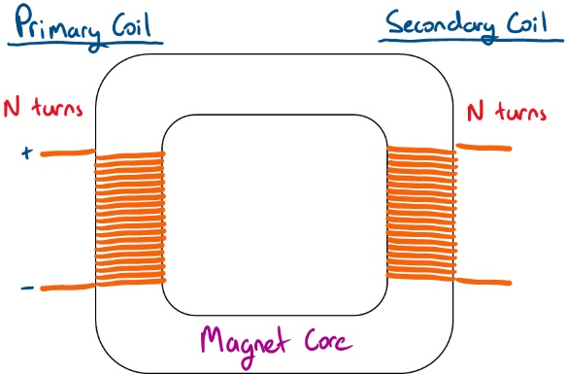
The induced emf on the secondary coil depends on the ratio of the number of turns of the primary, $N_{p}$, to the secondary, $N_{s}$, coil. If the emf in the primary and secondary is $V_{p}$ and $V_{s}$ respectively, the relationship between two coils is written as
 | $$\frac{V_{p}}{V_{s}}=\frac{N_{p}}{N_{s}}$$ | (3)
If the number of turns in the primary and secondary coils are the same, then the emf induced in the secondary coil is the same. This holds true for an ideal transformer where there is no loss of current due to resistance in the copper and no magnetic flux leakage. Following the law of conservation of energy, the power in the primary coil must be equal to the power out of the secondary coil (power going in must be equal to power going out). Since power from electric circuit can be calculated by multiplying voltage by the current ($P=VI$), the power through the coils is
 | $$V_{p}I_{p}=V_{s}I_{s}$$ | (4)
Thus, if the emf in the secondary is smaller than the primary, then the current in the secondary is greater than the primary and vice-versa.
We have defined ideal transformers where there is no energy loss in transmission. However, real transformers are far from ideal, and the efficiency of the transmission is less than 100%. One reason for a loss of energy during transmission is an incomplete flux linkage. This happens when the magnetic flux produced by the first coil is not fully linked to the second coil reducing the emf induced. Another issue is the generation of resistive heat from eddy currents. Eddy currents can be reduced by using a better material or laminated core.

Real World Application – power lines
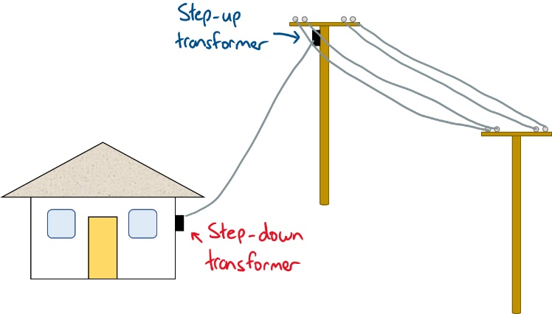
Transformers are used in the distribution of electricity through high-voltage power lines. The strength of electric current drops over long distance and the signal need to be boosted again for the signal to continue. From equation (3), if the number of turns in the primary coil is smaller than the secondary coil then induced emf will be greater than emf in the primary. This is an example of a step-up transformer where the voltage is boosted. If the number of turns in the primary is greater than the secondary then the opposite will occur, i.e. reduces the induced emf. This is an example of a step-down transformer. Step-up transformers are used to boost signals for long-range power. In NSW the voltage in power lines can be as high as 66,000 V. The power outlet in houses output 240 V. Thus a step-down transformer is required to reduce the voltage down to the appropriate value.

