Maxwell and classical theory

Content

In the 1800’s scientists were fascinated with two seemingly separate fields: electricity and magnetism. Preliminary research had been done relating magnetism to light, including the extraordinary work of Mary Somerville, who published a paper on the magnetisation of violet rays. But it was still largely not understood these fields were related.

In 1865, Maxwell published his work combining electricity and magnetism in the new field: electromagnetism. This work was summarised by four equations which combined and summarised all the current research of the time in both electricity and magnetism. Maxwell was able to mathematically connect both magnetism and electricity by combining them in equations. For example, if we look at the following equation (don’t worry about what the $∇$ or $×$ mean, we will go through each term separately):

$$∇×\vec{B}=μ_{0}(\vec{J}+ϵ_{0}\frac{∂\vec{E}}{∂t})$$
$$curl of magnetic field=static electric current+changing electric field$$

The term on the left, $∇×\vec{B}$, refers to how the magnetic field curls around, much like when we use the right-hand rule to curl around a solenoid to determine the direction of the magnetic field. The first term on the right, $μ_{0}\vec{J}$, is related to the electric current, while, the other term on the right-hand side, $μ_{0}ϵ_{0}\frac{∂\vec{E}}{∂t}$, is related to how the electric field changes with time. Altogether, this equation means an electric current and/or a changing electric field produces a magnetic field.

While we don’t need to know how to use this equation, because there are terms for both magnetic field and electric field, we can clearly see it relates the two. This equation summarises Maxwell’s contribution to unifying electricity and magnetism.

From this equation, we can also predict the existence of electromagnetic waves. The two constants included are
$ϵ_{0}$, the electric permittivity, and $μ_{0}$, magnetic permeability of free space. We have already seen these constants in Module 4: Electricity and Magnetism. They can be combined to determine the speed of light in a vacuum using the equation below:

$$c=\frac{1}{\sqrt{ϵ_{0}μ_{0}}}$$

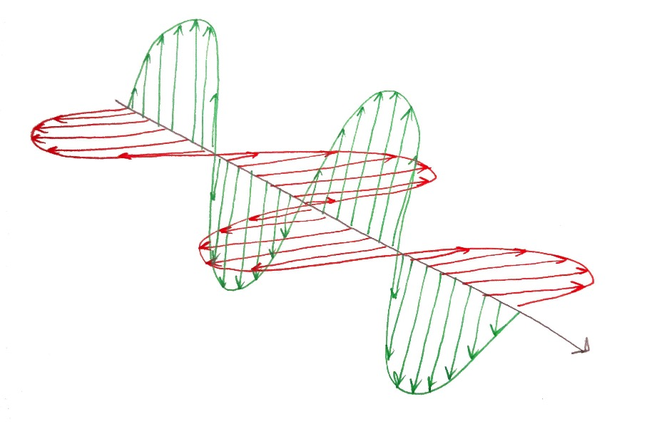
The combination of electricity and magnetism in this equation predicts not only that the speed of light is a constant, but that light is an electromagnetic wave. That is, it is an electric wave and a magnetic wave travelling together.

The prediction of electromagnetic waves comes directly from the definition of the speed of light in a vacuum. Thus, not only did Maxwell’s equations predict light was part of the electromagnetic spectrum, they also predicted the velocity of these waves, $c$, and set that velocity as a constant.

