Special Relativity
Content
We already know of Einstein’s two postulates: 1) the speed of light in a vacuum is an absolute constant; 2) all inertial frames of reference are equivalent. From the second postulate, we can conclude that the laws of physics must also be the same in each inertial frame. In order for these two postulates to be true then other properties that we consider to be constant in Newtonian physics, such as mass, momentum, and time must not be constant when measured from different frames of reference. These concepts will be familiar to you from the old syllabus, however their description has changed somewhat in the new syllabus.

Under the old syllabus, and also in some older physics textbooks, it is said that the mass of an object increases with its speed:
$$m_{v}=\frac{m_{0}v}{\sqrt{1-\frac{v^{2}}{c^{2}} }}$$

In this equation, $m_{0}$ is the rest mass of the object, which is the mass of the object when the measurer is at rest relative to the mass. This is an intrinsic property of an object that does not depend on speed. This has very important implications for momentum, although the old syllabus did not include it. Using the definition of momentum as mass times velocity, we get

$$p_{v}=\frac{m_{0}v}{\sqrt{1-\frac{v^{2}}{c^{2}} }}$$

That is, the momentum of an object is greater than expected from Newtonian physics $p=m_{0}v$, by the so-called Lorentz factor. If we were to calculate momentum using our traditional equation we find that between inertial frames the conservation of momentum is not always met, defying the second postulate. When velocities are small, i.e. $v≪c$, this is a fine approximation but as velocities approach the speed of light this approximation no longer holds. This is also why it becomes harder and harder to accelerate an object as its speed approaches the speed of light.

In the new syllabus, and more generally in modern physics, we no longer use the first equation and we don’t say that the mass of an object increases with speed but rather focus on the increase in momentum. In this more modern description the term ‘mass’ always refers to the rest mass. Hence, in the new syllabus (and in most textbooks), mass is given the symbol m, without the subscript and momentum is described as,
$$p_{v}=\frac{mv}{\sqrt{1-\frac{v^{2}}{c^{2}} }}$$

where $m$ is the rest mass, $v$ is the velocity and $c$ is the speed of light in a vacuum, roughly $2.998×{10}^{8}$m/s. So the momentum of an object is greater than expected from Newtonian physics, and increases steeply towards infinity as the speed approaches $c$. For this reason, it becomes progressively harder to accelerate an object as it gets faster, and it is impossible to accelerate it up to the speed of light. However, when we calculate the total relativistic momentum in different inertial frames the conservation of momentum is not violated, as is the case when we calculate the total momentum in different inertial frames using the Newtonian equation.

N.B. This entire discussion does not apply to a particle with zero mass. According to Special Relativity, such a particle always travels at $c$ and photons are the best-known example.
Example 1
Calculate the relativistic momentum for a muon travelling at $0.99$ times the speed of light and with a rest mass of $1.9×{10}^{-28}$kg. Assume the speed of light is $3×{10}^{8}$m/s.

- Firstly, we write down all the variables we have:
Variable | Value
$$m$$ | $1.9×{10}^{-28}$kg
$$v$$ | $$0.99c$$
$$p$$ | ?
We will use the relativistic equation for momentum:
$$p=\frac{mv}{\sqrt{1-\frac{v^{2}}{c^{2}} }}$$
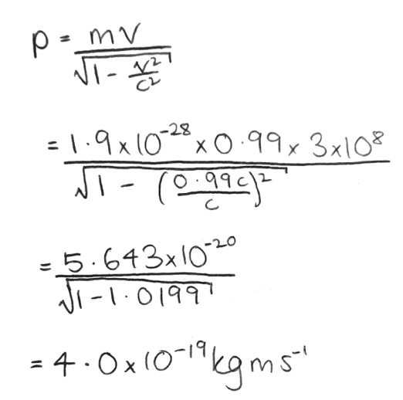
- Now, to calculate the value of the relativistic momentum:

Example 2
Using the same values for velocity from Example 1, calculate the classical momentum of the muon and compare it with the calculated relativistic momentum in Example 1.

- So, firstly, let us write down our variables and the equation we will use:
Variable | Value
$$m$$ | ?
$$p$$ | $4.0×{10}^{-19}$kgm/s
$$v$$ | $$0.99c$$

We will use the classical equation for momentum:
$$p=mv$$
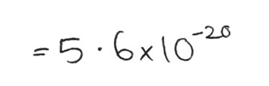
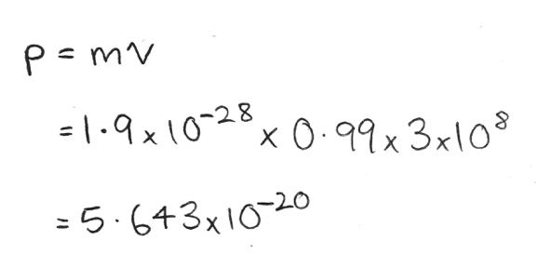
- Now, to calculate the mass:
- For the same mass, the classical momentum is less is than the relativistic momentum
Example 3

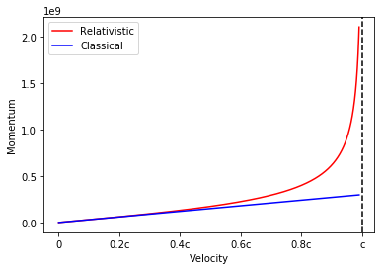
Consider the graph below of the momentum for a particle with unit mass. Using both classical momentum and relativistic momentum justify the use of classical momentum for small velocities and relativistic momentum for velocities approaching the speed of light.

- To tackle this question, we will consider it in two parts: smaller velocities below ~$0.5c$ and larger velocities above ~$0.5c$

- Firstly, the smaller velocities. From the graph, we can see both classical and relativistic momentum are almost identical until around $0.5c$. This proves that while classical momentum doesn’t account for relativity, it is a reasonable approximation for low velocities where the differences between the classical momentum and relativistic momentum are small.

- However, for the second case (larger velocities above $0.5c$), we can see these two cases produce significantly different values for momentum, suggesting that the approximation of classical is no longer applicable at large velocities. As we approach the speed of light, $c$, it is only the relativistic momentum that correctly accounts for the maximum velocity imposed on a particle by special relativity. This is seen by the dramatic rise of relativistic momentum as we approach the asymptote at $x=c$. Classical momentum continues straight and would continue beyond the speed of light despite it being a maximum value; this is not a physical situation and thus only relativistic momentum is correct for large velocities and can account for velocities approaching $c$

