Investigation: Spectroscopy

Introduction

The electrons orbiting around an atom have very specific energy levels they are allowed to be in. These electrons can absorb the energy of a photon to jump up an energy level, but this photon energy must be exactly the same as the energy difference between the two energy levels of the electron. Likewise, if an electron drops down an energy level it releases a photon which has the exact energy of the difference between the energy levels. As a result, we can see the bright lines called emission lines when the electron emits a photon and the absorption lines when the electron absorbs a photon.

The wavelengths of these lines depend on the element or molecule that has absorbed/emitted the photon and these lines are called the spectral lines or the spectra.

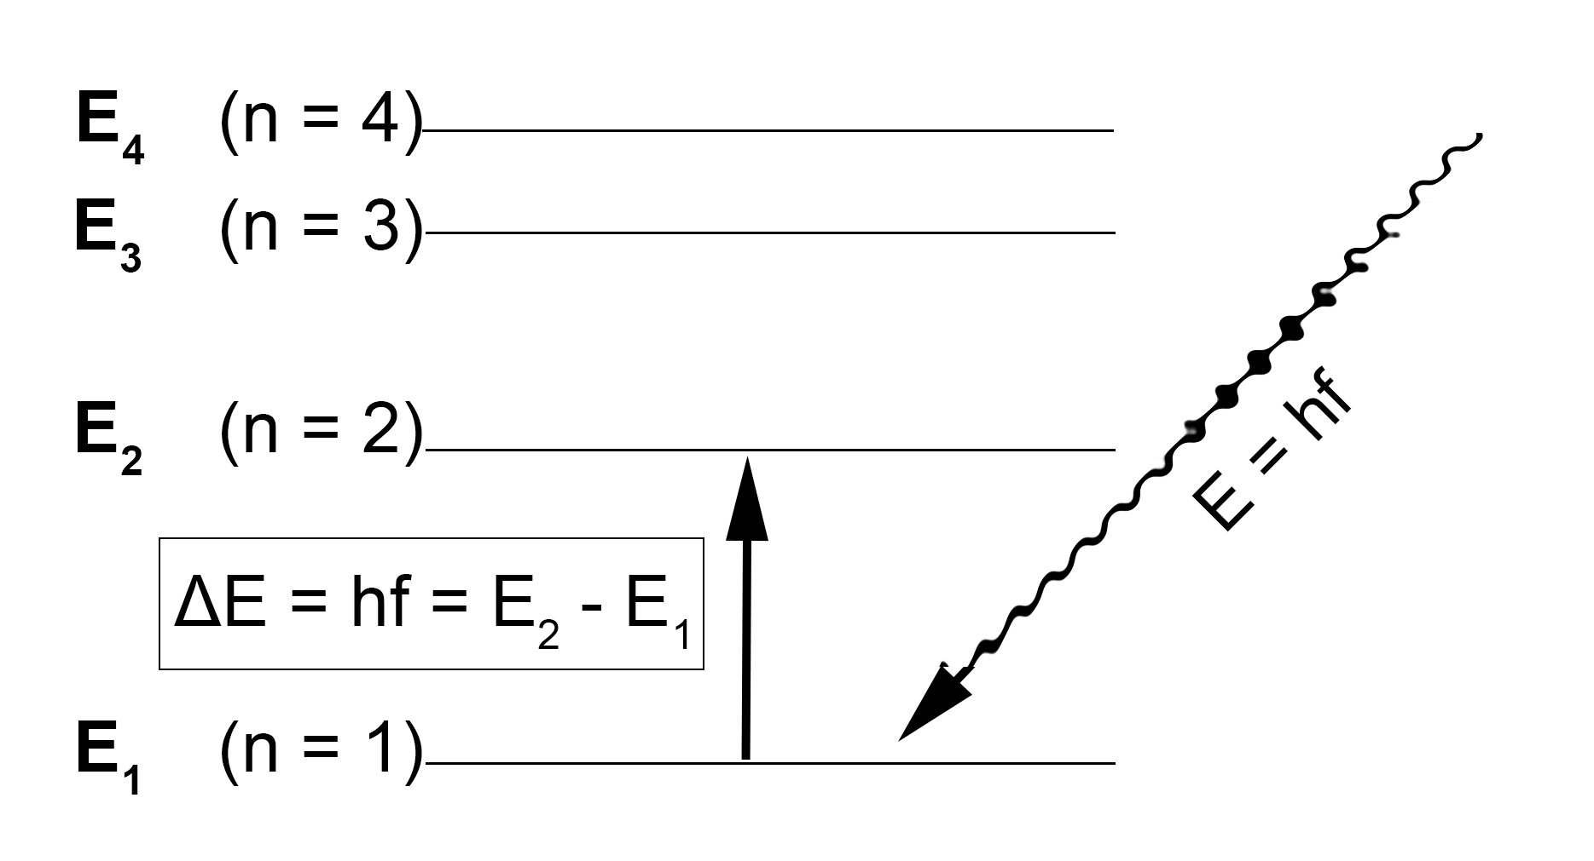
Absorption of a photon by an electron in an atom

In this experiment we will observe the spectra of several sources to see how they vary and what information we can glean from observing these features. We will also investigate the applications of spectral lines in both industry and astrophysics.

- Questioning and Predicting

Let us think about the aim of this investigation:
- What lines can we see when observing the different sources and how do these lines differ across the sources?
- What could cause changes in the spectral lines?
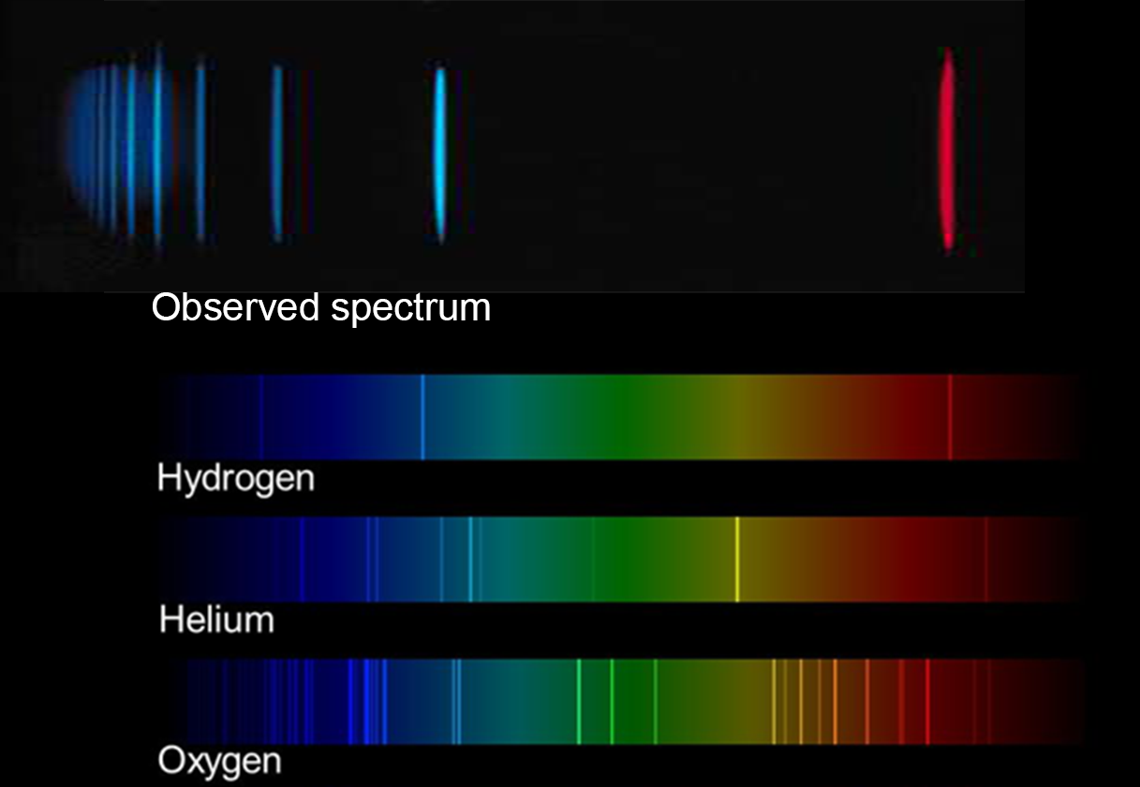
How can we determine what element the observed spectrum matches?

Hypothesis

The wavelength where a spectral line is observed depends on the ____________________________

The multiple lines in a spectrum for one element are due to __________________________________

- Planning Investigation

This investigation has been planned for you. It is most suited to being performed by a whole class.

You will need at least one incandescent filament (a lamp filled with specific elements or molecules) and a spectrograph or spectroscope to spread the light into its component wavelengths.

- Set up the incandescent filament so it is visible, and students can look at it with their spectroscopes.
- Consider other sources of light to study with the spectroscope, these could include lights in the classroom or light from the sun.
- Collect spectra of various elements to be able to compare and identify sources.

- Conducting Investigation

For each element you observe, measure the wavelengths of the spectral lines that you see from your spectroscope. Record the wavelengths of all the spectral lines you observe.

Source | Measured Spectral Lines  (wavelength nm)

Did you make any changes to the method? Did you have design problems to solve? Did you have some ‘smart’ ways of doing the investigation?

- Processing and Analysis

For each of the sources you observed and your measured spectral lines, try and identify which element or elements are present in the source. To do this compare your measured wavelengths with the wavelengths of the spectral lines of known elements.

Are you able to identify all the sources?

What did you notice about the spectral lines of different sources? Where they the same? Similar?

If they were different, what could cause the differences?

Were there any difficulties identifying the sources? What were they? How could you fix them?

- Problem Solving

All elements and molecules have very a specific set of spectral lines related to their electron orbits. Since these orbits occur at precise energies, when these electrons jump from orbit to orbit the photons they absorb or emit to do so will be of very specific frequencies. This means the differences we see in the spectral lines of the different sources is due to the different molecules present and their specific electron orbits.

As each element has a unique spectrum, we can observe the spectrum of an unknown source and compare it to known sources to identify which elements are present. You have just used this process of elemental identification to determine which elements are present in your various sources.

Discuss whether this process could be applicable in astronomy when trying to identify the elements present in stars.

- Conclusions

Spectral lines from different sources containing different elements or molecules were ___________________ (different/the same)

Some applications of studying spectral lines are:

