Energy Mass Equivalence, E=MC²

Content
One of the best-known results from Einstein’s Special Relativity Theory is the equation that relates energy and mass:

$$E=mc^{2}$$

where $E$ is the energy, $m$ is mass and $c$ is the speed of light in a vacuum, $3.00×{10}^{8}$ms⁻¹. This result has many applications and is able to explain where energy and mass go in certain reactions without violating the law of conservation of energy. Since the speed of light is a very large number, and in this equation it is being squared to make an even larger number, $E=mc^{2}$ shows how a very small amount of mass can be converted to produce a huge amount of energy. This had many implications, from explaining the energy of the sun, to where the energy in the combustion of conventional fuels and particle-anti-particle annihilations came from.

For many years, scientists had tried to explain where the energy of the sun came from. Calculations suggested it could only produce the energy it is currently producing for a period of at most a few million years. However, scientists had already aged rocks on the Earth to be over 4 billion years old. The energy mass equivalence explains where the energy from the sun comes from and how it is able to sustain itself for many billions of years.

Inside the sun, a process of nuclear fusion is occurring, a process that fuses, or combines, multiple atoms together to form a new product. The sun is fusing types of Hydrogen into Helium through several complicated reactions. However, the end product of this reaction has less mass than the beginning products. Using $E=mc^{2}$ we now know this missing mass is converted into energy.

Just like the nuclear fusion process in the sun, when a particle and its corresponding anti-particle collide, they annihilate each other and their mass is turned into energy via $E=mc^{2}$. If we know the mass of the two particles before the collision and there are no particles left after, we know all the mass has been converted to energy.

Example
The mass of an electron is about $9.11×{10}^{-31}$kg and a positron (its anti-particle counterpart) has the same mass. If an electron and positron collide and no particle is left after, how much energy is released by the conversion of mass to energy in the collision?

- Firstly, we add the mass of the electron and the positron since the total mass converted to energy is the combined mass of the two. So, our $m$ is $1.822×{10}^{-30}$kg

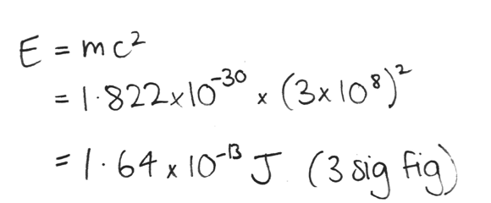
- Now to sub our values into $E=mc^{2}$ and calculate the energy released by the conversion of mass:

- Therefore, when all the mass of an electron and positron annihilation is converted to energy, $1.64×{10}^{-13}$J are released.

