Newton vs Huygens

Content

In the seventeenth century there was growing interest in the true nature of light; namely, whether it was a particle or a wave. Many experiments were done by different physicists in order to provide enough evidence for either case. Notably, Isaac Newton supported a particle model or corpuscular model while Christian Huygens argued a wave model. Both models had supporting evidence but were unable to completely explain the behaviour of light. At this time, it was already known that light travelled in straight lines, could reflect off surfaces and refract in mediums. In this worksheet we outline the experimental evidence for Newton’s model and Huygens’ model and then combine all the evidence to provide a conclusion.

Newton’s Model

Newton supported the theory that light was made of tiny, rigid and massless particles known as corpuscles. These corpuscles were emitted in a constant stream from sources and travelled in straight lines away from the source. This can easily explain the observation that light travels in straight lines, it also does not require a medium for the particles to travel through which, as we will see in Huygens’ model, avoids an added complication. Since these corpuscles are rigid massless particles, Newton was able to explain the reflection of light using the perfectly elastic collisions of the particles with a surface. This was also able to explain Snell’s Law regarding the angles involved in reflections.

While Newton was able to explain the reflection of light and how it travels in straight lines using corpuscular theory, he had to introduce many complications to this theory to explain the refraction of light in a medium. Newton required a force of attraction between the corpuscles and the particles within the water that changes the direction of the particles. However, for this to be true, it requires light to travel faster in water than in air. On top of this, when Young performed his double slit experiment in 1801, Newton’s model of light failed to explain these results at all. While the corpuscular theory of light was widely accepted from the 17th century (in part due to Newton’s prestige over Huygens’), this result was the final nail in the coffin that led to a wave model being preferred.

Huygens’ Model

Opposed to Newton was Huygens who proposed that light was a wave not a particle. However, at the time, it was believed waves required a medium in which to travel. Thus, Huygens also proposed an aether, an all pervasive, undetectable medium which allowed the light waves to travel through space. This caused a lot of doubt about Huygens’ model and it was not readily accepted. Despite this, Huygens’ model was able to explain reflection, refraction and, most notably, diffraction. Huygens proposed that sources emit spherical wavelets which travel outwards producing a wavefront. Waves allow the light to ‘bend’ around surfaces or diffract. This could explain the Fresnel Bright Spot, a bright dot observed in the middle of the shadow of a solid object. A wave model could easily explain how light is reflected off surfaces as this was already well known. But it also could simply explain refraction, compared to Newton’s corpuscle model, and required that light travels slower in water, a fact we now know. We can see in the diagram below how the wavefront moves as it passes through the surface of water.
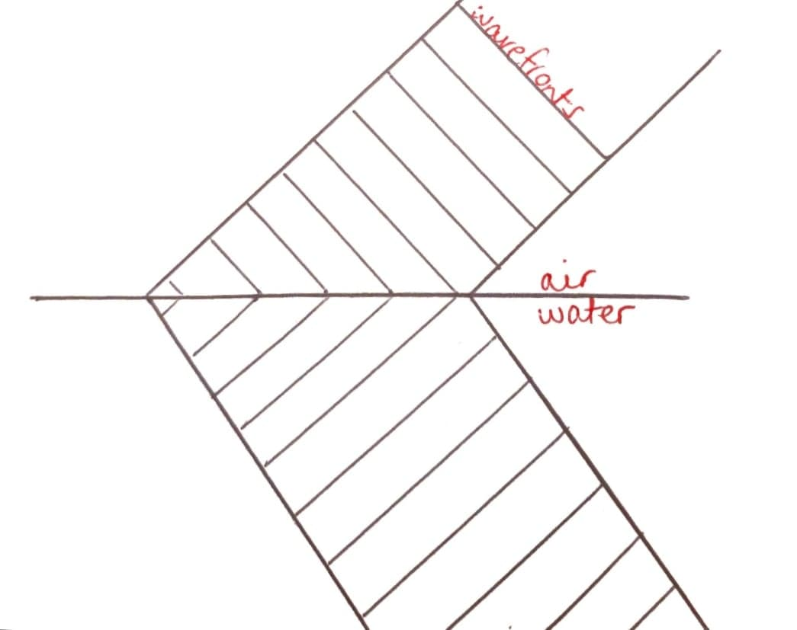

Conclusion

Both Huygens’ and Newton’s models have merit and are able to explain some properties of light, however neither is complete. With the addition of a quantum approach to light, our current model combines both a particle model and a wave model. However, the nature of the particles and the waves are slightly altered to the original models. We now know light as a wave is an electromagnetic wave, both an electric wave and a magnetic wave propagating together without the need for a medium. Similarly, we know photons are massless particles, however to explain diffraction we no longer need a complex force of attraction between particles.

