# De Broglie and Schrödinger

Content

Louis de Broglie was a French physicist who postulated that electrons could exhibit wave behaviour. This was based on the explanation Einstein gave for the photoelectric effect. Recall from the previous module ‘The Nature of Light’ that the photoelectric effect was an experimental result involving the interaction between light and metallic surfaces. These results could not be explained by the wave model of light but were explained successfully by Einstein using a particle model of light. He described the energy and momentum of the individual particles of light (photons) as:

$$E=hf$$

$$p= \frac{h}{λ}$$

In 1924, as a part of his PhD thesis, De Broglie postulated that this relationship between momentum and wavelength could apply to electrons as well. By rearranging the momentum equation, and substituting in the classical equation for momentum ($p=mv)$, he was able to predict the wavelength of electrons as:

$$λ= \frac{h}{mv}$$

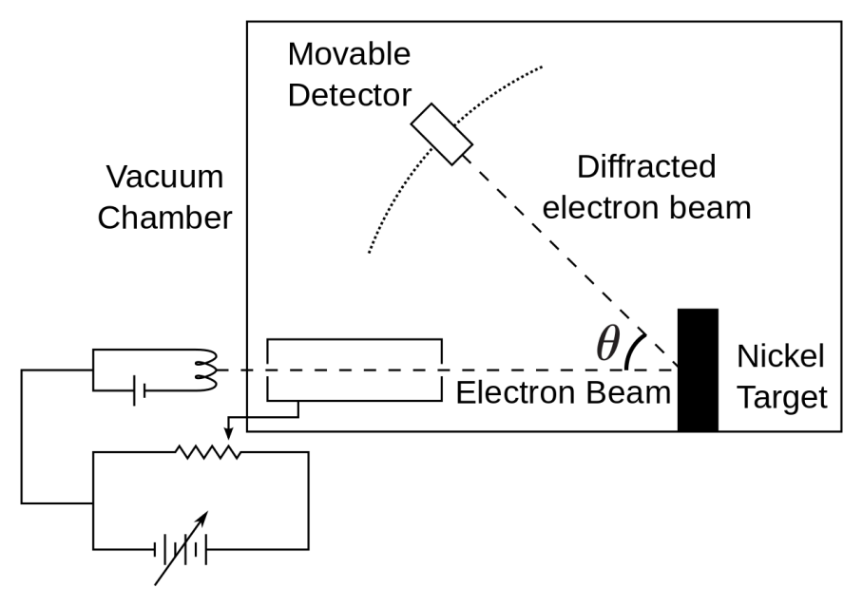These waves are referred to as ‘matter waves’ or ‘De Broglie waves’, and this relationship is now known to hold true for all types of matter, not only electrons. This was verified experimentally for the first time in 1927 with the Davisson–Germer experiment. After this verification De Broglie won the Nobel prize in physics for his prediction. The Davisson–Germer experiment was based on the principle of diffraction. Diffraction is the general principle that occurs when waves (light or other) encounter an object or aperture (covered in the previous module ‘The Nature of Light’). It was previously determined by Bragg that the crystal lattices of certain materials can cause diffraction patterns when X-rays pass through them. The Davisson–Germer experiment was simple in principle: an electron beam was fired at a nickel target and a detector was moved about in angle to search for reflected electrons, as shown in Figure 1.

Figure 1. Experimental setup of the Davisson–Germer experiment

Image Credit: User:Roshan/Wikimedia Commons/ CC BY-SA 3.0

This experiment was not initially designed to look for diffraction patterns but for looking at how electrons are reflected from the surface of the material. One day when the nickel target was accidentally exposed to air, an oxide layer developed on its surface. In order to remove this oxide layer the nickel target was heated in a high temperature oven. While this removed the oxide surface, it also had the unintended effect of turning the polycrystalline structure of the nickel into much larger areas of consistent crystal structure. These consistent crystal areas were now large enough to cover the whole width of the electron beam. When the experiment was repeated with the new target, a diffraction pattern with unexpected peaks was observed, similar to those observed with x-rays by Bragg. The results were published by Davisson and Germer but they did not understand what to make of them. It was Max Born who saw the diffraction patterns and realised that they were in fact the first experimental confirmation of the De Broglie Hypothesis.

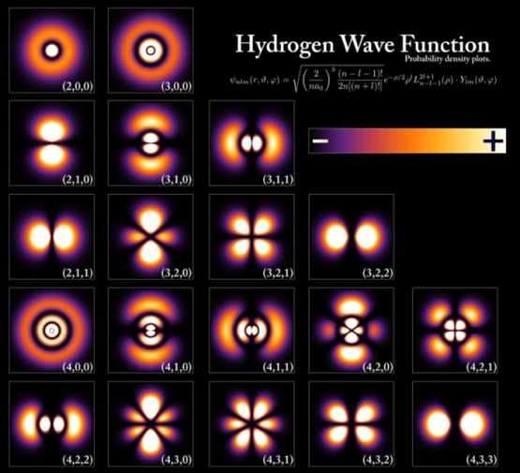The idea of matter waves was extended by Erwin Schrödinger through a series of three papers published in 1926. In these papers he presented what is now known as the Schrödinger equation, which describes what we now know as ‘wave-functions’. The wave function is a mathematical description of the state of a quantum system (e.g. electrons bound to atoms). It also describes the probabilities for the outcomes of making measurements of that system. These concepts formed the basis of quantum physics and have led to Schrödinger being referred to as the ‘father of quantum physics’. Schrödinger also provided solutions to the Schrödinger equation that corresponded to the energy levels for hydrogen or hydrogen like atoms (atoms with only one electron). This model of the atom was able to correctly predict the spectral lines associated with these energy levels. This new quantum model was also able to account for other things that the previous model (Bohr model) of the atom could not, such as the various intensities of spectral lines, and the Zeeman Effect. We still use the Schrodinger equation and the concept of wave functions to describe atoms, and we now refer to the states of the electrons in atoms as atomic orbitals. An example of the atomic orbitals found in the hydrogen atom is shown in Figure 2. Note that unlike the electron orbits of earlier atomic models these orbitals take on many different shapes, not only spherical. Also, rather than having an electron as a discrete particle orbiting a nucleus, the atomic orbitals are more akin to a cloud which surrounds the nucleus. The probability of finding the electron (if we attempt to measure it) is greatest where the cloud is most dense.

Figure 2. Atomic orbitals for different electron energy levels in hydrogen. The probability of finding the electron is given by the colour shown in the key (upper right).