Emission and absorption spectra

Black Body Radiation
Black-body radiation is the name given to the electromagnetic radiation emitted by an idealised opaque and non-reflective object, which is in thermal equilibrium with its surroundings. Put simply, a black body does not reflect any of the light which hits it, and all of the light which hits it is absorbed. However, despite its name a black body is still able to emit radiation. Approximating stars as black bodies is generally a reasonable approximation. Even though stars do reflect light the amount of reflected light is many orders of magnitude lower than that emitted due to black body radiation. A comparison between the observed spectrum of our sun, and a theoretical black body of the same temperature is shown in Figure 1. The overall shape is a good approximation; however, the solar spectrum has significantly more visible and infrared light, and less UV light.
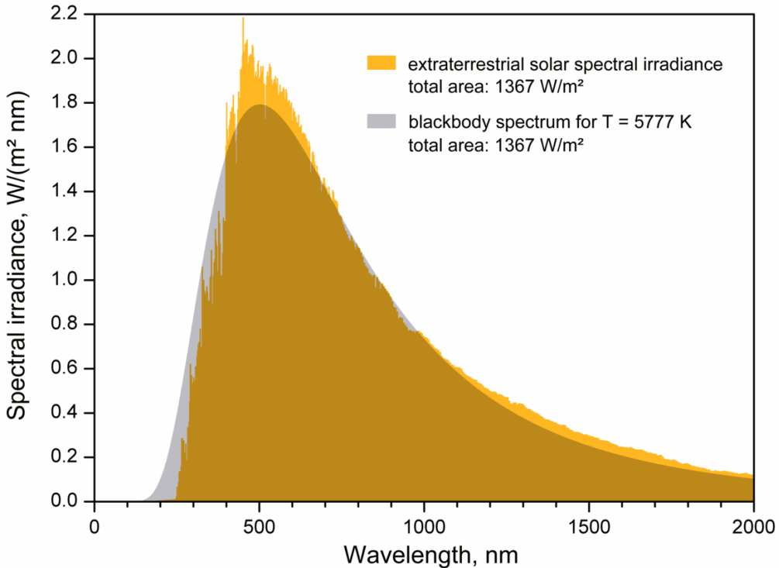
Figure 1. Comparison of observed solar spectrum and theoretical black body radiation
Image Credit: User:Sch/Wikimedia Commons/CC BY-SA 3.0
The wavelengths of the black body radiation are determined solely by the temperature of the material and not the composition of the material. Hotter temperatures shift the distribution to shorter wavelengths (bluer in colour) and colder temperatures produce longer wavelengths (redder in colour). Examples of these black body emissions for a range of temperatures are shown in Figure 2.
Another requirement for the black body radiation description to be valid is that the material must have a sufficiently large number of particles. Recall that there are discrete energy levels electrons can occupy in individual atoms. As we join atoms together the number of possible energy levels increases, and in the limit of a very large number of particles the number of energy levels grows to a point where it is no longer discrete as in a single atom but these possible energy levels become essentially continuous. This is why we get a seemingly continuous distribution in blackbody radiation. This is contrasted with the spectra we observe for gases, where the atoms are far enough apart that they maintain their discrete electron energy level structure. The emitted radiation from such a diffuse material appears as discrete ‘spectral lines’, which correspond directly to the discrete energy levels (this is covered in more detail in the resource ‘Quantised Energy Levels’).
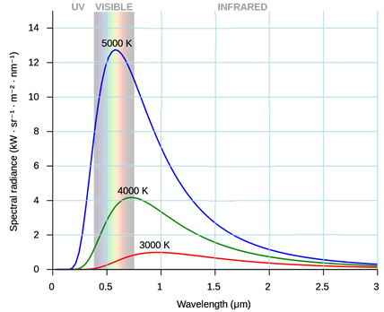
Figure 2. Black body radiation distributions for three different temperatures
Absorption and Emission
Although the bulk of a star is dense enough to produce continuous black body radiation, the outer layers are diffuse enough that the atoms in these outer layers maintain their discrete electron energy level structure. The electrons in these atoms can absorb specific wavelengths of light which correspond to these energy levels. This process causes absorption lines to appear superimposed on the continuous black body spectrum.
The inverse of absorption spectra are emission spectra. These spectra are observed when a diffuse region of gas (e.g. the outer layers of massive stars, or a galactic nebula) is excited by light from a star and they selectively re-emit this energy at the characteristic wavelengths of that gas. These emission spectra are found by observing the gaseous object from a direction which is out of line with the background source that is exciting the gas. These processes are depicted diagrammatically in Figure 3. Emission spectra can be used to determine the composition of gas clouds between the stars and the Earth.
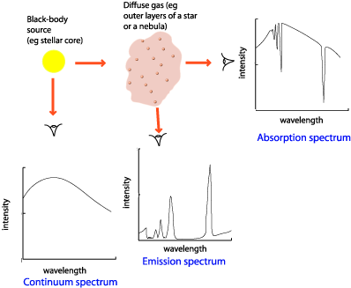
Figure 3. Creation of emission and absorption spectra
Image Credit: http://www.atnf.csiro.au/outreach/education/senior/astrophysics/
A real stellar spectrum is shown below in Figure 4. The most apparent or ‘strongest’ absorption lines correspond to the visible wavelengths of the Hydrogen atom known as the Balmer series.
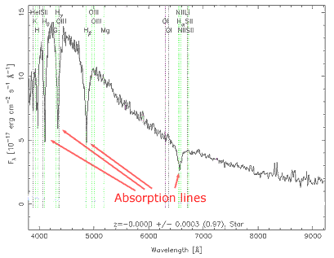
Figure 4. Real spectrum of a typical ‘main sequence’ star
Image Credit: The Sloan Digital Sky Survey

We can use these stellar spectra to classify stars by their temperature. By temperature we actually mean the ‘effective temperature’ of the star which corresponds to the temperature of the outer surface of the star that we actually observe. The inner core of the star is much hotter than the surface. The ‘effective temperature’ is determined by comparing the peak of the spectrum with the peak of the theoretical black body spectrum. Most stars can be classified into the following spectral classes, listed from hottest to coldest are O, B, A, F, G, K, M. The typical spectral features of these star are summarised in the table below.

Spectral Class | Effective Temperature (K) | Colour | H Balmer Features | Other Features | M/M_{Sun} | L/L_{Sun}
O | 28,000 - 50,000 | Blue | weak | ionised He⁺ lines, strong UV continuum | 20 - 60 | 90,000 - 800,000
B | 10,000 - 28,000 | Blue-white | medium | neutral He lines | 3 - 18 | 95 - 52,000
A | 7,500 - 10,000 | White | strong | strong H lines, ionised metal lines | 2.0 - 3.0 | 8 -55
F | 6,000 - 7,500 | White-yellow | medium | weak ionised Ca⁺ | 1.1 - 1.6 | 2.0 - 6.5
G | 4,900 - 6,000 | Yellow | weak | ionised Ca⁺, metal lines | 0.85 - 1.1 | 0.66 - 1.5
K | 3,500 - 4,900 | Orange | very weak | Ca⁺, Fe, strong molecules, CH, CN | 0.65 - 0.85 | 0.10 - 0.42
M | 2,000 - 3,500 | Red | very weak | molecular lines, eg TiO, neutral metals | 0.08 - 0.05 | 0.001 - 0.08
Table 1. Spectral features of stellar categories
Credit: Table reproduced from http://www.atnf.csiro.au/outreach//education/senior/astrophysics)
There are also rarer classes of stars that are distinguished by their relative abundance of carbon. For example R stars have the same temperature as K stars but have high abundances of carbon, and N stars are carbon-rich stars with the same temperature as M stars. Wolf-Rayet stars (classified as WN and WC), have the same temperature as O stars, but show strong broad emission lines of nitrogen or carbon. It is also important to mention that the light from distant stars often passes through diffuse gas clouds in between the star and earth. This can further complicate the interpretation of these absorption spectra. Aside from determining the chemical composition and temperature of stars, we can also use absorption spectra to infer the translational and rotational speed of a star. This is achieved by using the Doppler Effect and looking for the shift between the spectral lines observed in the stars and those from stationary sources here on earth.

