HERTZSPRUNG RUSSELL DIAGRAM
Content
The Hertzsprung–Russell diagram, or more simply HR diagram, was first created in 1910 by Ejnar Hertzsprung and Henry Norris Russell. It is a now famous scatter plot of stars which describes the relationship between the absolute magnitude or luminosity of stars and their stellar classifications or effective temperatures. More simply, each star is plotted on a graph with the star's brightness on the vertical axis and its temperature or colour on the horizontal axis. While there are several versions of the HR diagram, they all share the same general layout, with more luminous stars towards the top of the diagram, and fainter stars towards the bottom. Stars with higher surface temperature sit toward the left side of the diagram, and those with lower surface temperature sit to the right side of the diagram. Since stars are essentially hot black bodies, their colour is directly related to their surface temperature, with blue stars being the hottest and red stars being the coolest. The concept of blackbody radiation is covered in more detail in a previous resource. A descriptive version of the HR diagram is shown in Figure 1.
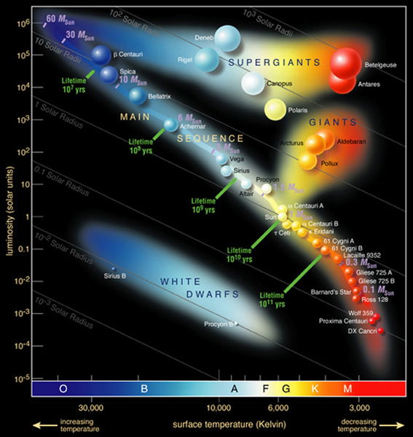
Figure 1: The Hertzsprung-Russell diagram
Image Credit: European Southern Observatory/CC BY 4.0

The life cycle of stars can also be tracked through the HR diagram. The basic stellar evolution of both high and low mass stars is covered in Figure 2. All stars begin as a star forming nebula of gas, and when enough mass has accumulated hydrogen fusion begins. The remains of the nebula that has not coalesced into a star is blown away by the energy generated by fusion. Once the fusion process has begun, the protostar is “born”. All stars, regardless of their mass, begin their life on the “main sequence” (this grouping of stars can be seen in Figure 1). Very low mass stars about 1/10 the mass of our sun, which can be found in the bottom right corner of the HR diagram, are only massive enough to fuse hydrogen into helium. Once their hydrogen supply is close to running out they move to the left of the HR diagram and become blue dwarfs, and once their fuel is consumed entirely they will slowly cool, eventually becoming white and then black dwarfs. There are no blue dwarfs yet as the lifetime of these small stars is very long, and there has not been enough time to exhaust their fuel given the limited age of the universe. All white dwarfs that currently exist are the remnants of mid-sized stars such as the sun.
Mid-size stars, such as our sun, begin fusing hydrogen on the “main-sequence” but are massive enough to fuse their helium through the CNO cycle (covered in more details in the ‘Origin of the Elements’ resource). Once the helium burning stage begins, these stars grow significantly in radius and move vertically up the HR diagram as they get much brighter. The outer surface temperature also decreases and the stars become redder in colour. This is due to the larger size of the star, as the surface is now further from the core where most of the energy and heat is being created. These stars are now off the “main-sequence” and in the “giant” area. This cooler surface temperature gives these stars the commonly used name “red giant”. Once the helium is exhausted the star collapses, creating a planetary nebula and ultimately a white dwarf. White dwarfs are located in the lower left of the HR diagram. These stars are small in radius and low luminosity as much of their mass is lost to the planetary nebula. However, they are still quite hot/blue when they are first created. They slowly move in a diagonal right-down direction as they slowly cool and become dimmer, eventually becoming so cool and dim that we can no longer observe them (black dwarfs).
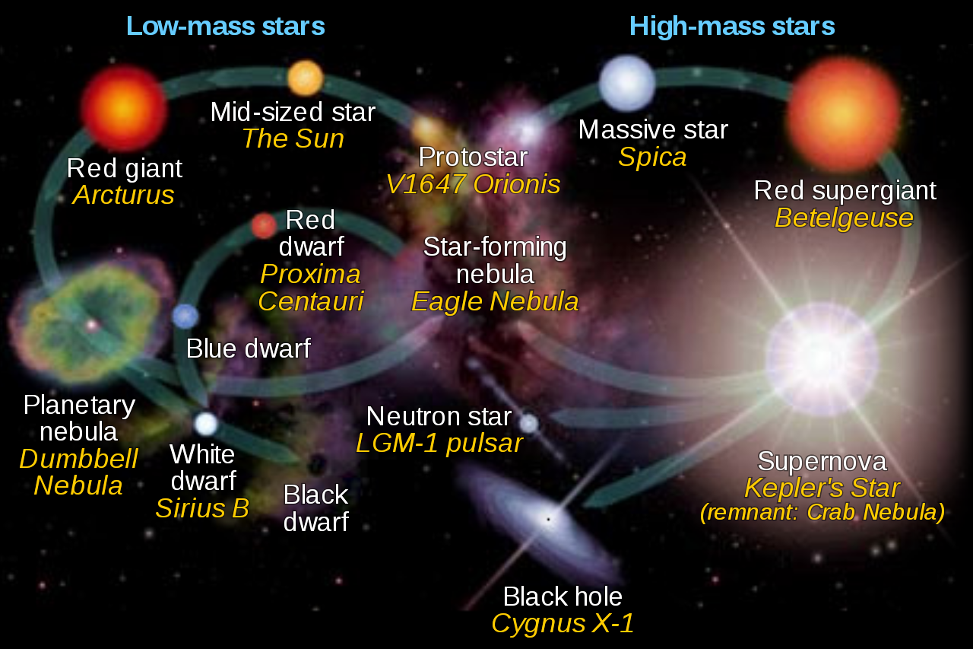
Figure 2: Life cycles of low and high mass stars
Image Credit: NASA Goddard Space Flight Center/CC BY-SA 4.0

High mass stars (>10 x mass of the sun) also begin on the “main sequence” as they consume their hydrogen. These stars quickly initiate helium fusion after they have exhausted their hydrogen, and are so massive that they will be able to continue fusing heavier elements after the helium fuel is exhausted. These stars will even fuse heavier elements up to iron until they develop an iron core. While these stars fuse these heavier elements they move off the main sequence towards the right. However, the most massive of these stars often don’t make it as far right as less massive supergiants. This is because they are so energetic and massive that their outer layers are completely blown away before the star goes supernova. A supernova occurs once the fuel begins to run out and the gravitational pressure on the iron core becomes so large that the matter reaches a threshold where the repulsive force between the electron clouds that keeps atoms separate forces a collapse into the atoms’ nuclei to form what is essentially one huge atomic nucleus made up of neutrons. We call this a neutron star. If the mass of the star is large enough then in a similar way the neutrons can also collapse and become a black hole, although this exact process is not well understood. These final states of the supergiant stars do not appear on the HR diagram.
The HR diagram can also be used by scientists to roughly measure the distances from Earth to a particular star cluster. This is achieved by comparing the apparent magnitudes of the unknown cluster stars to the absolute magnitudes of stars with known distances. The observed cluster is then shifted in the vertical direction on the HR diagram until the main sequence of the cluster overlaps with the main sequence of the reference stars of known distances. This technique is known as main sequence fitting, and by comparing the difference in luminosity between the unknown cluster and the reference stars, the distance to the unknown cluster can be determined.

