Nuclear Energy Calculations

Content
The laws of conservation of mass and energy are two fundamental premises in physics which state that both mass and energy cannot be created or destroyed and are therefore conserved. In most cases it serves us well to consider separately that the total mass and total energy is conserved, as this is true in all mechanical and chemical processes. However, when it comes to nuclear processes a significant change in the amount of mass and energy in the system is observed. These reactions highlight the fact that the laws of conservation of mass and energy are not correct in all circumstances. It is more accurate for us to state that it is the total amount of mass and energy that is conserved, and that mass and energy can be transformed into one another using Einstein’s most famous equation expressing the equivalence of mass and energy, E = mc².
Binding Energy
Binding energy is the term given to the energy that holds together the individual nucleons (protons and neutrons) within the nucleus of an atom. This is quite a large amount of energy, which is a result of how close the protons in the nucleus are to each other. Recall that particles which have like charges will generate a repulsion force between them and this force increases with the inverse square of the distance between them. The source of the binding energy is a small fraction of the mass of the nucleons; this mass is converted to binding energy according to E = mc².

Example 1:
Let’s take a look at the binding energy of the helium nucleus. The most common form of helium is known as ⁴He which contains two protons and two neutrons. In order to calculate the magnitude of the binding energy in a single atom of helium we need to compare the mass of 2 individual protons and 2 individual neutrons, with the mass of a helium nucleus.
Looking up a few values we find that
Mass of proton = 1.6726219 × 10⁻²⁷ kg
Mass of neutron = 1.674929 x 10⁻²⁷ kg
Mass of helium nucleus = 6.6464807 x 10⁻²⁷ kg
So, the difference in mass between the individual nucleons and the helium atom is:
$$\left(2 ×mass of proton+2 ×mass of neutron\right)-(mass of helium nucleus)$$
$$\left(6.69510×{10}^{-27}\right)- \left(6.64466×{10}^{-27}\right)$$
$$0.050441×{10}^{-27} kg$$
We then use the mass energy equivalence to convert to energy:
$$E=mc^{2}$$
$$E=0.050441×{10}^{-27} ×{\left(3×{10}^{8}\right)}^{2}$$
$$E=4.5334×{10}^{-12} J$$
This seems like a very small amount of energy, and it is, but remember that this is for only one atom, and there are a lot of atoms in the amounts of things that we are more familiar with. To put this in perspective there are about 1.5 x 10²³ atoms in 1 gram of helium, which gives us a binding energy of 680MJ per gram of helium, and this is quite a lot of energy!
The binding energy is relevant to fusion and fission reactions as it is a requirement that the products of the reaction be more stable than the reactants for either of these reactions to release a net gain of energy.
Energy Released In Nuclear Reactions
Example 2:
Let us calculate the energy released in the fusion reaction between deuterium and tritium. This is the most promising reaction for a potential fusion power source. The reaction is summarised below.
$${}_{1}^{2}{D+ }{}_{1}^{3}{T→ }{}_{2}^{4}{He+ }{}_{0}^{1}{n }$$
Here, a tritium nucleus fuses with a deuterium nucleus to produce a helium nucleus and a free neutron. By comparing the difference in the masses of the products and reactants, we can use E = mc² to calculate the energy released in this reaction. We can find from the literature the mass for the elements of the reaction
Mass of Deuterium: 3.34 x 10⁻²⁷ kg  Mass of Tritium: 5.01 x 10⁻²⁷ kg | Mass of Helium: 6.65 x 10⁻²⁷ kg  Mass of Neutron: 1.67 x 10⁻²⁷ kg
Calculating the energy released in joules
$$Energy Released=\left(Mass of reactants-Mass of products\right)×{speed of light}^{2}$$
$$=\left(\left({mass}_{T}+{mass}_{D}\right)- \left({mass}_{He}+{mass}_{n}\right)\right)×{speed of light}^{2}$$
$$=\left(\left(\left(3.34+5.01\right)- \left(6.65+1.67\right)\right) × {10}^{-27}\right)×3.00 ×{10}^{8}$$
$$=2.8 ×{10}^{-12} J$$
Nuclear reactions are typically described in units of MeV. In order to convert to MeV we must first divide by the charge of an electron, to convert from J to eV. Then divide by 10⁶ to convert eV to MeV.
$$Energy Released=17.5 MeV$$
This is consistent with the documented value of 17.59 MeV. This same method can be used to determine the energy released in any nuclear transmutation, including naturally occurring radioactive decay (alpha, beta, and gamma) and fission.
Binding Energy Per Nucleon
Let us now consider the changes in binding energy in the deuterium-tritium reaction. We won’t go through calculating the binding energy for all of these nuclei as we did in the last example, but we can easily look up the binding energies in order to compare them.
Values:
Binding energy for Deuterium, 2224 keV
Binding energy of Tritium, 8,481 keV
Binding energy of ⁴He, 28300 keV
We can clearly see that the binding energy for the helium nucleus is much greater than the deuterium and tritium nuclei, which indicates that the helium nucleus is more tightly bound and hence is a more stable nucleus. For this reason, it is a more energetically stable configuration for the nucleons (proton and neutrons) to exist in than as a deuterium and tritium nucleus.
However, there is one more caveat in understanding the relationship between binding energy and stability. The number that truly represents stability is not the total binding energy of the nucleus, but the binding energy per nucleon. This number accurately represents stability as it represents how easy it is to pull the individual nucleons apart.
For example, consider a nucleus that has 100 nucleons and a total binding energy of 200,000 keV, this would be a binding energy per nucleon of 2,000 keV. Now consider a nucleus with just 10 nucleons and a total binding energy of 100,000 keV, this would be a binding energy per nucleon of 10,000 keV. Despite the fact that the larger nucleus has more total binding energy, it is the smaller nucleus that is actually more stable as it has 5 times more binding energy per nucleon and hence requires 5 times more energy to separate an individual nucleon.
If we were to calculate the binding energy per nucleon for our previous deuterium-tritium example, we can see that it is still greater for helium than deuterium and tritium, hence the reaction can occur and release energy.
Binding energy per nucleon of Deuterium, 1112keV
Binding energy per nucleon of Tritium, 2827keV
Binding energy per nucleon of ⁴He, 7075keV
This brings us to the final figure which helps us understand binding energy. This graph plots the binding energy per nucleon for a range of different nuclei. On the left-hand side of the graph we can see that as the sizes of the nuclei increase, the binding energy per nucleon also increases. Hence, in this region it is possible for fusion reactions to occur and release energy. This is because the larger nuclei are more stable than the smaller reactants. However, on the right-hand side of the graph the opposite is true; these large nuclei are actually more stable and release energy when they split apart to make smaller nuclei (fission). This is the opposite process to fusion and is called fission. The most stable nucleus shown on this graph is ⁵⁶Fe.
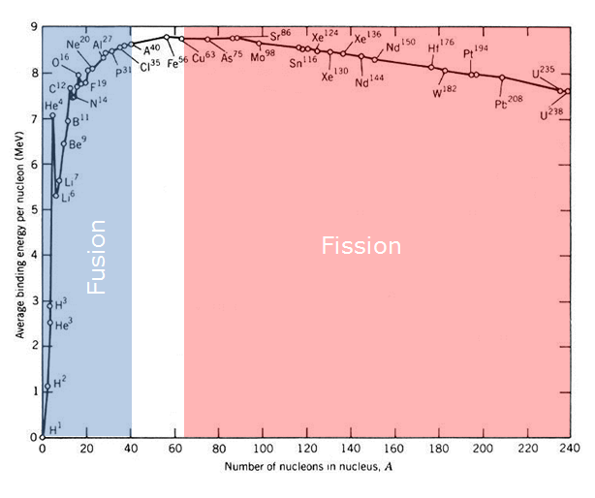
Figure 1. Binding energy per nucleon for a variety of atomic nuclei
Image Credit: http://www.earth-site.co.uk/Education/binding-energy/

