NUCLEAR Model of the atom
Content

In the late 1800’s and early 1900’s there was a fierce debate about the composition of matter. While there were many ideas at the time, two models dominated the discourse. These were Thomson’s ‘plum-pudding’ model, and Rutherford’s ‘atomic’ model. The electron was discovered by J. J. Thomson in 1897 through his famous cathode ray experiment, and although this experiment wasn’t conclusive, it suggested that the electron was a very light particle, about 2000 times lighter than the hydrogen atom. This result was conclusively determined by Millikan’s oil drop experiment, where the exact charge of the electron was confirmed. This idea about a small and mobile electron was incorporated into both the Thomson model and the Rutherford model. Descriptive depictions of these models are shown in Figure 1.

Both models depicted the electrons in the same way (shown in blue), as small localised and mobile sources of negative charge. It was known that matter contains some amount of positive charge which balances out the negative charge of the electrons. It was also known that unlike the negative charge of electrons which are highly mobile, the positive charge contained within matter is locked in place. The key difference between the two models is the distribution of this positive charge. In Thomson’s model the positive charge is spread out over a large volume, which makes up the bulk of the volume of matter. This can explain why the positive matter is not mobile as it is not condensed into small particles. Rutherford presumed that the positive matter should take on a much more similar form to the electrons. He thought that the positive charge should be localised as a discrete concentration of particles. Although much larger than the electrons, they still represented most of the mass of matter. This did suggest, however, that most of the space within matter is made up of nothing more than empty space. This is probably the most counter-intuitive part of Rutherford’s model.

Definitive evidence for Rutherford’s model came from the Geiger-Marsden experiment. A schematic diagram of this experiment is shown in Figure 1. An alpha particle source emits energetic particles in all directions. A collimated beam of alpha particles is created by encapsulating an alpha source in a box with a small hole in it. This beam is directed towards a very thin film of gold foil. Gold was chosen due to the fact that it is the most malleable metal and can be formed into incredibly thin sheets. The sheets had to be very thin as alpha particles have very poor penetration power and if the material was too thick then the alpha particles would be absorbed by the material. The expected results were quite different for the two models. Thomson’s model predicted that due to the spread out nature of the positive charges the repulsive forces from the positive charge would be small and the deflection of the alpha particles would be minor. However, due to the high concentrations of positive matter in Rutherford’s model, when an alpha particle approached one of these high concentrations of charge the predicted forces would be immense and the degree of deflection would be dramatic. The results were clear and clearly supported the ‘atomic’ model of the atom. After this discovery it was quickly surmised that the place of elements in the periodic table or ‘atomic number’ corresponded to the nuclear charge of the atom, and that the smallest atom (hydrogen) contained just one of these particles, which came to be named protons.

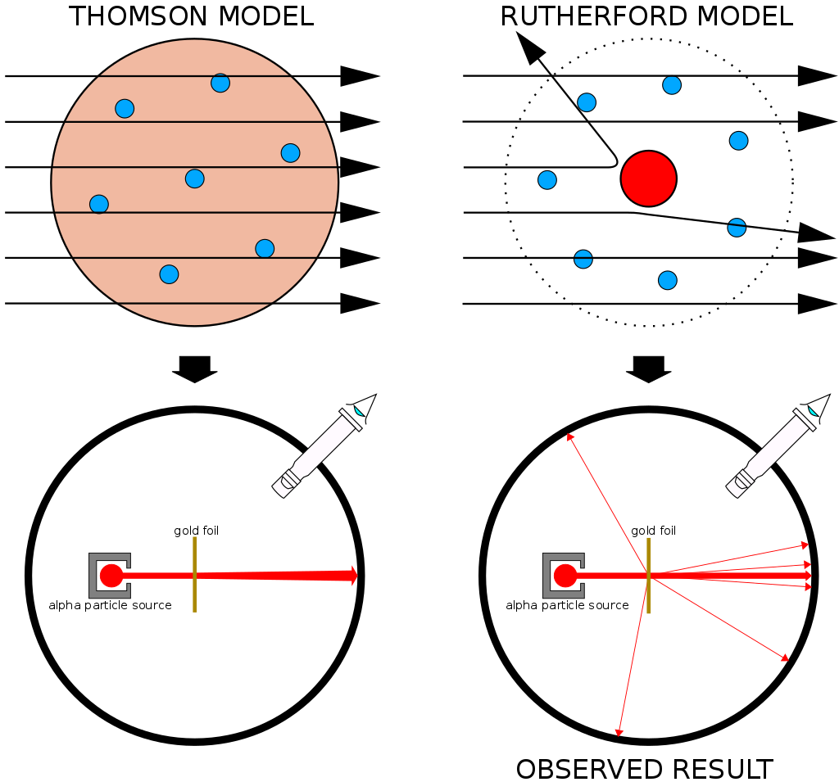
Figure 1. Comparison of Thomson and Rutherford models of the atom
Image credit: User:Kurzon/ Wikimedia Commons/CC BY-SA 3.0

After the validation of the atomic model by Rutherford, a more detailed version of Rutherford’s model, called the Rutherford-Bohr model, or just the Bohr model was developed by Rutherford and Bohr. A schematic diagram of this model is shown in Figure 2. The core feature of this model, which differs to the earlier Rutherford model, is the postulated fact that the electrons are able to occupy certain stable orbits without emitting radiation (in conflict to classical electromagnetism). Electrons cannot occupy orbits between these stable orbits and the stationary orbits are located at distances which correspond to an electron angular momentum that is a multiple of the reduced Planck’s constant (nħ). The final major point of the Bohr model is that electrons can move to different stable energy levels by the absorption and emission of electromagnetic radiation with a frequency that corresponds to the energy difference between the energy levels. This model was able to explain the atomic spectra of Hydrogen and similar atoms. This was a major improvement on previous models and suggested that there was some validity to the concept of ‘allowed electron energy levels’ in atomic structure. Despite these improvements, the Bohr model was not able to predict atomic spectra for the majority of atoms; it could not explain why some spectral lines were much more intense than others, it could not explain the Zeeman effect (where spectral lines are split in the presence of a magnetic fields, and most importantly it could not explain any reasoning as to why these energy levels were allowed and others were forbidden. It would take the introduction of quantum mechanics to answer these questions.

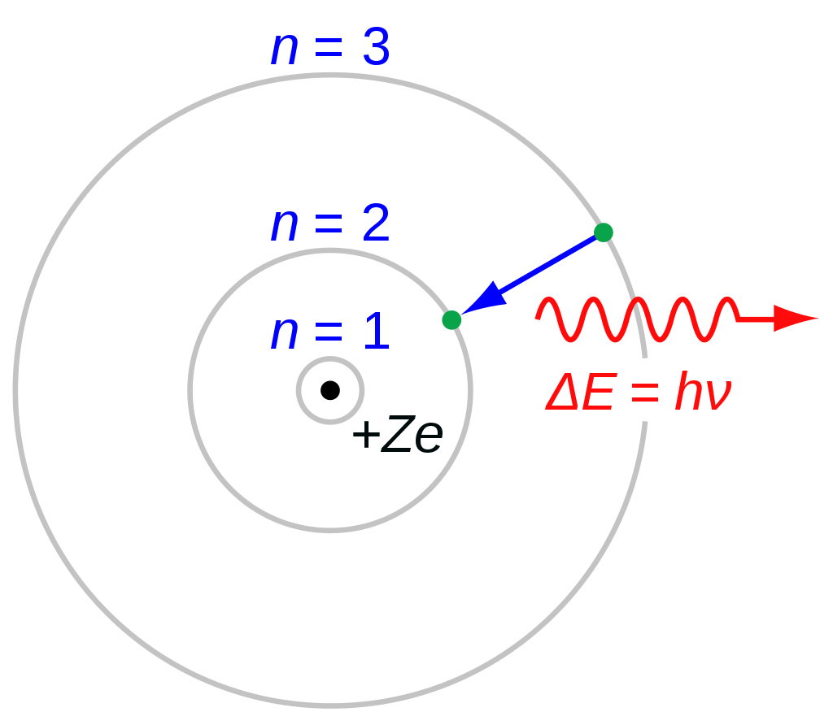
Figure 2: The Bohr model of the atom
Image credit: User:JabberWok/Wikimedia Commons/ CC BY-SA 3.0

The discovery of nuclear isotopes (that is, atoms that have the same atomic number and chemical nature, but a different atomic weight) was the first major piece of evidence that suggested the existence of the neutron. It was found that the mass of these isotopes could always be expressed as a whole number of proton masses, suggesting the existence of a particle that had the same mass as a proton but was neutral in terms of electric charge. Due to the fact that the neutron has no electric charge and the difficulty in creating free neutrons separate from the atomic nucleus, it would remain difficult to prove its existence.

An unknown and highly penetrating form of radiation was observed to be emitted when alpha particles struck specific light elements, such as beryllium. Initially, this radiation was thought to be gamma rays, but it was more highly penetrating than any gamma rays previously observed. It was also found that this unknown radiation caused the ejection of protons from paraffin wax at very high energies of 5 MeV. In order for gamma rays to be responsible for this interaction they must have an unbelievably high energy. James Chadwick was one of the physicists who did not believe the gamma ray explanation and designed the experiment shown in Figure 3 in order to study the reaction. By carefully measuring the range of the ejected protons and the interaction of the unknown radiation with a number of gases, Chadwick was able to determine that the unknown radiation could be interpreted as a neutral particle with about the same mass as the proton. Chadwick’s discovery of the neutron provided the final piece in the atomic model puzzle and, in 1935, won him the Nobel Prize on Physics.

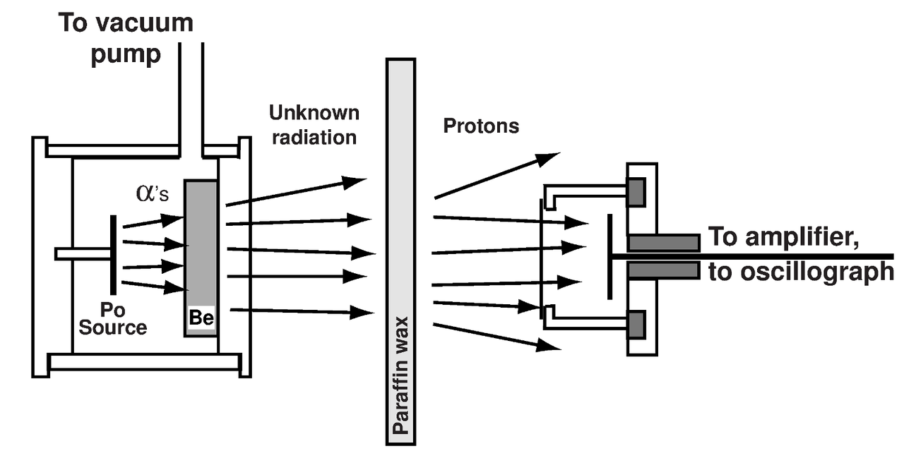
Figure 3: Schematic diagram of the experiment Chadwick used to discover the neutron
Image credit: User:Bdushaw/Wikimedia commons/CC BY-SA 4.0

