ORIGINS OF THE ELEMENTS
Content

The most famous equation in all of physics is, probably, Einstein’s description of the equivalence of energy and mass. This relationship tells us that energy can be converted into mass and vice versa.

$$E=mc^{2}$$

The first thing that we notice from this equation is that due to the large value of the speed of light (c), it takes a lot of energy to create a small amount of mass. For example, the amount of energy equivalent in a cup (250mL) of water is 2.24x10⁹ MJ. This is enough energy to power around 41,000 homes for 1 whole year! Let’s take a look at how we calculated these numbers.

Example 1
To demonstrate how to use this relationship we will calculate how much energy is equivalent to 250 mL of water.
First we need to know the mass of a cup of water. Given the density of water is 1000 kg/m³, we can calculate the mass with the following equation:

$$mass$$ | $$=density\left(kg/m^{3}\right) × volume\left(m^{3}\right)$$
 | $$=1000×0.00025$$
 | $$=0.25 kg$$

Now that we have the mass of the water, we can calculate the equivalent amount of energy:

$$E$$ | $$=mc^{2}$$
 | $$=0.25 kg*{\left(2.998×{10}^{8} m/s\right)}^{2}$$
 | $=2.247×{10}^{16}$J
 | = 2.25 $×{10}^{10}$MJ

This gives us the energy in Joules. However, we mostly measure electrical power consumption in units of kWh. We can use the conversion factor of 1MJ = 0.2778 kWh, thus

$$E_{kWh}$$ | $$=2.25×{10}^{10}×0.2778$$
 | $=6.25×{10}^{9}$kWh

The average Australian household consumes 40 kWh per day, meaning that the total number of houses that could be powered for a year would be:

$$Houses=\frac{6.25×{10}^{8}}{40×365}=428,116$$

Nuclear fusion reactions

It is the conversion of mass to energy that is responsible for the enormous energy released by stars. Nuclear reactions known as fusion reactions are responsible for this release of energy. There are two major fusion reactions that take place in stars.
In each example below the mass of the helium nucleus produced is slightly less than the mass of the four hydrogen nuclei consumed to produce it. Slightly less than 1% of the mass involved in the reaction is converted to energy.

Proton-proton fusion

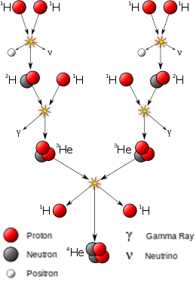
Step 1

Step 2

Step 3
Figure 1. Schematic diagram of the proton-proton cycles
Image credit: User: Borb/Wikimedia Commons/CC BY-SA 3.0

$$4H→{He}_{4}$$
Step 1: Two hydrogen nuclei, each a single proton, fuse together to create deuterium. This fusion process results in the emission of a positron (e+) and a neutrino.
Step 2: The newly-formed deuterium nucleus fuses with another hydrogen nucleus present inside the star. Together they form a ³He nucleus, emitting a single photon.
Step 3: Two ³He nuclei formed through the two steps above now fuse together, resulting in a stable ⁴He nucleus and the release of two hydrogen nuclei back into the star.
This entire fusion cycle releases around 26.2 MeV of energy each time. This proton-proton cycle is the dominant source of energy in a main sequence star like our Sun.

Carbon-nitrogen-oxygen fusion (CNO)
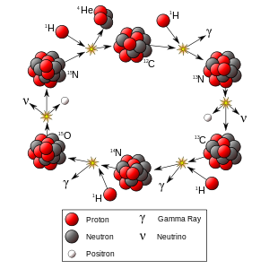
Figure 2. Shemcatic diagram of the CNO cycle
Image credit: User:Borb/Wikimedia Commons/CC BY-SA 3.0
Another way that stars can convert hydrogen into helium is through the carbon-nitrogen-oxygen (CNO) cycle. The CNO cycle is a catalytic process which involves multiple steps where heavier nuclei are involved in the reaction; however these nuclei are not used up in the process. Since the carbon nucleus is reconstructed at the end of the cycle, the overall reaction can be represented simply as $4H→{He}_{4}$, as before. There are many slightly different versions of the CNO cycle, which are divided into two main categories of cold and hot CNO cycles, with the former being limited by the rate of initial proton captures, and the latter being limited by the rate of beta decays of the intermediate nuclei. An example of a cold CNO cycle is given below. This is the most common CNO cycle found in typical conditions within stars.
Step 1: A carbon-12 (¹²C) nucleus fuses with a proton to form a nitrogen-13 (¹³N) nucleus, emitting a photon in the process.
Step 2: The nitrogen nucleus releases a positron (e+) and a neutrino to become a carbon-13 (¹³C) nucleus.
Step 3: The new carbon nucleus fuses with a proton to form nitrogen-14 (¹⁴N), releasing a photon.
Step 4: The nitrogen nucleus fuses with a proton to form oxygen-15 (¹⁵O), releasing a photon.
Step 5: The oxygen nucleus releases a positron and a neutrino to become a nitrogen-15 (¹⁵N) nucleus.
Step 6: The nitrogen-15 (¹⁵N) nucleus fuses with one final proton to produce a helium-4 (⁴He) nucleus and a carbon-12 (¹²C) nucleus that can be used once again for step 1, beginning the cycle over again.
Each complete CNO cycle produces about 25 MeV of energy. This is the main source of energy in higher-mass post-main sequence stars. This is because the repulsive electromagnetic force of the six-proton carbon nucleus prevents fusion without an incredibly high temperature and pressure to overcome it. Thus, it can only occur in the very centre of low mass stars, but is widespread in more massive stars. In the most massive stars even heavier elements, up to iron and nickel can form. Elements heavier than these typically don’t form as iron and nickel are very stable and the star loses energy when fusing even heavier elements together. The heaviest elements tend to form a dense core in the centre of the star, with the lighter elements forming the outer layers of the star.

