ORIGINS OF THE UNIVERSE
Content

Current scientific theory holds that at some point in history, there was no universe. In fact, time and space themselves didn’t even exist before the explosion of radiation known as the ‘Big Bang’. Suddenly, nearly 14 billion years ago, energy burst into being from a singularity and ultimately created everything that exists in our universe today, from atoms to stars to galaxies. But how did a bunch of light become physical matter?
Scientists believe that the universe was born at an incredibly high temperature, somewhere around 10³² K. With this much heat energy around, physical matter like particles and atoms couldn’t exist, and the four fundamental forces of the universe we’re familiar with - gravity, electromagnetism, and the strong and weak nuclear forces - were unified into a single superforce. We can trace a somewhat speculative timeline of the early universe as it expanded and cooled.
TIMELINE
- Inflationary phase (t = 10⁻⁴³ to 10⁻³⁵ s): The universe undergoes exponential expansion and cools down rapidly to ~10²⁷ K. Gravity separates itself out as an independent force.
- Age of leptons (t = 10⁻³⁵ to 10⁻⁶ s): The strong nuclear force separates, followed by the weak nuclear force and electromagnetism. Fundamental particles like quarks, leptons and photons come into existence.
- Age of nucleons (t = 10⁻⁶ to 225 s): Composite particles made up of two or more quarks known as hadrons come into being. Thanks to the high temperature, photons combine to form matter/anti-matter pairs, which then annihilate each other to create more photons in a thermal equilibrium. These processes are detailed in the equations following.
$$γ+γ⇔e^{-}+e^{+}$$
$$γ+γ⇔p+\overline{p}$$
$$γ+γ⇔n+\overline{n}$$
As this process continues, the universe cools down to 10¹¹ K, too cold for continued proton and neutron anti-matter pairs. There is slightly more matter than antimatter overall.
- Age of nucleosynthesis (t = 225 s to 1,000 years): Protons and neutrons, collectively known as nucleons, begin to combine with each other to form nuclei which then react with each other to form bigger nuclei. By the end of this stage about 25% of the universe is helium, and the remainder mainly hydrogen.
- Age of ions (t = 1,000 to 3,000 years): The temperature of the universe is still high enough to ionize any atoms formed, so it’s made mostly of photons, light nuclei and other charged particles.

- Age of atoms (t = 3,000 to 300,000 years): The temperature drops to 10⁵ K, allowing nucleons and electrons to form stable atoms of hydrogen and helium. Following the production of stable atoms, photons no longer interact frequently with normal matter in the thermal equilibrium described above. This electromagnetic radiation spreads out to fill the universe. Today, this ancient radiation can still be detected as a faint, omnipresent glow known as the cosmic microwave background, with a temperature equivalent to about 3 K.
- Age of stars and galaxies (t = 300,000 years to present): Matter aggregates into clumps. Extremely dense clumps allow hydrogen atoms to undergo nuclear fusion, and create the first stars.

Hubble and the expanding universe

Up until the early 1900s most scientists assumed that the universe was overall static. This means that while it was thought possible that stars and galaxies could move relative to each other, it was thought that the space in which all objects exist in does not expand or contract in any way. However, since we know that gravity is an attractive force between all matter, why has the matter in the universe not coalesced into one gigantic mass? This question was pondered by many; in fact even Newton raised this as a serious issue with his theory of gravitation.
In the 1920s, the American astronomer Edwin Hubble conducted an investigation into the observations that other astronomers had made of the red-shift of distant ‘nebulae’ (now known to be galaxies) a known distance away – especially studies by astrophysicist Henrietta Leavitt and her observation of variable stars in the Small and Large Magellanic Clouds. It was observed that characteristic spectral lines of stars (covered in detail in the resource ‘Stellar Spectra’) were red-shifted for distant galaxies when compared with the wavelengths of these same spectral lines when measured on earth. It was initially assumed that these shifts were due to the Doppler Effect. This was a known process where the relative motion between a source and an observer causes a shift in the wavelengths measured. This process is depicted in Figure 1. However, we now know that this interpretation is not accurate.
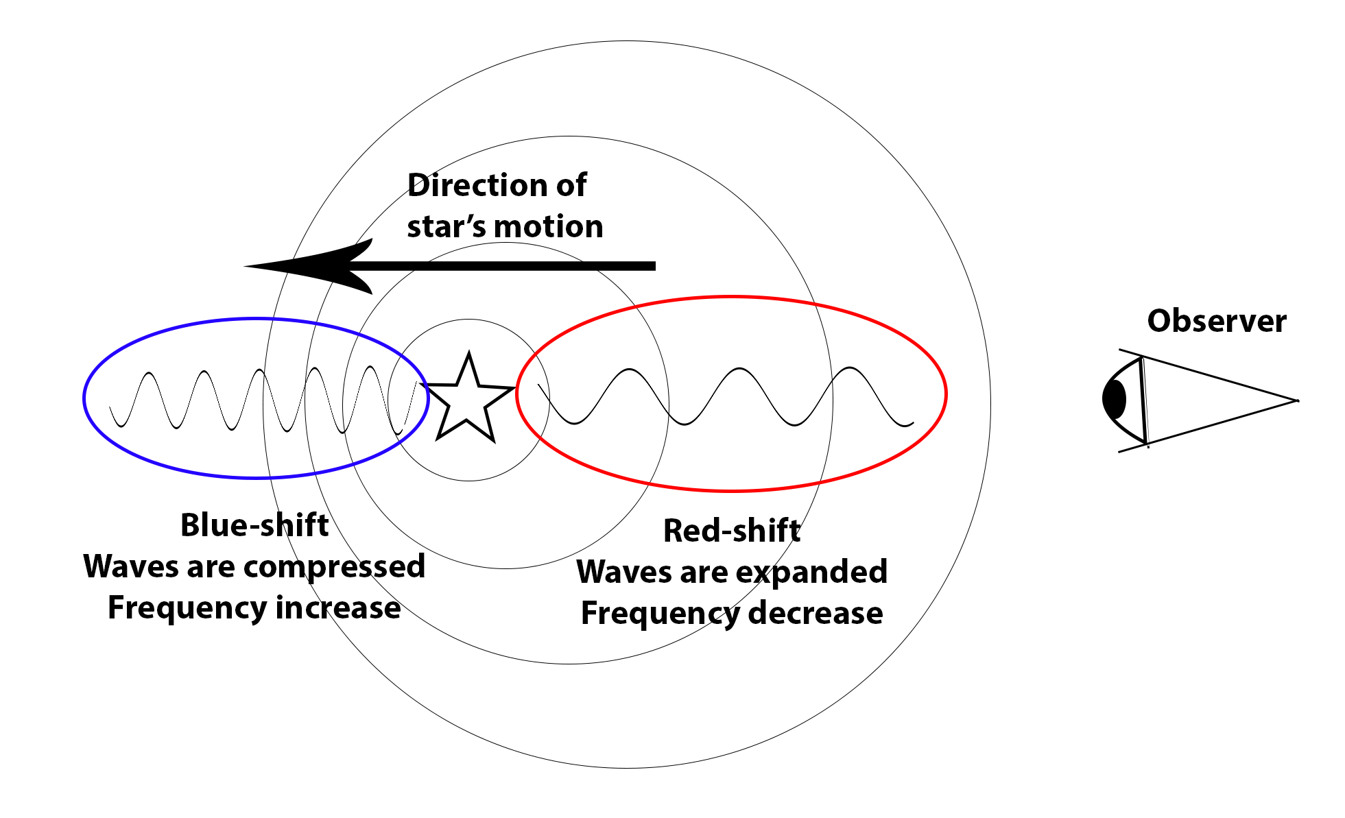
Figure 1. The initial interpretation of Hubble’s Data was Red/blue shift from stars motion

Two remarkable results were found from analysing Hubble’s data. First, it was found that the speed with which a galaxy is moving away from us is proportional to its distance, with the most distant galaxies moving the fastest and the closest galaxies moving the slowest. This relationship is called Hubble’s Law. The second major discovery is that the light from all of the galaxies is ‘redshifted’ indicating that all galaxies are moving away from us. We have no reason to think that we are located at the centre of the universe, or that the region of space that we are located in is special in any way. This is a consequence of what is known as the cosmological principle, which states that at a large scale the universe is homogeneous and isotropic. This leads us to conclude that from any galaxy it appears that all other galaxies are moving away or that from any point in the universe it appears that the universe is expanding in all directions. Hubble’s law supports the theory of a Big Bang, as it indicates that all of the matter in the universe was far more concentrated in the past than it is now.
Our understanding of the universe has improved with the introduction of the theory of general relativity. According to general relativity, the redshift in the observed wavelength of light is not caused by a Doppler shift as distant galaxies expand into a previously empty space. Rather, the observed redshift comes from the expansion of space itself and everything in intergalactic space, including the wavelengths of light traveling to us from distant sources. This can be a difficult concept to grasp at first. Consider the example shown in Figure 2, this shows a section of the ‘universe’. Note that the relative position (grid-coordinates) of the galaxies remains the same, while the distance between the galaxies has expanded, and the wavelength of the light between the galaxies has also expanded. This is a direct effect of the fact that it is the space on which the grid, galaxies, and light are placed which is expanding. The picture below is a little misleading as it still shows a ‘finite’ universe which seems to expand into ‘empty’ space on the page. This is where this simple illustration breaks down, as our best current evidence suggests that the universe is infinite. This means that there is nothing outside the universe, it has no edges, and it is not expanding into anything. This is a hard concept to capture in an illustration!
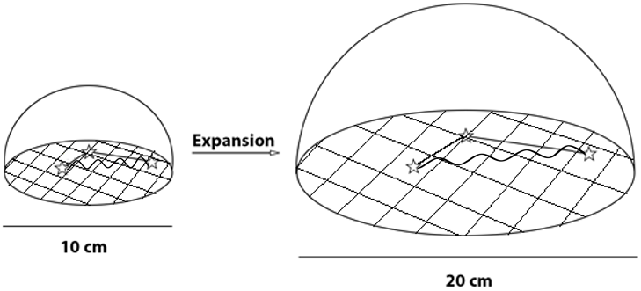
Figure 2. The general relativity view of the expansion of the universe

