quantised energy levels
Content
The Balmer series refers to a series of visible spectral lines that are observed when hydrogen gas is excited. These lines are shown in Figure 1 (upper). The four most prominent lines occur at wavelengths of 410 nm, 434 nm, 486 nm, and 656 nm. The combination of these spectral lines is responsible for the familiar pinkish/purplish glow that we associate with hydrogen discharges and gaseous nebulae, shown in Figure 1 (lower).
Figure1. The six lines of the Balmer series (upper), Hydrogen discharge (lower)
Image Credit: User: Jan Homann/Wikimedia Commons/CC BY-SA 3.0 & User: Alchemist-hp/(www.pse-mendelejew.de)/FAL

These spectral lines were observed long before an empirical equation was discovered by Johann Balmer in 1885 which could describe the wavelengths of the lines. However, it was not known at the time why this equation matched the observed wavelengths. Balmer’s equation for wavelengths is given as
$$λ=B \left(\frac{n^{2}}{n^{2}-m^{2}}\right),$$
where λ is the predicted wavelength, B is a constant with the value of 364.50682 nm, m is equal to 2, and n is an integer such that n > m.
We now know that this equation was able to describe the wavelengths of the Balmer series because these wavelengths correspond to electron transitions between higher energy levels and the n=2 energy level. As electrons transition from higher energy levels to lower energy levels, conservation of energy is maintained by the emission of a photon of energy equal to the difference between the final and initial energy levels of the electron. Such a transition is depicted in Figure 2, for the $H_{α}$ line. We also know the difference between successive energy levels decreases as n increases. In addition, in the limit as n goes to infinity, the wavelength approaches the value of the constant B. This limit corresponds to the amount of energy required to ionise the hydrogen atom and eject the electron. This is also referred to as the electron binding energy.
As previously stated, the law of conservation of energy dictates that the frequency of the emitted photon be equal to the energy difference between the transitioning electron energy levels in the atom. This relation is quantified by the Einstein-Planck equation (sometimes referred to, in the context of electron transitions, as Bohr’s frequency condition), given as
$$E=hf,$$
where E represents the difference in electron energy levels (this is also equal to the photon energy), h is Planck’s constant (6.626 ×10⁻³⁴ J.s), and f is the frequency of the emitted photon. We can also use the wave equation,
$$c=fλ,$$
where c is the speed of light, f is the frequency of the light, and λ is the wavelength of the light, in order to relate the energy of the electron transitions directly to the wavelength of the emitted photon
$$E=\frac{hc}{λ}.$$
Other hydrogen spectral series were also discovered, for instance the Lyman series describes transitions that end on the n = 1 energy level. As a result, the photons emitted from these transitions are higher in energy than the Balmer series, and the Lyman series is in the ultraviolet region of the electromagnetic spectrum. Another example is the Paschen series; this series describes transitions to the n = 3 level, so the emitted photons are lower in energy than the Balmer series and are categorised as infrared.
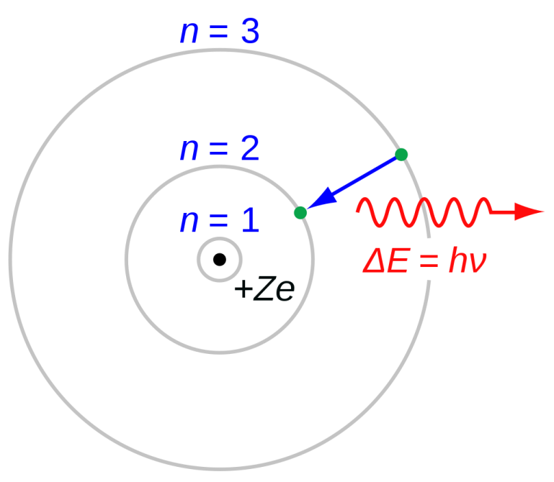
Figure 2: The Bohr model of the atom showing the $H_{α}$ line
Image credit: User: JabberWok/Wikimedia Commons/ CC BY-SA 3.0
The Balmer equation was generalised by Rydberg in order to describe the wavelengths of all of the spectral series of hydrogen, including for instance the Paschen and Lyman series. The Rydberg equation is described as:
$$\frac{1}{λ}= R_{H}\left(\frac{1}{n_{f}^{2}}- \frac{1}{n_{i}^{2}}\right),$$
where λ is the wavelength of electromagnetic radiation emitted in vacuum, $R_{H}$ is the Rydberg constant for hydrogen with a value of 1.097×10⁷m⁻¹, and $n_{f}$ and $n_{i}$ correspond to the final and initial energy levels of the transition.

Example 1:
Determine the wavelength of the 2nd line in the Lyman series (electron transition from n = 3 to n = 1), known as Lyman β
$$\frac{1}{λ}= R_{H}\left(\frac{1}{n_{1}^{2}}- \frac{1}{n_{2}^{2}}\right)$$
$$\frac{1}{λ}= 1.097×{10}^{7}\left(\frac{1}{1^{2}}- \frac{1}{3^{2}}\right)$$
$$\frac{1}{λ}= 1.097×{10}^{7}\left(\frac{8}{9}\right)$$
$$λ=1.0255×{10}^{-7}m$$
$$λ=103 nm$$

