Radioactive Decay
Content
Soon after the initial discovery of radioactivity, researchers found that applying an electric field would cause the radiation to split into three different types, as shown in Figure 1. This result indicated that alpha particles are positively charged, beta particles are negatively charged, and gamma rays have no electric charge.
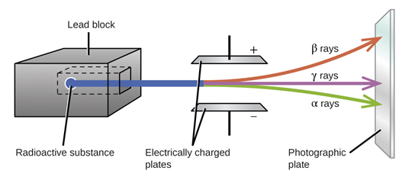
Figure 1. The discovery of three different types of radiation
Image Credit: http://letslearnnepal.com/class-12/physics/modern-physics/radioactivity
These types of radiation were named by their penetrating power, with alpha radiation being the least penetrating, being shielded by a few cm of air or just a sheet of paper. Beta radiation was found to be somewhat more penetrating, requiring a few mm of metal, such as aluminium in order to be blocked. Gamma rays are by far the most penetrating requiring several centimetres of lead in order to be absorbed. All of these are referred to as ‘ionising radiation’. This means that the energy of this radiation is sufficient to ionise atoms and break chemical bonds. This is biologically important, as this is the type of radiation that can damage our DNA and cells, causing injury or even death. Examples of non-ionising radiation found in our everyday lives are microwaves and radio waves. While alpha radiation is the least penetrating it is actually the most ionising of these three forms of radiation. Although this may be counter-intuitive at first, it is the fact that the alpha particles so readily ionise the material they encounter, and transfer their energy into that material, that leads to them penetrating less material and dumping all of their energy in a small volume.
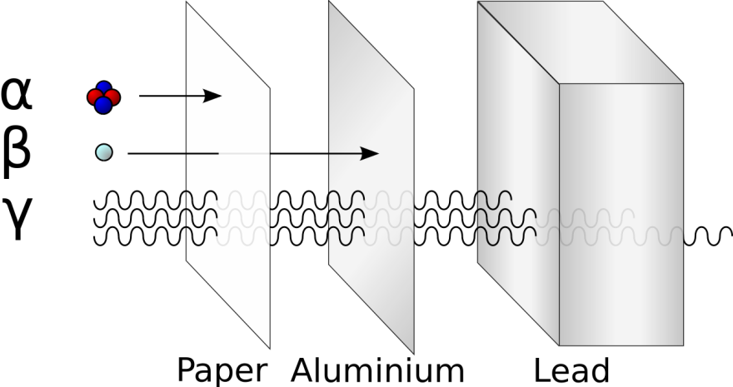
Figure 2. Penetrating power of alpha, beta, and gamma radiation
User: Stannered derivative work: Ehamberg/Wikimedia Commons/ CC BY 2.5
The composition of alpha, beta and gamma radiation is also different. An alpha particle is actually a helium-4 nucleus, which itself consists of two protons and two neutrons. Alpha decay typically occurs only in heavy nuclei. With the exception of beryllium-8 which spontaneously decays into two alpha particles, there are no elements below tellurium (atomic number 52) that undergo alpha decay. However, all elements heavier than lead (atomic number 82) are unstable, with the majority decaying through alpha radiation. Alpha decay has the largest effect on the decaying nucleus reducing the atomic mass number by 4 and atomic number by 2. A common isotope which is regularly used by students to observe an alpha decay is americium-241. Americium-241 has a relatively long half-life of 432.2 years, and the decay process is summarised in the equation below:
$${}_{95}^{241}{Am→ {}_{93}^{237}{Np}+ {}_{2}^{4}∝}+ γ 59 keV$$
As you can see, this decay process also results in the emission of a gamma ray with an energy of 59 keV. Gamma rays always occur with another decay process. This is because the gamma rays are not actually emitted during the initial alpha or beta decay, but rather from the resultant nucleus. In the americium-241 example above the neptunium nucleus is actually created in an excited state, and this excited state rapidly decays (with a very short half-life) into a stable ground state with the emission of a gamma photon. This is very similar to how electrons that are bound to atoms can decay from excited states to lower energy states with the emission of a photon.
A beta particle is an electron that has been ejected from a nucleus. The electron is created in the nucleus of the atom by a neutron decaying into a proton and an electron. The proton remains in the nucleus and the electron is emitted. Beta decay typically occurs in nuclei that have a large ratio of neutrons to protons. Since beta decay will reduce the number of neutrons by one and increase the number of protons by one, the ratio of neutrons to protons is made even by this reaction. A common example of beta decay is caesium-137, and the reaction is summarised in the equation below:
$${}_{55}^{137}{Cs}→ {}_{56}^{137}{Ba}+ {}_{-1}^{0}β$$
For alpha, beta and gamma radiation it is impossible to predict when any specific nucleus will decay. That is why we describe these reactions as ‘probabilistic’, and we are only able to predict the average fraction of nuclei that will decay over a certain period of time. This introduces us to the characteristic time scale which we call ‘half-life’ ($t_{1/2})$. This is the time it takes for half of the nuclei in a sample to decay. If we consider the number of nuclei remaining after a period of many half-lives the amount of remaining nuclei follows an exponential decay, with half the nuclei remaining after one ‘half-life’, and half of that half (a quarter) remaining after another ‘half-life’, and so on. This is depicted diagrammatically in Figure 3. This relationship is described mathematically by:

$$N_{t}= N_{0}e^{-λt}$$

where $N_{t}$ is the number of particles at time t, $N_{0}$ is the number of particles present at t=0, $λ= \frac{ln⁡(2)}{t_{1/2}}$ is called the decay constant, and $t_{1/2}$ is the half-life.

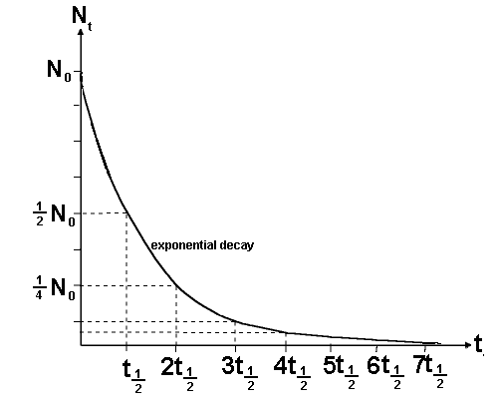
Figure 3. Number of nuclei versus number of half-life periods
Image Credit: https://www.cyberphysics.co.uk/topics/radioact/Radiodecay.htm

Example 1: In a student lab it is common to use americium-241 to demonstrate alpha decay. Say that a student’s source contains 0.1g of americium-241. How much americium will be left after 1000 years? The half-life of americium-241 is 432.2 years.

$$N_{t}= N_{0}e^{-λt}$$

$$N_{t}= 0.1e^{(-\frac{ln⁡(2)}{432.2})1000}$$

$$N_{t}= 0.020 g$$

Example 2: Iodine-131 is a very dangerous substance with a short half-life (8.3 days), it is produced in significant quantities in nuclear reactors and weapons. Let’s say a lake is polluted with iodine-131, how many days do we have to wait for 99.9% of the iodine to decay and for the water to be safe to drink?

$$N_{t}= N_{0}e^{-λt}$$  $$0.1= 100e^{-λt}$$  $$1×{10}^{-3}= e^{-λt}$$  $$λt= -ln⁡(1×{10}^{-3})$$  $$t= \frac{-ln⁡(1×{10}^{-3})}{λ}$$ | $$t= \frac{-ln⁡(1×{10}^{-3})}{(\frac{ln⁡(2)}{t_{1/2}})}$$  $$t= \frac{-ln⁡(1×{10}^{-3})}{(\frac{ln⁡(2)}{8.3})}$$  $$t= 82.7 days$$  $$t= 83 days$$

